SECURITIES AND EXCHANGE COMMISSION

Washington, D.C. 20549

FORM 6-K

Report of Foreign Private Issuer

Pursuant to Rule 13a-16 or 15d-16 under the

Securities Exchange Act of 1934

For the month of March 2024

Commission File Number: 001-14014

CREDICORP LTD.

(Translation of registrant’s name into English)

Of our subsidiary

Banco de Credito del Peru:

Calle Centenario 156

La Molina

Lima 12, Peru (Address of principal executive office)

Indicate by check mark whether the registrant files or will file annual reports under cover of Form 20-F or Form 40-F.

Form 20-F ☒ Form 40-F ☐

Indicate by check mark if the registrant is submitting the Form 6-K in paper as permitted by Regulation S-T Rule 101(b)(1): ____

Indicate by check mark if the registrant is submitting the Form 6-K in paper as permitted by Regulation S-T Rule 101(b)(7): ____

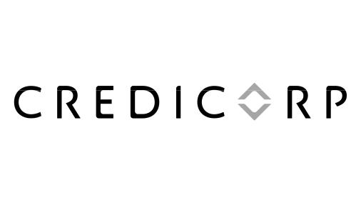

March 4, 2024

Securities and Exchange Commission - SEC

Re.: MATERIAL EVENT

Dear Sirs:

As disclosed in the Forms 6-K furnished to the SEC on January 25 and March 1, 2024, the Board of Directors of Credicorp Ltd. (‘Credicorp’) agreed to set the date for the Annual General Meeting of Shareholders for March 27, 2024, at 3:00 p.m. (Peru time) in a virtual meeting.

In this sense, we hereby notify you as a Material Event, that since March 1, 2024, Credicorp has started the distribution of the documents that support the proposal that will be addressed in the Annual General Meeting of Shareholders. The documents (letter to shareholders and Notice of Annual General Meeting of Shareholders) are available through the following hyperlink: https://credicorp.gcs-web.com/annual-materials under the section “Investors” and “Annual Materials and 20-Fs”.

The information in this Form 6-K (including any exhibit hereto and any information available through the hyperlink above) shall not be deemed “filed” for purposes of Section 18 of the Securities Exchange Act of 1934 (the ‘Exchange Act’) or otherwise subject to the liabilities of that section, nor shall it be deemed incorporated by reference in any filing under the Securities Act of 1933 or the Exchange Act.

Sincerely,

/s/ Guillermo Morales

Authorized Representative

Credicorp Ltd.

SIGNATURE

Pursuant to the requirements of the Securities Exchange Act of 1934, the registrant has duly caused this report to be signed on its behalf by the undersigned, thereunto duly authorized.

Date: March 4, 2024

CREDICORP LTD.

(Registrant)

By: /s/ Guillermo Morales

Guillermo Morales

Authorized Representative

