UNITED STATES

SECURITIES AND EXCHANGE COMMISSION

Washington, D.C. 20549

FORM 6-K

Report of Foreign Private Issuer

Pursuant to Rule 13a-16 or 15d-16 under the

Securities Exchange Act of 1934

For the month of August 2025

Commission File Number: 001-14014

CREDICORP LTD.

(Translation of registrant’s name into English)

Of our subsidiary

Banco de Credito del Peru:

Calle Centenario 156

La Molina 15026

Lima, Peru

(Address of principal executive office)

Indicate by check mark whether the registrant files or will file annual reports under cover of Form 20-F or Form 40-F.

Form 20-F ☒ Form 40-F ☐

The information in this Form 6-K (including any exhibit hereto) shall not be deemed “filed” for purposes of Section 18 of the Securities Exchange Act of 1934 (the “Exchange Act”) or otherwise subject to the liabilities of that section, nor shall it be deemed incorporated by reference in any filing under the Securities Act of 1933 or the Exchange Act.

SIGNATURE

Pursuant to the requirements of the Securities Exchange Act of 1934, the registrant has duly caused this report to be signed on its behalf by the undersigned, thereunto duly authorized.

Date: August 18, 2025

CREDICORP LTD.

(Registrant)

By: /s/ Milagros Cigüeñas

Milagros Cigüeñas

Authorized Representative

Exhibit 99.1
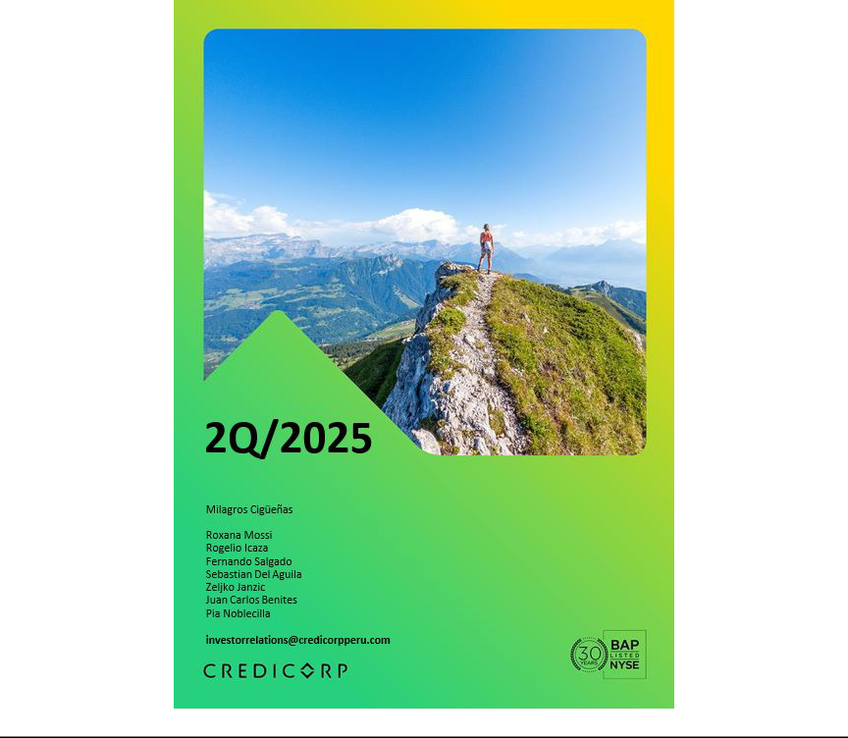

| Earnings Release 2Q / 2025 Analysis of 2Q25 Consolidated Results

Table of Contents

Operatng and Financial Highlights | 03
Senior Management Quotes | 04
Second Quarter 2025 Earnings Conference Call | 05
Summary of Financial Performance and Outlook | 06
Financial Overview | 11
Credicorp’s Strategy Update | 12
Analysis of 2Q25 Consolidated Results

01

02

03

04

05

06

07

08

09

10

11

12

Loan Portolio | 16
Deposits | 19
Interest Earning Assets and Funding | 22
Net Interest Income (NII) | 24
Portolio Quality and Provisions | 27
Other Income | 32
Insurance Underwritng Results and the Medical Services | 36
Operatng Expenses | 38
Operatng Efciency | 40
Regulatory Capital | 41
Economic Outlook | 43
Appendix | 47


| Earnings Release 2Q / 2025 Analysis of 2Q25 Consolidated Results

Credicorp Ltd. Reports Financial and Operatng Results for 2Q25

Strong contributons from Universal Banking and Insurance & Pensions, contnued recovery in Microfnance, and higher fee-based and transactonal income reinforce our diversifed platorm.

Risk-adjusted NIM at a record high of 5.44%, up 104 bps year-on-year refectng resilient NIM and a low level of Cost of Risk.

Progress in decoupling strategy with 6.2% of risk-adjusted revenues from the innovaton portolio and on track to reach 10% target by 2026.

ROE at a record high of 20.7%, which includes a positve 120 bps impact related to relevant gains in BCP’s investment portolio, was driven by sustained momentum

in core businesses and increasing contributon of innovaton portolio.

Lima, Peru – August 14, 2025 – Credicorp Ltd. (“Credicorp” or “the Company”) (NYSE: BAP | BVL: BAP), the leading fnancial services holding company in Peru with a presence in Chile, Colombia, Bolivia, and Panama today reported its unaudited results for the three-and six-months ended June 30, 2025. Financial results are expressed in Soles and are presented in accordance with IFRS.

2Q25 OPERATING AND FINANCIAL HIGHLIGHTS

- Net Income atributable to Credicorp increased 36.1% YoY and 2.5% QoQ to S/1,822.0 million, translatng into an ROE of 20.7%. These results include a positve 120 bps impact related to a relevant gain in BCP’s investment portolio.

- In 2Q25 Credicorp revalued Bolivia’s balance sheet using a market-refectve FX rate, resultng in an accountng contracton of 2.8% in Credicorp Total Assets with no impact on cash fow. The loan and deposit fgures cited below exclude this adjustment.

- Total Loans measured in quarter-end balances declined 0.3% YoY, but up 2.6% FX Neutral mainly led by BCP through Retail Banking, where stand-out performers were Mortgage and Consumer (Yape), and by Mibanco. QoQ, total Loans rose 1.2%, with 2.5% FX Neutral growth driven by the same segments, along with Wholesale Banking at BCP.

- Total Deposits increased 6.2% (+10.2% FX Neutral) YoY refectng growth in Low-cost deposits, amid higher system liquidity, and contracted 0.5% (+1.0% FX Neutral) QoQ. Low-cost deposits accounted for 71.8% of total deposits and 57.2% of the total funding base.

- Net Interest Income (NII) increased 4.2% YoY mainly supported by lower Interest and Similar Expenses. QoQ, NII increased 1.2%. Net Interest Margin (NIM) stood at 6.42%, increasing 9 bps YoY and 20 bps QoQ.

- NPL Rato contracted across segments, improving 102 bps YoY to 5.0%, driven by debt repayments at BCP Stand-alone and a drop in overdue loans at BCP and Mibanco. QoQ, the NPL Rato improved 14 bps.

- Provisions declined by 47.4% YoY, driven by BCP and Mibanco, supported by strengthened risk management, improved payment behavior, beneftng from an economic recovery, and a higher share of lower-risk vintages within the portolio. QoQ, provisions dropped 1.2%. As a result, Cost of Risk hit a low of 1.6% and Risk-Adjusted NIM reached a record-high of 5.44%.

- Core Income increased 5.3% YoY, refectng a stronger NII and ongoing diversifcaton in revenue streams, which drove growth of 8.2% in Fee income and 7.9% in Net Gain on FX Transactons.

- Other Non-Core Income reported a relevant gain of S/106 million, which was associated with a sovereign bond exchange at BCP.

- Insurance Underwritng Results increased 11.2% YoY, driven primarily by lower insurance service expenses in the Life business and secondarily, by higher insurance service income in P & C; and was up 6.6% QoQ.

- Yape reached 14.9 million Monthly Actve Users (MAU), with an operatng leverage contnuing to expand and accountng for 5.5% of Credicorp’s total risk-adjusted revenue.

- Efciency Rato for 1H25 reached 44.9%, aligned with our full-year guidance. Operatng expenses during this period increased 11.4% YoY, driven mainly by the core business at BCP Stand-alone and investments in our innovaton portolio initatves.

- IFRS CET 1 Rato stood at 12.56% for BCP Stand-alone and at 16.73% for Mibanco.

- Afer quarter-end, on August 13, 2025, Credicorp announced the cancellaton of approximately 1.6 billion soles in Tax resolutons issued by Sunat on June 27, 2025. The company will record this cash outlow as an asset. As the contngency remains classifed as remote, no provision is required in accordance with Internatonal Accountng Standards.



| Earnings Release 2Q / 2025 Analysis of 2Q25 Consolidated Results

SENIOR MANAGEMENT QUOTES
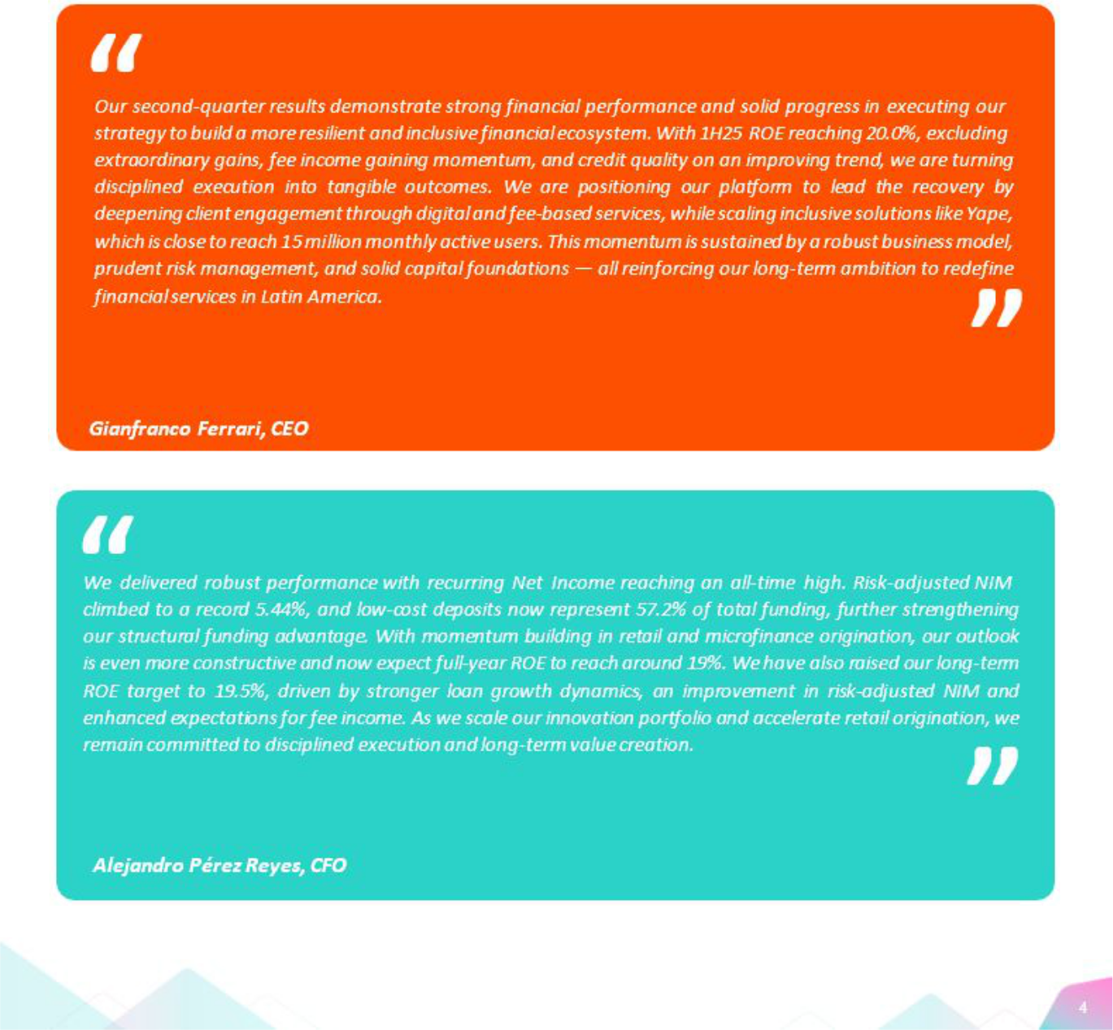


| Earnings Release 2Q / 2025 Analysis of 2Q25 Consolidated Results

Second Quarter 2025 Earnings Conference Call

SECOND 2025 EARNINGS CONFERENCE CALL

Date: Friday, August 15th, 2025

Time: 10:30 am E.T. (9:30 am Lima, Perú)

Hosts: Gianfranco Ferrari – Chief Executve Ofcer, - Alejandro Perez Reyes - Chief Financial Ofcer, Francesca Rafo – Chief Innovaton Ofcer, Cesar Rios - Chief Risk Ofcer, Diego Cavero – Head of Universal Banking, Piero Travezan - Pacifco CFO, Rocio Benavides - Mibanco CFO and Investor Relatons Team.

To pre-register for the listen-only webcast presentaton use the following link:

htps://dpregister.com/DiamondPassRegistraton /register?confrmatonNumber=10201755&linkSecurityString=fa6c99 a9a

Callers who pre-register will be given a conference passcode and unique PIN to gain immediate access to the call and bypass the live operator.

Partcipants may pre-register at any tme, including up to and afer the call start tme.

Those unable to pre-register may dial in by calling:

1 844 435 0321 (U.S. toll free)

1412 317 5615 (Internatonal)

Partcipant Web Phone: Click here

Conference ID: Credicorp Conference Call

The webcast will be archived for one year on our investor relatons website at:

htps://credicorp.gcs-web.com/events-and-presentatons/upcoming-events

For a full version of Credicorp´s First Quarter 2025 Earnings Release, please visit:

htps://credicorp.gcs-web.com/company-reports/quarterly-materials

| Earnings Release 2Q / 2025 Analysis of 2Q25 Consolidated Results

Loans and Deposits

Our balance in 2Q25 was impacted by an accountng adjustment (which did not afect cash fow) related to our operatons in Bolivia. This adjustment entailed updatng the exchange rate used to translate Bolivia’s balance to beter refect market conditons. In this context, the book value of Credicorp’s total assets dropped 2.8% but cash fow was unafected.

Loans in End-of-Period (EOP)

Total loans measured in quarter-end balances contracted 0.2% QoQ and 4.1%

YoY, impacted by the aforementoned accountng adjustment at BCP Bolivia.

If we exclude this impact:
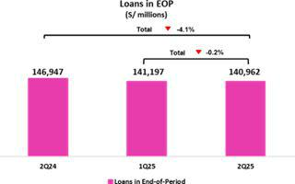

QoQ, the portolio’s balance rose 1.2%, which refects a +2.5% FX Neutral. This evoluton was driven mainly by: (i) Individuals and Small Businesses, where stand-out performers were Mortgage, which grew through an uptck in demand due to a more favorable economic environment, and Consumer, which registered growth in disbursements through BCP Stand-alone and Yape;

- Wholesale Banking, where Middle Market Banking reported growth due to an uptck in demand for working capital loans, which was partally ofset by a decrease in Corporate Banking, and (iii) Mibanco, which reported a reducton in write-ofs.

YoY, the portolio’s balance dropped 0.3%. Notwithstanding, growth stood at 2.6% in FX Neutral terms, driven mainly by: (i) Individuals and Small Businesses, led by an uptck in Mortgage, which was driven by the same dynamics seen QoQ, and by Consumer, which rose on the back of growth in disbursements through Yape; and (ii) Wholesale Banking, specifcally Middle Market Banking, which registered an uptck in demand for short-term fnancing.

Deposits
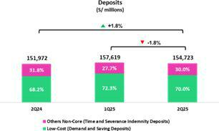

The total deposit balance (measured in quarter-end balances) contracted 1.8% QoQ and rose 1.8% YoY, impacted by the aforementoned accountng adjustment for BCP Bolivia.

If we exclude this impact, the dynamics were:

QoQ, our deposit base contracted 0.5% (+1.0% FX Neutral). This evoluton refected a drop in the balance for Demand Deposits, which was partally ofset by growth in the Time Deposit balance. YoY, the deposit base increased 6.2% (+10.2% FX Neutral). This result was driven by (i) Low-cost deposits, which grew 16.9% and represented 71.8% of our total deposit base at quarter-end, and (ii) Time Deposits.

At BCP, the 30-day Liquidity Coverage Rato (LCR) in PEN a 30-day stood at

162.2% under regulatory standards and 135.0% according to stricter internal

standards. The 30-day LCR stood at 140.9% under regulatory standards, and

116.7% according to stricter internal standards.

| Earnings Release 2Q / 2025 Analysis of 2Q25 Consolidated Results

Net Interest Income (NII) and Margin (NIM)
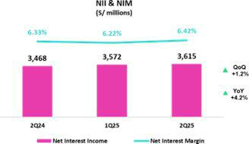

NII rose 1.2% QoQ. This evoluton was fueled mainly by a reducton in Similar Interest and Expenses, which were impacted by a drop in market rates. NIM stood at 6.42% at the end of the quarter, versus 6.22% in 1Q25 and 6.33% in 2Q24.

YoY, NII rose 4.2%. This evoluton was driven primarily by a decrease in Similar Interest and Expenses, which were pressured downward by a reducton in market rates, and by an uptck in low-cost deposits’ share of our funding base. In this context, NIM rose 9 bps YoY.

Portolio Quality and the Cost of Risk

Portolio quality ratos and the Cost of Risk have improved substantally over the last year and contnue to strengthen. This positve evoluton was driven by strengthened risk management, improvements in payment performance, and a more favorable economic environment.
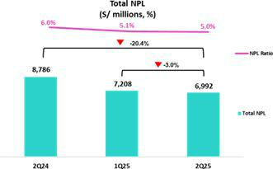

QoQ, the NPL balance fell 3.0%, fueled mainly by BCP Stand-alone and Mibanco. At BCP Stand-alone, the decline was driven primarily by Wholesale Banking, which reported debt repayment by an overdue client. The NPL balance at Retail Banking remained relatvely stable in Individuals and SMEs. At Mibanco, the decline was atributable to a decrease in overdue loans.

YoY, NPLs dropped 20.4%, driven by a decline across segments at BCP Stand-alone and Mibanco. At BCP Stand-alone, the decrease was fueled mainly by Wholesale Banking, which was impacted primarily by debt repayment, and by Retail Banking, led by: (i) SME-Pyme, due to a reducton in overdue loans; and

- Consumer and Credit Cards. At Mibanco, the decrease was driven by the same dynamics as those that drove the QoQ evoluton.

In this context, the NPL Rato dropped 14 bps QoQ and 102 bps YoY to stand at 5.0% at quarter-end.
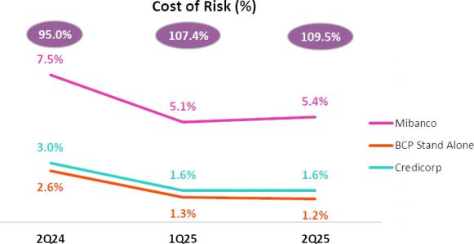

Provisions fell 1.2% QoQ, driven by BCP Stand-alone and partally ofset by Mibanco. At BCP Stand-alone, the reducton in provisions was fueled primarily by (i) Wholesale Banking, due to an improvement in payment performance, and (ii)Retail Banking, led by Individuals, due to a base efect for risk model calibratons. This evoluton was partally ofset by SME-Pyme, which reported an uptck in disbursements. At Mibanco, growth in provisions was mainly atributable to a shif in the portolio mix toward smaller-tcket, higher-yield loans.

YoY and YTD, provisions dropped 47.4% and 39.4% respectvely, driven by BCP Stand-alone and Mibanco, which reported improvements in payment performance due to economic recovery and growth in lower- risk vintages’ share of total loans.

| Earnings Release 2Q / 2025

Other Income

QoQ, Other Core Income increased 4.8%, hitng a record high and topping S/1.4 billion. This evoluton was driven mainly by BCP Stand- alone’s solid performance. Other Non-Core Income reported an important gain of S/106 million, which was associated with a sovereign bond exchange at BCP. Notwithstanding, this growth was ofset by a base efect given that an extraordinary gain was reported in 1Q25 for the acquisiton of the remaining 50% stake in Empresas Banmédica.

YoY, Other Core Income rose 8.1%, driven by growth in fee income from Yape and transactonal products at BCP Stand-alone. Other Non- Core income dropped 6.4%, which refects the fact that BCP and Pacifco reported extraordinary income in 2Q24.

YTD, Other Core Income rose 11.4%, fueled primarily by BCP Stand- alone. Other Non-Core income increased 19.6%, driven mainly by the gains related to the consolidaton of Banmédica and a sovereign bond exchange at BCP.

Insurance Underwritng Result

The Insurance Underwritng Result increased 6.6% QoQ. This evoluton was driven mainly by the Life Business, which reported a decrease in Insurance Service Expenses, and to a much lesser extent, by the solid performance of the EPS business.

YoY and YTD, the Insurance Underwritng Result increased 11.2% and 14.4%, driven primarily by Life, which reported a drop in in Insurance Service Expenses; secondarily by P & C, which registered growth in Insurance Service Income; and lastly by EPS.

Efciency

Operatng expenses rose 11.4% YTD, fueled mainly by core business at BCP Stand-alone and innovaton initatves at the Credicorp level. Operatng income, in turn, rose 7.9% YTD.

In this context, the Efciency Rato stood at 44.9% in 1H25, in line with guidance for the year.

Analysis of 2Q25 Consolidated Results
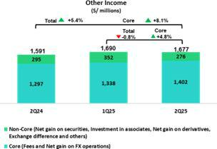

Insurance Underwritng Result*
(S/ millions)
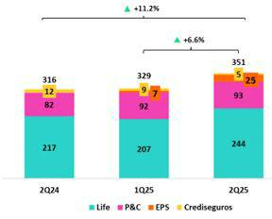

*Totals may difer from the sum of the parts due to eliminatons in PGA consolidaton.
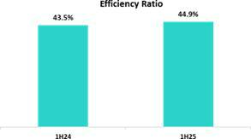

| Earnings Release 2Q / 2025 Analysis of 2Q25 Consolidated Results

Net Earnings Atributable to Credicorp
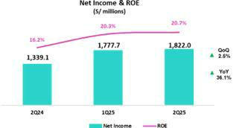

In 2Q25, net earnings atributable to Credicorp totaled S/1,822.0 million (+2.5% QoQ and +36.1% YoY). This evoluton was supported by strong results in all our lines of business. Net shareholders’ equity stood at S/34,459 million (-3.9% QoQ and +6.3% YoY). In this context, ROE stands at 20.7%. This result includes a positve 120 bps impact related to a relevant gain in BCP’s investment portolio.

YTD, net earnings atributable to Credicorp increased 26.3%. Consequently, ROE for 1H25 stood at 20.9%. If we exclude the impact of extraordinary gains related to Banmedica’s transacton, ROE stands at 20.0%.

Contributons and ROE by subsidiary in 2Q25

(S/ millions)
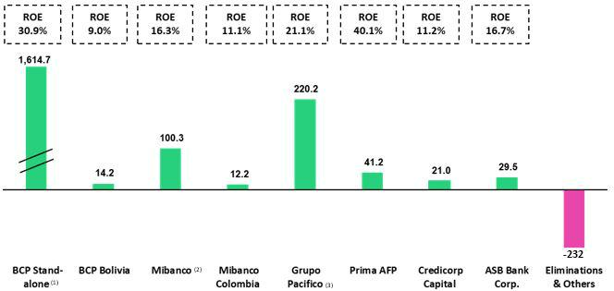

- In BCP Stand-alone, the fgure is lower than the net proft since the contributon eliminates investment gains in other subsidiaries of Credicorp (Mibanco). ROE excludes the impact of 200 bps related to the relevant gain associated with the sovereign bond exchange.
- In Mibanco, the fgure is less than the net proft because Credicorp owns (directly and indirectly) 99.921% of Mibanco.
- The contributon for Grupo Pacifco presented here is greater than the proft of Pacifco Seguros since 100% of Crediseguros is being included (including 48% under Grupo Crédito).

| Earnings Release 2Q / 2025 Analysis of 2Q25 Consolidated Results

Universal Banking | Microfnance


BCP posted a noteworthy proftability this quarter, supported by a low level of the cost of risk and a resilient NIM, on the back of economic recovery and a decrease in the cost of funding, respectvely. Core income remained solid, underpinned by a growing and diversifed revenue base. Other Non-Core Income benefted from gains related to a sovereign bond exchange. Operatng efciency remained strong, with expenses well contained.

Insurance and Pensions


Net income at Grupo Pacífco refect solid underlying business performance, partcularly in the Life and General Insurance segments, which contnue to deliver strong underwritng results. The consolidaton of Empresas Banmédica’s operatons has further strengthened Medical Services. These positve dynamics were partally ofset by the impact of a credit downgrade on a couple of assets in the investment portolio.

Proftability at Mibanco rose YoY, driven mainly by a rebound in disbursements; strengthened risk management; and efectve interest-rate strategies. NIM remained strong, fueled by actve management of loan pricing and a reducton in the funding cost.

Results at Mibanco Colombia contnued to improve on the back of turnaround measures taken last year and a more supportve environment for the microfnance sector. Growth remained stable and the risk levels, controlled.


Investment Management and

Advisory


Operatng proftability in the Investment Management and Advisory line of business remained resilient in 2Q25. Core income- generatng businesses delivered robust results this quarter, refectng broad-based business strength that helped partally ofset the absence of last year’s one-of income from our now-discontnued Corporate Finance Business. Our Asset Management and Wealth Management businesses reported signifcant growth in AUMs.


Outlook

We revised our 2025 ROE guidance to around 19.0%. We antcipate that this result will be

driven by: (i) acceleraton of our loan portolio growth, partcularly in the retail segment, (ii) the resilience of our NIM, and (iii) a lower than initally

expected cost of risk.

We have also raised our long-term ROE target to 19.5%, driven by stronger retail loan growth dynamics, an improvement in risk-adjusted NIM and enhanced expectatons for diversifed sources of income.


| Earnings Release 2Q / 2025 Analysis of 2Q25 Consolidated Results

Financial Overview

Credicorp Ltd. |  | Quarter |  | % change |  |  | Up to | % change
S/ 000 | 2Q24 | 1Q25 | 2Q25 | QoQ | YoY | Jun 24 | Jun 25 | Jun 25 / Jun 24
Net interest, similar income and expenses | 3,468,464 | 3,572,012 | 3,615,371 | 1.2% | 4.2% | 6,894,587 | 7,187,383 | 4.2%
Provision for credit losses on loan portolio, net of | (1,093,371) | (581,893) | (575,159) | -1.2% | -47.4% | (1,908,070) | (1,157,052) | -39.4%
recoveries
Net interest, similar income and expenses, afer provision | 2,375,093 | 2,990,119 | 3,040,212 | 1.7% | 28.0% | 4,986,517 | 6,030,331 | 20.9%
for credit losses on loan portolio
Other income | 1,591,330 | 1,690,216 | 1,677,373 | -0.8% | 5.4% | 2,983,889 | 3,367,589 | 12.9%
Insurance underwritng result | 315,500 | 329,134 | 350,873 | 6.6% | 11.2% | 594,562 | 680,007 | 14.4%
Medical services result | - | 42,689 | 123,319 | 188.9% | n.a. | - | 166,008 | n.a.
Total expenses | (2,395,205) | (2,532,874) | (2,630,310) | 3.8% | 9.8% | (4,607,687) | (5,163,184) | 12.1%
Proft before income tax | 1,886,718 | 2,519,284 | 2,561,467 | 1.7% | 35.8% | 3,957,281 | 5,080,751 | 28.4%
Income tax | (519,344) | (704,469) | (696,969) | -1.1% | 34.2% | (1,047,810) | (1,401,438) | 33.7%
Net proft | 1,367,374 | 1,814,815 | 1,864,498 | 2.7% | 36.4% | 2,909,471 | 3,679,313 | 26.5%
Non-controlling interest | 28,278 | 37,118 | 42,483 | 14.5% | 50.2% | 58,718 | 79,601 | 35.6%
Net proft atributable to Credicorp | 1,339,096 | 1,777,697 | 1,822,015 | 2.5% | 36.1% | 2,850,753 | 3,599,712 | 26.3%
Dividends paid to third partes | 2,791,652 | - | 3,181,440 | n.a. | 14.0% | 2,791,652 | 3,181,440 | 14.0%
Net income / share (S/) | 16.8 | 22.3 | 22.8 | 2.5% | 36.1% | 36 | 45 | 26.3%
Dividends per Share (S/) | - | - | 40 | n.a. | n.a. | 35 | 40 | 14.0%
Loans | 146,946,546 | 141,196,646 | 140,961,978 | -0.2% | -4.1% | 146,946,546 | 140,961,978 | -4.1%
Deposits and obligatons | 151,971,984 | 157,619,082 | 154,723,334 | -1.8% | 1.8% | 151,971,984 | 154,723,334 | 1.8%
Net equity | 32,413,767 | 35,843,202 | 34,459,012 | -3.9% | 6.3% | 32,413,767 | 34,459,012 | 6.3%
Proftability
Net interest margin(1) | 6.3% | 6.2% | 6.4% | 20 bps | 9 bps | 6.3% | 6.3% | 1 bps
Risk-adjusted Net interest margin | 4.4% | 5.2% | 5.4% | 20 bps | 104 bps | 4.6% | 5.3% | 72 bps
Funding cost(2) | 2.9% | 2.4% | 2.4% | 2 bps | -42 bps | 0.03 | 2.4% | -50 bps
ROAE | 16.2% | 20.3% | 20.7% | 40 bps | 450 bps | 17.6% | 20.9% | 330 bps
ROAA | 2.2% | 2.8% | 2.9% | 10 bps | 70 bps | 2.3% | 2.9% | 51 bps
Loan portolio quality
Internal overdue rato(3) | 4.2% | 3.7% | 3.6% | -11 bps | -66 bps | 4.2% | 3.6% | -66 bps
Internal overdue rato over 90 days | 3.2% | 3.0% | 3.0% | -4 pbs | -28 pbs | 3.2% | 3.0% | -28 pbs
NPL rato(4) | 6.0% | 5.1% | 5.0% | -14 bps | -102 bps | 6.0% | 5.0% | -102 bps
Cost of risk(5) | 3.0% | 1.6% | 1.6% | 1 bps | -141 bps | 2.6% | 1.6% | -100 bps
Coverage rato of IOLs | 134.0% | 148.7% | 151.8% | 310 bps | 1780 bps | 134.0% | 151.8% | 1780 bps
Coverage rato of NPLs | 95.0% | 107.4% | 109.5% | 210 bps | 1450 bps | 95.0% | 109.5% | 1450 bps
Operatng efciency
Operatng income(6) | 5,143,084 | 5,340,199 | 5,529,301 | 3.5% | 7.5% | 10,076,862 | 10,869,500 | 7.9%
Operatng expenses(7) | 2,270,785 | 2,442,089 | 2,441,547 | 0.0% | 7.5% | 4,383,595 | 4,883,636 | 11.4%
Efciency rato(8) | 44.2% | 45.7% | 44.2% | -150 bps | 0 bps | 43.5% | 44.9% | 143 bps
Operatng expenses / Total average assets | 3.7% | 3.8% | 3.9% | 9 bps | 19 bps | 3.6% | 3.9% | 27 bps
Capital adequacy - BCP Stand-alone
Global Capital Rato(9) | 16.2% | 16.9% | 17.3% | 47 bps | 109 bps | 16.2% | 17.3% | 109 bps
Rato Tier 1(10) | 11.9% | 11.3% | 12.2% | 91 bps | 34 bps | 11.9% | 12.2% | 34 bps
Rato common equity ter 1(11) (13) | 11.9% | 11.3% | 12.2% | 91 bps | 34 bps | 11.9% | 12.2% | 34 bps
Capital adequacy - Mibanco
Global Capital Rato(9) | 18.9% | 18.5% | 19.6% | 108 bps | 66 bps | 18.9% | 19.6% | 66 bps
Rato Tier 1(10) | 16.6% | 15.5% | 16.5% | 100 bps | -15 bps | 16.6% | 16.5% | -14 bps
Rato common equity ter 1(11) (13) | 16.7% | 15.9% | 16.7% | 84 bps | 0 bps | 16.7% | 16.7% | 0 bps
Employees(14) | 38,641 | 46,621 | 46,423 | -0.4% | 20.1% | 38,641 | 46,423 | 20.1%
Share Informaton
Issued Shares | 94,382 | 94,382 | 94,382 | 0.0% | 0.0% | 94,382 | 94,382 | 0.0%
Treasury Shares(12) | 14,949 | 15,016 | 15,016 | 0.0% | 0.4% | 14,949 | 15,016 | 0.4%
Outstanding Shares | 79,433 | 79,366 | 79,366 | 0.0% | -0.1% | 79,433 | 79,366 | -0.1%

- Net Interest Margin = Net Interest Income (Excluding Net Insurance Financial Expenses)/ Average Interest Earning Assets
- Funding Cost = Interest Expense (Does not include Net Insurance Financial Expenses) / Average Funding
- Internal Overdue Loans: include overdue loans and loans under legal collecton, according to our internal policy for overdue loans. Internal Overdue Rato: Internal overdue loans/ Total loans
- Non-performing loans (NPL): Internal overdue loans + Refnanced loans. NPL rato: NPL / Total loans.
- Cost of risk = Annualized provision for loan losses, net of recoveries/ Total loans.
- Operatng Income = Net interest, similar income and expenses + Fee Income+ Net gain on foreign exchange transactons + Net Gain From associates + Net gain on derivatves held for trading + Result on exchange diferences + Insurance Underwritng Result + Results for Medical Services
- Operatng Expenses = Salaries and employee benefts + Administratve expenses + Depreciaton and amortzaton + Associaton in partcipaton + Acquisiton cost.
- Efciency Rato = (Salaries and employee benefts + Administratve expenses + Depreciaton and amortzaton + Associaton in partcipaton) / (Net interest, similar income and expenses + Fee Income+ Net gain on foreign exchange transactons + Net Gain From associates + Net gain on derivatves held for trading + Result on exchange diferences + Insurance Underwritng Result)
- Regulatory Capital/ Risk-weighted assets (legal minimum = 10% since July 2011).
- Tier 1 = Capital + Legal and other capital reserves + Accumulated earnings with capitalizaton agreement + (0.5 x Unrealized proft and net income in subsidiaries) - Goodwill - (0.5 x Investment in subsidiaries) + Perpetual subordinated debt (the maximum amount that can be included is 17.65% of Capital + Reserves + Accumulated earnings with capitalizaton agreement + Unrealized proft and net income in subsidiaries - Goodwill).
- Common Equity TierI = Capital + Reserves – 100% of applicable deductons (investment in subsidiaries, goodwill, intangibles, and net deferred taxes that rely on future proftability) + retained earnings + unrealized gains.
- Consider shares held by Atlantc Security Holding Corporaton (ASHC) and stock awards.
- Common Equity Tier I calculated based on IFRS Accountng.
- Internal management fgures. Since 1Q25, it has included corporate health and medical services employees.


| Earnings Release 2Q / 2025 Analysis of 2Q25 Consolidated Results

Main Strategic Milestones at Credicorp

Strategy at Credicorp

Credicorp is redefning fnancial services in Latn America through a long-term strategy anchored in innovaton, inclusion, and digital transformaton. By embedding technology across core and emerging businesses, we are building a more resilient and diversifed platorm. Our focus goes beyond growth as we deepen client engagement and unlock new sources of value through data and ecosystem synergies.

In 2Q25, we contnued executng this strategy by investng in technology to strengthen our core businesses while expanding our innovaton portolio, which currently represents 6.2% of Credicorp’s risk-adjusted income, signaling tangible progress in our eforts to decouple from macroeconomic cycles. Diversifying revenue sources is key to strengthening our adaptability and sustained performance.

In the framework of the 30° anniversary of its listng on the NYSE, Credicorp reafrms its commitment to innovaton as a driver of sustainable value creaton.

Credicorp invites investors and analysts to its 2025 Investor Day, which will be held on October 9, 2025.

Senior management and business leaders will outline the company’s strategic transformaton of its fnance operatons to enhan ce lives and positon its platorm for leadership in an evolving region. The organizaton is developing a forward-looking fnancial services model rooted in innovaton, inclusion, and data-driven client engagement, while expanding distributon and leveraging synergies within the ecosystem. Additonally, business leaders will discuss how AI, advanced risk management, and robust data capabilites— paired with disciplined executon—are equipping the business for sustainable growth and long-term resilience.

For more informaton, see: www.credicorpday.com

Main KPIs of Credicorp’s Strategy

Core Businesses Transformaton ⁽¹⁾ |  | Quarter |  |  | Up to
Core Businesses Transformaton ⁽¹⁾ | 2Q24 | 1Q25 | 2Q25 | Jun 24 | Jun 25
Credicorp
Innovaton Portolio Risk-Adjusted Revenue Share ⁽²⁾ | 3.4% | 5.4% | 6.2% | 3.3% | 5.8%
BCP Stand-alone
Digital clients ⁽³⁾ | 72% | 78% | 79% | 70% | 78%
Digital monetary transactons ⁽⁴⁾ | 85% | 89% | 90% | 84% | 89%
Cashless transactons ⁽⁵⁾ | 61% | 66% | 66% | 58% | 65%
Mibanco
Disbursements through leads ⁽⁶⁾ | 68% | 70% | 65% | 69% | 68%
Disbursements through alternatve channels ⁽⁷⁾ | 23% | 26% | 23% | 23% | 25%
Relatonship managers productvity ⁽⁸⁾ | 21.9 | 28.2 | 25.9 | 23.8 | 25.6
Pacifco
Digital Policies (thousands) ⁽⁹⁾ | 582.0 | 722.3 | 579.0 | 1111.5 | 1301.3

- Management fgures. Figures for June 2024, March 2025, and June 2025.
- As a percentage of Credicorpʼs total Risk-Adjusted Revenue.

- Retail clients that made 70%, or more, of their transactons through digital channels in the last 6 months (including Yape).

- Monetary Transactons conducted through Mobile Banking, Internet Banking, Yape and Telecredito/Total Monetary Transactons in Retail Banking.

- Amount transacted through Mobile Banking, Internet Banking, Yape y POS/Total amount transacted through Retail Banking.

- Disbursements generated through leads/Total disbursements.
- Disbursements conducted through alternatve channels/Total disbursements. Figures difer from previously reported due to a methodological change.

- Number of loans disbursed/Total relatonship managers.

- Number of insurance policies issued through digital channels.


| Earnings Release 2Q / 2025 Analysis of 2Q25 Consolidated Results

Credicorp’s Strategy Update

Yape

Main Management KPI’s

Management KPI's ⁽¹⁾ |  | Quarter |  |  | Change % |  | Up to | Change %
Management KPI's ⁽¹⁾ | 2Q24 | 1Q25 | 2Q25 | QoQ | YoY | Jun 24 | Jun 25 | Jun 25 / Jun 24
Users
Users (millions) | 15.9 | 18.0 | 18.6 | 3.5% | 17.3% | 15.9 | 18.6 | 17.3%
Monthly Actve Users (MAU) (millions) ⁽²⁾ | 12.3 | 14.3 | 14.9 | 4.2% | 21.9% | 12.3 | 14.9 | 21.9%
Revenue Generatng MAU (millions) | 9.5 | 12.0 | 12.6 | 4.9% | 32.5% | 9.5 | 12.6 | 32.5%
Engagement
# Transactons (millions) | 1,400.6 | 2,025.4 | 2,384.9 | 17.8% | 70.3% | 2,528.3 | 4,410.3 | 74.4%
# Transactons / MAU | 40.2 | 52.1 | 54.5 | 4.6% | 35.6% | 40.2 | 54.5 | 35.6%
# Average Functonalites / MAU | 2.3 | 2.6 | 2.7 | 1.5% | 14.2% | 2.3 | 2.7 | 14.2%
Experience
_{NPS} (3) | 76 | 77 | 77 | 0.0% | 60.0% | 77 | 77 | -40.0%
Unit Economics
Monthly Indicators ⁽⁴⁾
Revenues / MAU (S/) | 3.9 | 6.2 | 6.5 | 3.8% | 64.3% | 3.9 | 6.5 | 64.3%
Expenses / MAU (S/) | -3.9 | -4.7 | -4.4 | -6.9% | 11.5% | -3.9 | -4.4 | 11.5%
Quarterly Indicators ⁽⁵⁾
Revenues / MAU (S/) | 3.8 | 5.5 | 6.4 | 15.4% | 69.4% | 3.5 | 6.0 | 69.2%
Expenses / MAU (S/) | -3.9 | -4.2 | -4.5 | 5.3% | 15.1% | -3.8 | -4.3 | 12.8%
Drivers Monetzaton
Total TPV (S/, billions) ⁽⁶⁾ | 62.1 | 91.6 | 103.4 | 12.9% | 66.3% | 103.5 | 174.2 | 68.3%
Total Revenue Generatng TPV (S/, billions) ⁽⁷⁾ | 4.9 | 8.7 | 10.1 | 16.6% | 107.6% | 8.7 | 18.8 | 117.9%
Payments
# Bill Payments transactons (millions) | 28.6 | 45.0 | 50.1 | 11.4% | 75.0% | 52.1 | 95.2 | 82.7%
Financials
# Loans Disbursements (thousands) | 751.9 | 3,100.4 | 3,855.1 | 24.3% | 412.7% | 1,264.3 | 6,955.6 | 450.1%
E-Commerce
GMV (S/, millions) ⁽⁸⁾ | 75.0 | 124.6 | 129.1 | 3.6% | 72.1% | 134.1 | 253.7 | 89.2%

- Management Figures.
- Yape users that have made at least one outgoing transacton in the measurement month.
- Net Promoter Score.
- Monthly indicators consider the results of the last month of the quarter for the numerator and denominator.
- Quarterly indicators are calculated using the sum of the three months in the period for numerator accounts, and the average of the denominator—based on last month’s data from both the current and previous quarters."
- Total Payment Volume.
- Revenue Generatng Total Payment Volume (TPV).
- Gross Merchant Volume, includes the following functonalites: Yape Promos, Yape Store, Ticketng, Gaming, Delivery, Buses, Insurance, Gas, Brand Solutons and Insurance.

Main Financial Results

Financial Results ⁽¹⁾ |  | Quarter |  |  | Change % |  | Up to | Change %
S/ millions | 2Q24 | 1Q25 | 2Q25 | QoQ | YoY | Jun 24 | Jun 25 | Jun 25 / Jun 24
Net Interest Income afer Provisions ⁽²⁾ | 56.2 | 93.0 | 123.9 | 33.2% | 120.4% | 106.9 | 216.9 | 103.0%
Other Income ⁽³⁾ | 80.0 | 141.6 | 158.5 | 11.9% | 98.2% | 139.7 | 300.1 | 114.8%
Total Income | 136.2 | 234.6 | 282.4 | 20.4% | 107.4% | 246.6 | 517.0 | 109.7%
Total Operatng Expenses | -139.5 | -179.1 | -196.6 | 9.7% | 40.9% | -268.4 | -375.7 | 40.0%
- Management fgures. Beginning in 1Q25, reclassifcatons between Operatng Expenses and Fee Income have been incorporated, along with new accountng allocatons —primarily related to interest expenses associated with the Deposit Insurance Fund. Figures for prior periods have been restated for comparability and may difer from those previously reported.
- Includes interest income, interest expense and net provisions.
- Includes Other income recorded in BCP and in Yape Market


| Earnings Release 2Q / 2025

Credicorp’s Strategy Update

Main Operatng Results

At the end of 2Q25, Yape reached the 14.9-million mark for actve monthly users (MAU), equivalent to 75% of the EAP. The Super-App contnues to add more than half a million users per quarter and is on track to achieving its aspiraton of 16.5 million MAU by 2026. The average use per user also showed a favorable trend, with transactons per MAU increasing to 54.5, while the average use of functonalites within the app rose to 2.7. These indicators refect growing adopton and deeper engagement with the platorm, driven by the contnued expansion of its business lines in Payments, Financial services, and E-commerce.

Monetzaton Drivers

Analysis of 2Q25 Consolidated Results

Evoluton of MAU, # of Transactons and # of Functonalites
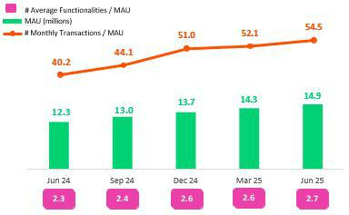

Yape contnues to strengthen its monetzaton strategy, with sustained growth in operatonal leverage per user. As of 2Q25, the gap between revenue (S/6.5) and expense (S/4.4) per MAU contnues to widen steadily.

The Payments business remains the main driver of monetzaton. Performance Evoluton of monthly revenue and expenses / MAU

was driven by an uptck in the transactons volume through Service Payments,

where the average tcket sizes and income per transacton have increased.
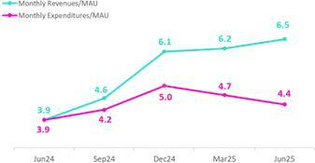
Commercial initatves, such as seasonal and holiday-centered campaigns,

have boosted organic growth. It is important to note that the pace of growth

of the revenue-generatng TPV (RGTPV) has outstripped the pace of expansion

of the total TPV, refectng greater sophistcaton and diversifcaton of

functonalites.

The pace of growth in the Financial business rose across business lines, driven by the balance increase of the loan portolio. The number of disbursements contnues to rise, which refects an uptck in the efectveness of leads. The portolio compositon remained stable, with single installment and mult-installment loans each representng 50% of the loans’s balance. In June, a new credit line targetng SMEs was launched, ofering higher amounts and longer terms. Its impact is expected to materialize over the coming quarters. At the end of 2Q25, Yape reached the 3-million user mark for clients with at least one loan disbursement, as we move closer to our goal of 5 million for 2026. Almost 30% of Yape’s borrowers accessed their frst formal fnancial system loan through the app, reafrming its role as an agent of fnancial inclusion. Finally, growth in net interest income was bolstered by an uptck in the Floatng generated by Yape, which rose on the back of growth in the entry volume.

In the E-Commerce business, the GMV totaled S/129.1 million. This performance was driven by Yape Proms, which maintains solid transactons levels and is registering improvement in the conversion of visits to sales.

Financial Results Evoluton of revenue by business

At the end of 2Q25, Yape represents 5.5% of Credicorp’s risk- adjusted revenue, refectng a growing share of MAUs actvely contributng to revenue generaton.
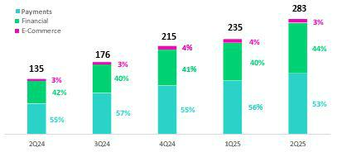

In the quarter, the Payments business accounted for 53% of Yape’s revenue. The Bill Payments, Merchant fees, and Top-Ups are most mature solutons and main contributors. The Financial business generated 44% of revenue, where Floatng contnues to be the main contributor. The Loan business, nevertheless, is gainingnoteworthy tracton, and increased its share of total revenue from 4% in 2Q24 to 18% in 2Q25.


| Earnings Release 2Q / 2025 Analysis of 2Q25 Consolidated Results

Credicorp’s Strategy Update

Integratng Sustainability in Our Businesses

We contnue to successfully roll out our Sustainability Strategy 2025–2030. This strategy focuses on three pillars within a plan for impact: Inclusion, Finance for the

Future and Trust, which a transversal axis of Country Vision. The milestones achieved in 2Q25 include:

Inclusion

- BCP and Yape fnancially included 100 thousand people in 2Q25, and cumulatve growth stands at 6.1 million since 2020. More than 1.9 million clients disbursed loans through Yape and 190 thousand were fnancially included through this channel during the quarter.

- BCP achieved a change in behavior among more than 159 thousand clients this quarter through fnancial educaton initatves, focused on promotng healthy personal fnancial practces and preventng over-indebtedness, late payments, overdrawing credit cards, among others.

- Yape rolled out an in-app version of its fnancial educaton material to give users access to its modules. By the end of 2Q25, clients had completed +122 thousand modules.

- Pacifco reported that as of 2Q25, 2.9 million clients had received inclusive insurance protecton¹ through channels at BCP, Mibanco and Yape. Pacifco provided insurance coverage to 391 thousand people by the end of the quarter, highlightng the launch of its new product Salud Yape.

Finances for the Future

- Mibanco Peru signed a fnancing contract for up to US$100 million with IDB Invest and JICA to drive access to credit for micro, small and medium enterprises (MSMEs) in Peru, including those led by women.

- The Crediagua product at Mibanco Peru, which provides fnancing for household drinking water and sewage connectons, disbursed 190 million soles to serve more than 12 thousand people in 2Q25.

- As of May 31, BCP disbursed USD 1,150 million in sustainable fnancing, including working capital loans for the agricultural sector.

- BCP, in the framework of the program “Contgo Emprendedor,” served more than 122 thousand MSMEs clients through its Whatsapp accompaniment programs, promotng improvements in fnancial management.

- Pacifco contnued to drive training in risk preventon to strengthen resilience through its “ABC de Pacifco”, “Comunidad Segura” and “Protege365” programs, which have educated more than 74 thousand people thus far this year, including clients, non-clients and employees at companies.

- We published and presented a study on emissions factors for economic actvites in Peru, which we developed with Universidad del Pacifco. This pioneering tool in the region enables fnancial insttutons to estmate their fnanced emissions, supportng more informed and responsible climate management of their portolios.

Trust

- For the second consecutve year, we worked alongside Peru Sostenible² and Valora Consultores to promote the CFO Program to strengthen sustainability leadership in fnance areas. More than 38 leading companies actvely partcipate in this initatve, which atests to our commitment to addressing the country’s development goals and promotng responsible and sustainability-based business management practces.

The table below summaries some of our main results:

Indicator | Company | Unit | 2024 | 1Q24 | 1Q25
Inclusion
People included fnancially through BCP and Yape – cumulatve since 2020³ | BCP Peru and Yape | Million | 5.7 | 4.2 | 6.1
Clients included in inclusive insurance services | Pacifco | Million | 2.7 | N.D. | 2.9
Finance for the Future
Total loan balance for micro and small businesses | Mibanco Peru | S/ Million | 11,356 | 11,303 | 11,894
Disbursements of sustainable fnancings - YTD | BCP Peru | $ Million | +1500 | 796 | 1,150 ⁴

- Simple and affordable optional insurance products with single or monthly payments of S/40 or less.

2 Perú Sostenible: A network of companies that promotes sustainable development in Peru.
3 Stock of financially included clients through BCP since 2020: (i) New clients with savings accounts or affiliated to Yape. (ii) New clients without debt in the financial system or BCP products in the last twelve months. (iii) Clients with 3 monthly average transactions in the last three months.
4 Up to May.

| Earnings Release 2Q / 2025 Analysis of 2Q25 Consolidated Results

01 Loan Portolio


This quarter, total loans in quarter-end balances fell 0.2% QoQ. This contracton was driven by a non-cash accountng adjustment at the Credicorp level to incorporate a revaluaton of BCP Bolivia’s asset balance. If we exclude the impact of this adjustment, loans rose 1.2% QoQ (+2.5% FX neutral). The main dynamics that drove this evoluton were (i) an increase in the demand for short-term fnancing in Middle Market banking, (ii) growth in disbursements in Mortgage and (iii) a decline in write-ofs at Mibanco.

YoY, total loans in quarter-end balances dropped 4.1% (-0.3% excluding the aforementoned accountng efect and +2.6% FX Neutral). This FX Neutral result was driven mainly by (i) growth in disbursements in Mortgage, (ii) an uptck in disbursements mainly through Yape in Consumer and (iii) an upswing in disbursements in the frst half of the year at Mibanco.

1.1. Loans

As of this quarter, our analysis will focus on quarter-end loan balances.

Nonetheless, detailed informaton on the evoluton of average daily balances can be found in Appendix 12.1 of this report.

Evoluton of Loans in Quarter-end Balances.

This quarter, quarter-end balances dropped 0.2% and 4.1%, QoQ and YoY, respectvely. Both evolutons were impacted by a non- cash accountng adjustment following a revaluaton of BCP Bolivia’s asset balance. The analysis of drivers that follows will exclude the impact of this adjustment.

If we exclude the impact of the asset revaluaton at BCP Bolivia, quarter-end loan balances rose 1.2% QoQ (+2.5% FX Neutral). This evoluton was primarily driven by growth in the loan balance at BCP Stand-alone and secondarily by an increase at Mibanco. At Mibanco, the uptck in the loan balance was driven mainly by a decrease in write-ofs, which was atributable to improvements in loan originaton afer lending guidelines were tghtened last year. Thanks to these policies, 70% of the loan portolio is currently comprised of newer vintages of healthier loans. YoY, quarter-end loan balances contracted 0.3% (+2.6% FX Neutral), driven mainly by a decrease in the balance at BCP Bolivia and partally ofset by growth in the balance at Mibanco, while the balance at BCP Stand- alone remained stable. At Mibanco, the loan balance rose due to an upswing in disbursements in the frst half of the year, which was primarily concentrated in smaller-tcket, higher-yield loans.

Total Loans (In Quarter-end Balances)

Total Loans |  | As of |  | Volume change |  | % change |  | % Part. in total |  | loans
(S/ Millions) | Jun 24 | Mar 25 | Jun 25 | QoQ | YoY | QoQ | YoY | Jun 24 | Mar 25 | Jun 25
BCP Stand-alone | 121,056 | 119,379 | 120,999 | 1,620 | -57 | 1.4% | 0.0% | 82.4% | 84.5% | 85.8%
Mibanco | 12,706 | 12,525 | 12,785 | 260 | 80 | 2.1% | 0.6% | 8.6% | 8.9% | 9.1%
Mibanco Colombia | 1,757 | 1,904 | 1,976 | 72 | 219 | 3.8% | 12.5% | 1.2% | 1.3% | 1.4%
Bolivia | 10,229 | 6,294 | 4,189 | -2,105 | -6,040 | -33.4% | -59.0% | 7.0% | 4.5% | 3.0%
ASB Bank Corp. | 1,953 | 1,777 | 1,559 | -218 | -394 | -12.3% | -20.2% | 1.3% | 1.3% | 1.1%
Others ⁽¹⁾ | -754 | -682 | -546 | 135 | 207 | -19.9% | -27.5% | -0.5% | -0.5% | -0.4%
Total Loans BAP | 146,947 | 141,197 | 140,962 | -235 | -5,985 | -0.2% | -4.1% | 100.0% | 100.0% | 100.0%

For consolidaton purposes, loans generated in Foreign Currency (FC) are converted into Local Currency (LC).
(1) Includes eliminatons for intercompany transactons.


| Earnings Release 2Q / 2025 Analysis of 2Q25 Consolidated Results

01. Loan Portolio

Next, we will analyze the dynamics by segment at BCP Stand-alone:

Total Loans by BCP Segment (in Quarter-end Balances)

Total Loans | As of |  |  | Volume change |  | % change |  | % Part. in total |  | loans
(S/ Millions) | Jun 24 | Mar 25 | Jun 25 | QoQ | YoY | QoQ | YoY | Jun 24 | Mar 25 | Jun 25
BCP Stand-alone | 121,056 | 119,379 | 120,999 | 1,620 | -57 | 1.4% | 0.0% | 82.4% | 84.5% | 85.8%
Wholesale Banking | 54,320 | 52,602 | 53,025 | 423 | -1,294 | 0.8% | -2.4% | 37.0% | 37.3% | 37.6%
Corporate | 32,010 | 31,369 | 30,496 | -873 | -1,514 | -2.8% | -4.7% | 21.8% | 22.2% | 21.6%
Middle - Market | 22,310 | 21,234 | 22,529 | 1,296 | 220 | 6.1% | 1.0% | 15.2% | 15.0% | 16.0%
Retail Banking | 64,827 | 64,875 | 66,176 | 1,301 | 1,349 | 2.0% | 2.1% | 44.1% | 45.9% | 46.9%
SME - Business | 7,936 | 7,711 | 7,692 | -20 | -245 | -0.3% | -3.1% | 5.4% | 5.5% | 5.5%
SME - Pyme | 16,369 | 15,922 | 16,091 | 169 | -278 | 1.1% | -1.7% | 11.1% | 11.3% | 11.4%
Mortgage | 21,554 | 22,115 | 22,824 | 710 | 1,270 | 3.2% | 5.9% | 14.7% | 15.7% | 16.2%
Consumer | 12,900 | 13,173 | 13,446 | 273 | 545 | 2.1% | 4.2% | 8.8% | 9.3% | 9.5%
Credit Card | 6,068 | 5,955 | 6,124 | 169 | 57 | 2.8% | 0.9% | 4.1% | 4.2% | 4.3%
Others ⁽¹⁾ | 1,909 | 1,901 | 1,797 | -103 | -112 | -5.4% | -5.8% | 1.3% | 1.3% | 1.3%
Total Loans BAP | 146,947 | 141,197 | 140,962 | -235 | -5,985 | -0.2% | -4.1% | 100.0% | 100.0% | 100.0%

For consolidaton purposes, loans generated in Foreign Currency (FC) are converted into Local Currency (LC).
(1) Includes other assets and accruals.

QoQ, total loans in quarter-end balances at BCP Stand-alone rose 1.4% (+2.5% FX Neutral). This growth was driven primarily by Retail Banking and secondarily by Wholesale Banking. In Retail, growth was driven primarily by:

- Mortgage, where loan demand was boosted by improvements in the economic environment and lower interest rates.

- Consumer, due to an upswing in disbursements, mainly through BCP and Yape.

In Wholesale Banking, growth was driven by:

- Middle Market Banking, which registered an uptck in demand for working capital loans afer the frst fshing campaign began in April.

The aforementoned was partally ofset by a drop in loans through:

- Corporate Banking, due to growth in amortzatons of short-term loans.

YoY, total loans in quarter-end balances at BCP Stand-alone remained stable, given that growth in loans through Retail Banking was ofset by a drop in Wholesale Banking Loans.

Nonetheless, in the FX neutral analysis, total loans increased 2.6% YoY, on the back of expansion in both segments.

In Retail Banking, a 3.0% growth was primarily driven by:

- Mortgage, due to the same dynamics in play QoQ.
- Consumer, spurredmainly by growth in disbursements through Yape.

In Wholesale Banking, a 2.2% growth in the loan balance was primarily driven by:

- Middle Market Banking (+5.8%), due to an uptck in demand for short-term fnancing.


| Earnings Release 2Q / 2025 Analysis of 2Q25 Consolidated Results

01. Loan Portolio

Evoluton of the Dollarizaton Level of Total Loans (In Quarter-end Balances) ⁽¹⁾⁽²⁾
Total Loans |  | Local Currency (LC) - S/ millions |  |  | % change |  | Foreign Currency (FC) - S/ millions |  |  |  |  | % change |  | % part. by currency
 |  |  | Total |  |  |  |  |  | Total |  |  |  |  | Jun 25
(S/ Millions) |  |  | Total |  |  |  |  |  | Total |  |  |  |  | Jun 25
(S/ Millions) |  | Jun 24 | Mar 25 | Jun 25 | QoQ | YoY | Jun 24 | Mar 25 |  |  | Jun 25 | QoQ | YoY | MN | ME
BCP Stand-alone |  | 80,749 | 79,702 | 81,217 | 1.9% | 0.6% | 40,307 | 39,677 |  |  | 39,782 | 0.3% | -1.3% | 67.1% | 32.9%
Wholesale Banking |  | 23,538 | 22,209 | 22,475 | 1.2% | -4.5% | 30,781 | 30,407 |  |  | 30,551 | 0.5% | -0.7% | 42.4% | 57.6%
Corporate |  | 14,475 | 13,049 | 13,194 | 1.1% | -8.8% | 17,535 | 18,334 |  |  | 17,302 | -5.6% | -1.3% | 43.3% | 56.7%
Middle - Market |  | 9,064 | 9,160 | 9,281 | 1.3% | 2.4% | 13,246 | 12,073 |  |  | 13,249 | 9.7% | 0.0% | 41.2% | 58.8%
Retail Banking |  | 56,733 | 56,911 | 58,176 | 2.2% | 2.5% | 8,115 | 7,911 |  |  | 7,953 | 0.5% | -2.0% | 87.9% | 12.1%
SME - Business |  | 4,683 | 4,525 | 4,471 | -1.2% | -4.5% | 3,205 | 3,074 |  |  | 3,122 | 1.6% | -2.6% | 58.1% | 41.9%
SME - Pyme |  | 16,225 | 15,791 | 15,949 | 1.0% | -1.7% | 144 | 131 |  |  | 142 | 8.3% | -1.6% | 99.1% | 0.9%
Mortgage |  | 19,574 | 20,325 | 21,130 | 4.0% | 7.9% | 1,981 | 1,789 |  |  | 1,694 | -5.3% | -14.5% | 92.6% | 7.4%
Consumer |  | 11,209 | 11,329 | 11,517 | 1.7% | 2.8% | 1,760 | 1,902 |  |  | 1,979 | 4.1% | 12.5% | 85.7% | 14.3%
Credit Card |  | 5,043 | 4,941 | 5,109 | 3.4% | 1.3% | 1,025 | 1,014 |  |  | 1,015 | 0.1% | -0.9% | 83.4% | 16.6%
Others ⁽¹⁾ |  | 478 | 582 | 567 | -2.7% | 18.6% | 1,411 | 1,359 |  |  | 1,278 | -5.9% | -9.4% | 31.5% | 68.5%
Mibanco |  | 12,691 | 12,515 | 12,776 | 2.1% | 0.7% | 14 | 10 |  |  | 9 | -11.3% | -35.0% | 99.9% | 0.1%
Mibanco Colombia |  | - | - | - | - | - | 1,757 | 1,904 |  |  | 1,976 | 3.8% | 12.5% | - | 100%
Bolivia |  | - | - | - | - | - | 10,229 | 6,294 |  |  | 4,189 | -33.4% | -59.0% | - | 100%
ASB Bank Corp. |  | - | - | - | - | - | 1,953 | 1,777 |  |  | 1,559 | -12.3% | -20.2% | - | 100%
Others ⁽²⁾ |  | -756 | -573 | -883 | 54.2% | 16.8% | 2 | -109 |  |  | 336 | -408.1% | n.a. | - | -
Total Loans BAP |  | 92,685 | 91,644 | 93,110 | 1.6% | 0.5% | 54,261 | 49,553 |  |  | 47,852 | -3.4% | -11.8% | 66.1% | 33.9%

For consolidaton purposes. Loans generated in Foreign Currency (FC) are converted into Local Currency (LC).
- Includes other assets and accruals.
- Includes eliminatons for intercompany transactons

At the end of June 2025, the dollarizaton level of total loans dropped 115 bps QoQ (35.1% in Mar 25). This evoluton was driven mainly by a reducton in FC loan volumes via BCP Bolivia and Corporate Banking in partcular.

YoY, the dollarizaton level of total loans fell 298 bps. This evoluton was spurred primarily by a decrease in total loans in FC (-11.8%), led by BCP Bolivia and Mortgage, and partally ofset by growth in total loans in LC (+0.5%), mainly through Mortgage and Consumer.

Evoluton of Loans in Average Daily Balances

Total loans in average daily balances (ADB) rose 0.8% QoQ and 1.5% YoY. It is important to note that the fgures for ADB loans are taken from internal management fgures and exclude the impact of the revaluaton of BCP Bolivia’s asset balance.

For more details on the evoluton of ADB balances, refer to Appendix 12.1.

| Earnings Release 2Q / 2025 Analysis of 2Q25 Consolidated Results

02 Deposits


This quarter, total Deposits fell 1.8% QoQ. This contracton was driven by a non-cash accountng adjustment to refect a revaluaton of BCP Bolivia’s balance sheet. If we exclude the impact of this adjustment total deposits fell slightly QoQ (+ 1% FX neutral), driven primarily by a 7.7% drop in the balance for Demand Deposits due a seasonal efect related to income tax payments. This decline was partally ofset by an 8.4% increase in the balance for Time Deposits, which was spurred by an uptck in onboarding of wholesale clients. YoY, deposits rose 6.2% (+10.2% FX neutral), driven by Savings, which rose on the back of growth in transactonal oferings that stmulate deposit captures in a high-liquidity environment, and by Time Deposits, which increased via the same dynamics seen QoQ.

At the end of 2Q25, 69.2% of total deposits were low-cost (Demand + Savings). Credicorp contnues to lead the low-cost deposit market with a 40.3% share at the end of June.

Deposits | As of |  |  | % change |  | Currency
S/000 | Jun 24 | Mar 25 | Jun 25 | QoQ | YoY | LC | FC
Demand deposits | 50,657,031 | 53,992,480 | 49,237,039 | -8.8% | -2.8% | 47.2% | 52.8%
Saving deposits | 53,015,745 | 59,969,559 | 59,086,275 | -1.5% | 11.5% | 61.3% | 38.7%
Time deposits | 43,504,883 | 39,779,546 | 42,361,180 | 6.5% | -2.6% | 53.3% | 46.7%
Severance indemnity deposits | 3,358,408 | 2,921,196 | 3,268,583 | 11.9% | -2.7% | 77.0% | 23.0%
Interest payable | 1,435,917 | 956,301 | 770,257 | -19.5% | -46.4% | 36.2% | 63.8%
Low-cost deposits ⁽¹⁾ | 103,672,776 | 113,962,039 | 108,323,314 | -4.9% | 4.5% | 54.9% | 45.1%
Total Deposits | 151,971,984 | 157,619,082 | 154,723,334 | -1.8% | 1.8% | 54.8% | 45.2%

(1) Includes Demand Deposits and Saving Deposits

As was the case in the frst quarter, our 2Q25 fgures refect the impact of the aforementoned non-cash accountng adjustment. In March and June, Credicorp revalued BCP Bolivia’s Balance Sheet with exchange rates that beter refect the market exchange rate in that country. This led the book value of Credicorp’s total assets to decline 2.0% in March and 2.8% June.

To analyze the evoluton of Deposits, we will isolate the impact of this accountng adjustment to focus on operatng trends.

Total Deposits dropped 1.8% QoQ but rose 1.8% YoY. If we exclude the aformentoned accountng adjustment, the Deposit balance evolved as follows:

At the end of 2Q25, the balance for total Low-cost Deposits represents 69.2% of the balance for Total Deposits (+101 bps YoY). This solid funding base refects the strength of our deposit model, which contnues to lead the market in this type of funding, with a market share of 40.3% as of the end of June. This leadership positon represents a key compettve advantage in an environment characterized by declining interest rates, as it allows us to maintain an efcient and resilient funding structure.

QoQ, our Total Deposit balance fell slightly by 0.5% (+1.0% neutral FX) due primarily to:

- A 7.7% reducton (-6.0% FX neutral) in the Demand Deposit balance; this evoluton was mainly driven by a drop in wholesale deposit volumes in LC, which refects a seasonal impact associated with income tax payments, and secondarily, by a base efect given a temporary large deposit related to a Wholesale

client by last-quarter-end.

The aforementoned was ofset by:

- A 8.4% growth in (+10.2% FX neutral) in the balance for Time Deposits, which rose on the back of strategic growth in deposit captures from wholesale clients at BCP Stand-alone.

YoY, our balance of Total Deposits rose 6.2% (+10.2% FX neutral) due mainly to:

- A 14.1% increase (+17.7% FX neutral) in the balance for Savings Accounts, which was fueled mainly by BCP Stand-alone via Individuals. Growth was driven primarily by an uptck in LC deposits, which have been positvely impacted by a diferentated transactonal ofering that allows us to capture deposits in a high-liquidity environment, and secondarily by growth in the FC deposit balance, which was impacted by a drop in the exchange rate, which led clients to dollarize their funds.

- Growth of 3.8% (+7.9% FX neutral) in the balance for Time Deposits, which was fueled by an increase in volume at BCP Stand-alone. This growth was primarily spurred by Wholesale Banking via the same dynamics seen QoQ.


| Earnings Release 2Q / 2025 Analysis of 2Q25 Consolidated Results

- Deposits

  - An increase of 1.2% (+5.5% neutral exchange rate) in the balance for Demand Deposits, which was mainly driven by an uptck in the FC balance at BCP Stand-alone via wholesale deposits. This efect was partally ofset by a decrease in the LC balance, which was driven by the same dynamics in play QoQ.

Dollarizaton Level of Deposits

Deposits by Currency

(measured at quarter-end balances)
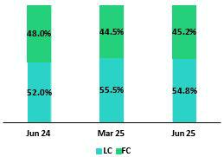

At the end of June 2025, the dollarizaton level of Total Deposits rose 65 bps QoQ to stand at 45.2%, which is below the average for the last three years (48.7%). This result was driven by a drop in Demand Deposits, which was driven by income tax payments and an increase in Time Deposits in FC following eforts to bolster captures that optmize the funding structure.

YoY, the dollarizaton level dropped 288 bps. This evoluton was spurred mainly by growth in LC balances for Low-cost Deposits, which refected an uptck in deposit captures, and was partally ofset by an uptck in Time Desposits in FC, driven by the same dynamics seen QoQ.

Deposits by Currency and Type

Loan / Deposit Rato (L/D rato)
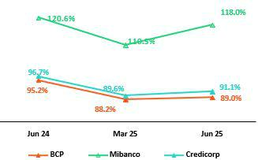

(measured at quarter-end balance)
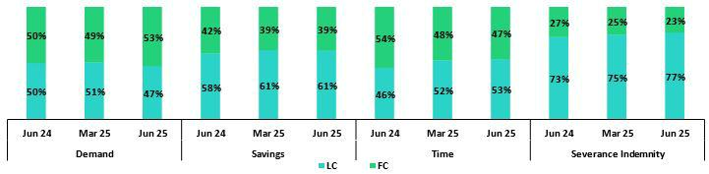

QoQ, the L/D rato increased 79 bps at BCP Stand-alone, driven by growth in the loan balance via wholesale loans and partally ofset by a slight increase in tme deposits. At Mibanco, the rato rose 743 bps, fueled mainly by an uptck in loans following improvements to models; eforts to broaden oferings to new clients; and a decrease in tme deposits.

YoY, the L/D rato dropped 624 bps and 266 bps at BCP and Mibanco respectvely. At BCP, the decline was atributable to growth in Low- Cost Deposits in a context of higher liquidity and to a decrease in the loan balance. At Mibanco, the decrease was driven by growth in Savings Deposits, which was ofset by loan growth.

In this context, the L/D rato at Credicorp stood at 91.1%.


| Earnings Release 2Q / 2025 Analysis of 2Q25 Consolidated Results

02. Deposits

L/D Rato Local Currency L/D Rato Foreign Currency
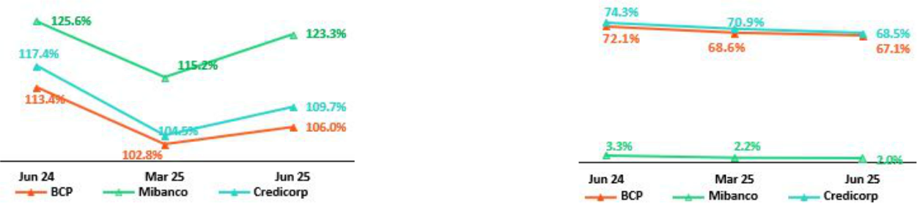

Market Share (MS) of Deposits in the Peruvian Financial System

Share of the Deposit Market in the Peruvian Financial System
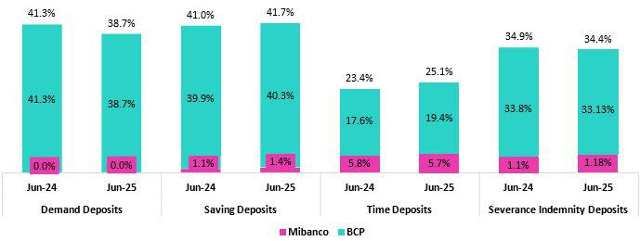

At the end of June 2025, the MS of Total Deposits held by BCP Stand-alone and Mibanco in Peru stood at 32.1% and 2.6% (51 bps and -4 bps vs June 2024, respectvely). BCP contnued to lead the market for total deposits.

BCP Stand-alone reported YoY growth in Low-Cost Deposits (+6.5%); this fgure fell below the fgure registered for the fnancial system (+9.2%). BCP contnues to lead the market for Low-cost Deposits with an MS of 39.6% at the end of June 2025 (-101 pbs vs June 2024). Time Deposits grew across the fnancial system (-0.4% vs June 2024) and at BCP, which registered growth of 10.0% versus 2024. In this context, BCP’s MS rose (184 bps vs June 2024) to stand at 19.4% at the end of June 2025.

Credicorp’s share (BCP + Mibanco) of the market for Low-cost Deposits dropped 82 bps versus June 2024 and stood at 40.3% at the end of June 2025. Credicorp’s market share of Time Deposits rose 170bps at the end of June 2024 to stand at 25.1% at the end of June 2025.

| Earnings Release 2Q / 2025 Analysis of 2Q25 Consolidated Results

03 Interest-earning Assets (IEA) and Funding


Excluding the impact on Credicorp’s balance sheet resultng from an accountng adjustment at BCP Bolivia, intended to refect the currency devaluaton, the evoluton of IEA and Funding presented the following dynamics:

QoQ, IEA dropped 1.1% following a contracton in the investment balance, which was driven mainly by a reducton in the portolio of BCRP certfcates of deposits. Cash and due from banks also declined, following payment of an expired bond at BCP. Funding, in turn, dropped 0.8%, primarily on the back of a reducton in the balance for Bonds and, secondarily, due to a drop in BCRP instruments afer less liquidity was taken via this mechanism.

YoY, IEA grew 4.1%, fueled by growth in the balance of Cash and due from banks, which peaked in 4Q24 due to high liquidity last year. Finally, funding increased 3.2%, fueled by growth in Deposits, which was led by low-cost deposits. Growth in the later was spurred by economic recovery and a consequent increase in transactonal actvity.

As was the case in the frst quarter, our 2Q25 fgures refect the impact of a non-cash accountng adjustment. In March and June, Credicorp revalued BCP Bolivia’s Balance Sheet with exchange rates that beter refect the market exchange rate in that country. This led the book value of Credicorp’s total assets to decline 2.8% in June.

The analysis of the evoluton of IEA and Funding will focus on the operatng dynamics, excluding the impact of the accountng adjustment.

3.1. IEA

Interest earning assets |  | As of |  | % change
S/000 | Jun 24 | Mar 25 | Jun 25 | QoQ | YoY
Cash and due from banks | 27,157,901 | 37,521,839 | 34,206,000 | -8.8% | 26.0%
Total investments | 52,426,146 | 55,604,610 | 51,603,447 | -7.2% | -1.6%
Cash collateral, reverse repurchase agreements and securites borrowing | 1,777,491 | 1,835,893 | 4,593,501 | 150.2% | 158.4%
Loans | 146,946,546 | 141,196,646 | 140,961,978 | -0.2% | -4.1%
Total interest earning assets | 228,308,084 | 236,158,988 | 231,364,926 | -2.0% | 1.3%

IEA dropped 2.0% QoQ and rose 1.3% YoY. If we exclude the efect of the accountng adjustment for BCP Bolivia, IEA followed the following dynamics:

QoQ, IEA dropped 1.1%. This evoluton was driven primarily by a reducton in the Investment balance, which was impacted by the expiraton and non-renewal of BCRP certfcates of deposits (BCRP CD), and secondarily by a decrease in Cash and due from banks afer funds from this account were used to pay the expiraton of a subordinated bond at BCP. These dynamics were partally ofset by an increase in Cash collateral, reverse repurchase agreements and securites borrowing, which rose on the back of an investment strategy at Credicorp Capital Colombia.

YoY, IEA increased 4.1%, fueled mainly by a higher balance of Cash and due from banks due to: i) growth in transactonal actvity and

- high levels of market liquidity partally due to the positve shock of withdrawals from AFP funds in 2024. To a lesser extent, Cash collateral, reverse repurchase agreements and securites borrowing contributed to IEA growth due to the same strategy described in the QoQ analysis. Loans, in turn, negatvely impacted IEA growth due to the contracton in BCP Bolivia’s balances (excluding the exchange rate adjustment).


| Earnings Release 2Q / 2025 Analysis of 2Q25 Consolidated Results

03. Interest-earning Assets (IEA) and Funding

3.2. Funding

Funding |  | As of |  |  | % change
S/ 000 | Jun 24 | Mar 25 | Jun 25 | QoQ | YoY
Deposits and obligatons | 151,971,984 | 157,619,082 | 154,723,334 | -1.8% | 1.8%
Due to banks and correspondents | 12,620,346 | 10,899,579 | 11,152,813 | 2.3% | -11.6%
BCRP instruments | 5,542,892 | 7,064,476 | 5,096,459 | -27.9% | -8.1%
Repurchase agreements with clients and third partes | 2,146,797 | 3,094,138 | 6,168,934 | 99.4% | 187.4%
Bonds and notes issued | 17,953,508 | 14,391,733 | 12,112,403 | -15.8% | -32.5%
Total funding | 190,235,527 | 193,069,008 | 189,253,943 | -2.0% | -0.5%

Funding dropped by 2.0% QoQ and 0.5% YoY. If we exclude the impact of BCP Bolivia’s accountng adjustment, funding presented the following dynamics:

QoQ, funding dropped 0.8%. This evoluton was atributable to a reducton in the balance for Bonds and notes issued, which was impacted by the expiraton of a BCP subordinated bond for US$ 850 million. The bond payment was setled on July 1, but an accountng adjustment was registered on June 30. An additonal factor that led funding to drop, albeit to a lesser extent, was the reducton in the balance of BCRP instruments, which refected the reconfguraton of the funding mix to favor other, more efcient sources of funding. The decrease in funding this quarter was partally ofset by an increase in Repurchase agreements with clients and third partes to fnance an investment strategy at Credicorp Capital Colombia (mentoned in the IEA secton).

YoY, funding rose 3.2%, driven primarily by an uptck in Deposits and obligatons. It is important to note that growth was concentrated in low-cost deposits, which rose in a context marked by economic recovery and growth in the transactons volume. These dynamics were partally ofset by expiratons of BCP bonds in the frst half of the year and, to a lesser extent, by a drop in the balance for Due to banks and correspondents, which was impacted by the expiraton of a club deal in 4Q24.

| Earnings Release 2Q / 2025 Analysis of 2Q25 Consolidated Results

04 Net Interest income (NII)

In 2Q25, Net Interest Income (NII) rose 1.2% QoQ mainly due to a drop in interest on deposits, amid a downward trend in market interest rates.


YoY, NII tcked up 4.2%, driven mainly by a reducton in Interest and similar expenses. This decrease was fueled by a drop in expenses for deposits, which were impacted primarily by declining interest rates and secondarily by an uptck in low-cost deposits’ share of the funding structure.

NIM rose 20 bps QoQ to stand at 6.42%, driven mainly by a shif in the IEA mix toward higher-yielding assets. It is important to note that risk-adjusted NIM contnued to trend upward and hit a new high¹ of 5.44%.

Net interest income |  | Quarter |  |  | % change |  | Up to | % Change
S/000 | 2Q24 | 1Q25 | 2Q25 | QoQ | YoY | Jun 24 | Jun 25 | Jun 25 / Jun 24
Interest and Similar Income | 4,935,238 | 4,894,790 | 4,922,292 | 0.6% | -0.3% | 9,861,164 | 9,817,082 | -0.4%
Interest and Similar Expenses | (1,466,774) | (1,322,778) | (1,306,921) | -1.2% | -10.9% | (2,966,577) | (2,629,699) | -11.4%
Interest Expense (excluding Net Insurance Financial Expenses) | (1,342,088) | (1,187,156) | (1,167,866) | -1.6% | -13.0% | (2,719,887) | (2,355,023) | -13.4%
Net Insurance Financial Expenses | (124,686) | (135,622) | (139,055) | 2.5% | 11.5% | (246,690) | (274,676) | 11.3%
Net Interest, similar income and expenses | 3,468,464 | 3,572,012 | 3,615,371 | 1.2% | 4.2% | 6,894,587 | 7,187,383 | 4.2%
Balances
Average Interest Earning Assets (IEA) | 227,161,179 | 238,435,117 | 233,761,957 | -2.0% | 2.9% | 226,444,444 | 236,038,086 | 4.2%
Average Funding | 187,904,862 | 195,997,306 | 191,161,476 | -2.5% | 1.7% | 187,491,207 | 194,089,774 | 3.5%
Yields
Yield on IEAs | 8.69% | 8.21% | 8.42% | 21 bps | -27 bps | 8.71% | 8.32% | -39 bps
Cost of Funds⁽¹⁾ | 2.86% | 2.42% | 2.44% | 2 bps | -42 bps | 2.90% | 2.43% | -47 bps
Net Interest Margin (NIM)⁽¹⁾ | 6.33% | 6.22% | 6.42% | 20 bps | 9 bps | 6.31% | 6.32% | 1 bps
Risk-Adjusted Net Interest Margin⁽¹⁾ | 4.40% | 5.24% | 5.44% | 20 bps | 104 bps | 4.62% | 5.34% | 72 bps
Peru's Reference Rate | 5.75% | 4.75% | 4.50% | -25 bps | -125 bps | 5.75% | 4.50% | -125 bps
FED funds rate | 5.50% | 4.50% | 4.50% | 0 bps | -100 bps | 5.50% | 4.50% | -100 bps
(1) For further detail on the NIM and Cost of Funds calculaton, please refer to Annex 12.8

QoQ, Net Interest Income (NII) tcked up 1.2%. This dynamic was primarily driven by a decline in interest on deposits, which refected a lower market interest rate environment, as tme deposits were renewed at lower rates.

YoY, NII rose 4.2% on the back of a reducton in Interest and similar expenses. This decline was fueled by lower expenses for deposits, due to lower market rates and growth in low-cost deposits’ share of the funding structure. Interest and similar income posted a decline, atributable to a drop in interest on loans, which was in turn triggered by a negatve volume efect via a reducton in wholesale loan balances at BCP, atenuatng NII growth.

YTD, NII grew 4.2%. This result was fueled by a reducton in Interest and similar expenses, which was triggered by a drop in expenses for deposits (through the same dynamics as those seen YoY). Interest and similar income reported a negatve contributon to NII, which refected a drop in interest on loans, driven by the same factors that drove the YoY result.

1 Since the implementaton of IFRS 9 in 2018.


| Earnings Release 2Q / 2025 Analysis of 2Q25 Consolidated Results

- Net Interest income (NII)

Net Interest Margin

NIM rose 20 bps QoQ to stand at 6.42%. This evoluton was driven by a 21 bps increase in the yield on IEAs, afer a reducton in the average balance of Investments, and Cash and equivalents led to a higher-yielding IEA mix. The cost of funding increased slightly on the back of growth in the balance of tme deposits. Risk-adjusted NIM contnued to trend upward, increasing 20 bps QoQ to reach a new high of 5.44%. It is important to note that risk-adjusted NIM increased 104 bps YoY, which refects the positve impact of our strategy to increase retail loans’ share of total loans while adequately managing risk
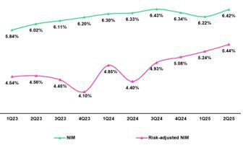

Dynamics of the Net Interest Margin by Currency

Interest Income / IEA |  | 2Q24 |  |  | 1Q25 |  |  | 2Q25
S/ millions | Average |  |  | Average |  |  | Average
 | Balance | Income | Yields | Balance | Income | Yields | Balance | Income | Yields
Total (LC + FC)
Cash and equivalents | 29,146 | 320 | 4.4% | 38,821 | 345 | 3.6% | 35,864 | 342 | 3.8%
Other IEA | 1,652 | 26 | 6.3% | 1,434 | 19 | 5.3% | 3,215 | 69 | 8.6%
Investments | 52,491 | 668 | 5.1% | 54,716 | 683 | 5.0% | 53,604 | 670 | 5.0%
Loans | 143,873 | 3,922 | 10.9% | 143,465 | 3,848 | 10.7% | 141,079 | 3,841 | 10.9%
Total IEA | 227,162 | 4,936 | 8.7% | 238,436 | 4,895 | 8.2% | 233,762 | 4,922 | 8.4%
IEA (LC) | 57.4% | 69.4% | 10.5% | 55.6% | 70.5% | 10.4% | 56.5% | 71.1% | 10.6%
IEA (FC) | 42.6% | 30.6% | 6.2% | 44.4% | 29.5% | 5.5% | 43.5% | 28.9% | 5.6%
Interest Income / Funding |  | 2Q24 |  |  | 1Q25 |  |  | 2Q25
S/ millions | Average |  |  | Average |  |  | Average
 | Balance | Expense | Yields | Balance | Expense | Yields | Balance | Expense | Yields
Total (LC + FC)
Deposits | 149,914 | 738 | 2.0% | 159,731 | 620 | 1.6% | 156,171 | 541 | 1.4%
BCRP + Due to Banks | 17,851 | 268 | 6.0% | 17,683 | 266 | 6.0% | 17,107 | 265 | 6.2%
Bonds and Notes | 17,747 | 200 | 4.5% | 15,830 | 168 | 4.2% | 13,252 | 193 | 5.8%
Others | 2,392 | 261 | 43.6% | 2,754 | 269 | 39.1% | 4,632 | 307 | 26.5%
Total Funding | 187,904 | 1,467 | 3.1% | 195,998 | 1,323 | 2.7% | 191,162 | 1,306 | 2.7%
Funding (LC) | 49.5% | 51.7% | 3.3% | 51.7% | 53.4% | 2.8% | 52.4% | 51.9% | 2.7%
Funding (FC) | 50.5% | 48.3% | 3.0% | 48.3% | 46.6% | 2.6% | 47.6% | 48.1% | 2.8%
NIM(1) | 227,162 | 3,469 | 6.1% | 238,436 | 3,572 | 6.0% | 233,762 | 3,616 | 6.2%
NIM (LC) | 57.4% | 76.9% | 8.2% | 55.6% | 76.8% | 8.3% | 56.5% | 78.0% | 8.5%
NIM (FC) | 42.6% | 23.1% | 3.3% | 44.4% | 23.2% | 3.1% | 43.5% | 22.0% | 3.1%

Average | Jun 24 |  | Average | Jun 25
Balance | Income | Yields | Balance | Income | Yields
26,568 | 654 | 4.9% | 37,162 | 687 | 3.7%
1,594 | 54 | 6.8% | 2,813 | 89 | 6.3%
52,320 | 1,362 | 5.2% | 52,715 | 1,353 | 5.1%
145,961 | 7,790 | 10.7% | 143,348 | 7,688 | 10.7%
226,443 | 9,860 | 8.7% | 236,038 | 9,817 | 8.3%
57.2% | 69.6% | 10.6% | 55.6% | 70.8% | 10.6%
42.8% | 30.4% | 6.2% | 44.4% | 29.2% | 5.5%
Average | Jun 24 |  | Average | Jun 25
Balance | Expense | Yields | Balance | Expense | Yields
149,839 | 1,518 | 2.0% | 158,283 | 1,160 | 1.5%
18,952 | 532 | 5.6% | 16,825 | 532 | 6.3%
16,274 | 398 | 4.9% | 14,690 | 362 | 4.9%
2,427 | 519 | 42.8% | 4,291 | 576 | 26.8%
187,492 | 2,967 | 3.2% | 194,089 | 2,630 | 2.7%
49.7% | 51.8% | 3.3% | 51.1% | 52.7% | 2.8%
50.3% | 48.2% | 3.0% | 48.9% | 47.3% | 2.6%
226,443 | 6,893 | 6.1% | 236,038 | 7,187 | 6.1%
57.2% | 77.3% | 8.2% | 55.6% | 77.4% | 8.5%
42.8% | 22.7% | 3.2% | 44.4% | 22.6% | 3.1%

(1) Unlike the NIM fgure calculated according to the formula in Appendix 12.8, the NIM presented in this table includes “Financial Expense associated with the insurance and reinsurance actvity, net”.

QoQ Analysis

QoQ, Net Interest Income (NII) increased 1.2%, registering growth in NII in LC and a drop in NII in FC. IEA in LC represented 56.5% of total IEAs at the end of the quarter and accounted for 71.1% of Interest Income generated in 2Q25.

Local Currency Dynamics (LC)

NII in LC increased 2.7%, fueled by growth in interest income. This evoluton refected higher interest income on Loans, which was driven by an uptck in retail loans’ share of total loans. This dynamic was partally ofset by a reducton in income on Investments, which mainly refected a drop in investment dividends. Interest expenses, which fell afer a drop in market rates pressured expenses for Deposits downward, were a secondary contributor to growth in NII in LC.

| Earnings Release 2Q / 2025 Analysis of 2Q25 Consolidated Results

- Net Interest income (NII)

Foreign Currency Dynamics (FC)

NII in FC dropped 3.6% QoQ, driven mainly by a reducton in interest income and growth in interest expenses. The reducton in interest income was atributable to a contracton in interest on Loans, which was fueled primarily by a decrease in balances due to a drop in the exchange rate (depreciaton of the US Dollar) and secondarily by lower market rates. Interest expenses rose due to an uptck in interest on Bonds and notes. This increase was partally ofset by a drop in interest expenses on Deposits, driven by declining market rates.

YoY analysis

YoY, NII rose 4.2% fueled by LC NII and while FC NII contracted.

Local Currency Dynamics (LC)

NII in LC rose 5.7% YoY, driven mainly by a drop in interest expenses, and to a lesser degree, by growth in interest income:

Interest expenses dropped, due to a reducton in interest on Deposits, which was atributable to a downward trend in market rates. A secondary driver in the reducton in expenses was the drop in interest on Bonds and Subordinated Notes, which fell due to a negatve volume efect. In this context, the cost of funding in LC fell 56 bps to stand at 2.7%.

Growth in interest income was fueled by an uptck in interest on Loans, which was spurred by an increase in loan volumes at Mibanco and BCP’s retail segments, which yield higher rates relatve to the total portolio. In this context, the yield on IEA in LC rose 8 bps to 10.6%.

Foreign Currency Dynamics (FC)

NII in FC dropped 0.8% YoY due to the following dynamics:

Interest income decreased, fueled mainly by a drop in interest on Loans, which fell on the back of the exchange rate efect mentoned in the QoQ analysis. In this context, the yield on IEA in FC fell 64 bps to stand at 5.6%.

The decrease registered for interest expenses partally ofset the drop in interest income. This reducton was mainly driven by lower interest on Deposits, impacted by a downward trend in market rates, and to a lesser extent by a drop in the funding volume with BCRP + due to banks. In this scenario, the cost of funding in FC decreased 22 bps to stand at 2.8%.

YTD Analysis

YTD, NII rose 4.2%, bolstered by growth in both LC and FC.

Local Currency Dynamics (LC)

NII in LC increased 4.4%. This evoluton was driven primarily by a drop in interest expenses and secondarily by growth in interest income. As in the case of the YoY analysis, expenses fell over the period, fueled mainly by a decrease in expenses on Deposits and to a lesser extent, by a drop in expenses for Bonds and notes. Interest income, in turn, rose on the back of the same portolio dynamics reported for interest on Loans from the YoY analysis.

Foreign Currency Dynamics (FC)

NII in FC increased 3.8% due to a drop in interest expenses; this result was partally ofset by a reducton in interest income. Expenses in FC decreased through the same dynamics that drove the YoY evolutons of Deposits and BCRP + due to banks. Interest income in FC was negatvely impacted by a drop in interest on Loans, which fell on the tails of the same market dynamics that drove the YoY evoluton of NII.

| Earnings Release 2Q / 2025 Analysis of 2Q25 Consolidated Results

05 Portolio Quality and Provisions


Portolio quality ratos have reported substantal and contnuous improvements over the last year, driven by strengthened risk management measures and supported by improvements in payment performance and in the Peruvian economy.

QoQ, the drop in NPLs at BCP Stand-alone was fueled primarily by debt payments in Wholesale. At Mibanco, the reducton in NPLs was driven by a decrease in overdue loans. In this context, the NPL rato dropped 14 bps and 102 bps QoQ and YoY respectvely to stand at 5.0% at quarter-end.

QoQ, provisions dropped, fueled by BCP Stand-Alone and mainly through (i) an improvement in payment performance in Wholesale Banking, and secondarily (ii) through risk model calibratons in Individuals. This evoluton was partally ofset by growth in provisions at Mibanco, which reported a shif in the portolio mix. In this context, the cost of risk remained stable QoQ but fell 141 bps YoY to stand at 1.6% for 2Q25.

Portolio quality metrics have registered substantal improvements over the last twelve months and contnue to strengthen across segments, led by Retail Banking, where results have improved on the back of fortfed risk management measures and supported by improvements in payment performance and in the Peruvian economy.

5.1 | Portolio Quality
 |  | Total Portolio Quality (in quarter-end balances)
Loan Portolio quality and Delinquency ratos |  |  |  | As of |  |  | % change
S/000 |  |  | 2Q24 | 1Q25 | 2Q25 | QoQ | YoY
Total loans (Quarter-end balance) |  |  | 146,946,546 | 141,196,646 | 140,961,978 | -0.2% | -4.1%
Write-ofs |  |  | 994,556 | 716,585 | 581,373 | -18.9% | -41.5%
Internal overdue loans (IOLs) |  |  | 6,230,761 | 5,206,395 | 5,044,212 | -3.1% | -19.0%
Internal overdue loans over 90-days |  |  | 4,760,837 | 4,232,843 | 4,171,379 | -1.5% | -12.4%
Refnanced loans |  |  | 2,555,135 | 2,001,282 | 1,947,709 | -2.7% | -23.8%
Non-performing loans (NPLs) |  |  | 8,785,896 | 7,207,677 | 6,991,921 | -3.0% | -20.4%
IOL rato |  |  | 4.2% | 3.7% | 3.6% | -11 bps | -66 bps
IOL over 90-days rato |  |  | 3.2% | 3.0% | 3.0% | -4 bps | -28 bps
NPL rato |  |  | 6.0% | 5.1% | 5.0% | -14 bps | -102 bps

QoQ, NPLs dropped 3.0%, led primarily by BCP Stand-alone and secondarily by Mibanco. Write-ofs declined 18.9%, mainly on the back of an uptck in the share of new vintages with lower risk levels within the SME-Pyme portolio at BCP Stand-Alone and at Mibanco.

QoQ, at BCP Stand-alone, the reducton in NPLs was mainly driven by Wholesale, which refected debt payment by an overdue client in the commercial real estate sector. In Retail Banking, NPL volumes remained relatvely stable both in Individuals and SMEs. At Mibanco, the decline in NPLs was fueled by a reducton in overdue loans, which fell on the back of eforts insttuted last year to tghten originaton guidelines and improve debt collectons management. Thanks to these measures, 70% of the loan portolio is currently comprised of new, healthier loans that were issued under these policies.

YoY, NPLs dropped 20.4%, led primarily by BCP Stand-alone and secondarily by Mibanco. The decline in write-ofs (-41.5%) was driven by the same dynamics as those seen QoQ and by an improvement in the quality of loan originaton in the Individuals segment. YoY, at BCP Stand-alone, the reducton in NPLs was fueled mainly by Wholesale and secondarily by Retail Banking. In Wholesale, the reducton in NPLs was driven primarily due to debt cancellaton by a refnanced client in the commercial real estate sector; while in Retail Banking, it was fueled mainly by (i) SME-Pyme, due primarily to drop in overdue loans, which was mainly concentrated in medium-sized, lower-risk tckets (> S/ 150 thousand) and secondarily by an uptck in honoring of loan guarantees under Reactva; and (ii) Consumer and Credit Cards, driven mainly by an uptck in debt cancellatons amid a high-liquidity context following pension fund withdrawals in the last half of 2024 and secondarily by an improvement in the quality of loan originaton and debt collectons management. At Mibanco, the drop in NPLs was atributable to the same dynamics in play QoQ.

| Earnings Release 2Q / 2025 Analysis of 2Q25 Consolidated Results

05. Portolio Quality and Provisions

NPL Rato for Total Loans

The NPL rato at Credicorp fell 14 bps QoQ to stand at 5.0%. This decline was driven mainly by the same dynamics that fueled the evoluton of NPLs in the QoQ analysis and partally ofset by a reducton in the loan portolio.
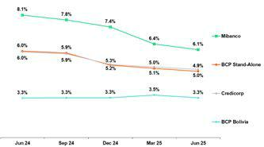

If we analyze the QoQ evoluton of the NPL rato by Subsidiary, we see:

• BCP Stand-alone, where the NPL rato dropped 17 bps. In the case of Wholesale and SME-Business, the reducton was fueled mainly by a decline in NPL volumes. In the case of SME-Pyme and Individuals, the decline was spurred mainly by loan growth.

- Mibanco, where the NPL rato fell 32 bps, driven mainly by a drop in NPL loan volumes and secondarily by loan growth.

NPL Rato for Total Loans at BCP ⁽¹⁾

The NPL rato at Credicorp fell 102 bps YoY to stand at 5.0%. This decline was fueled primarily by the same dynamics that drove the evoluton of NPLs in the YoY analysis and was partally ofset by a drop in loan portolio.
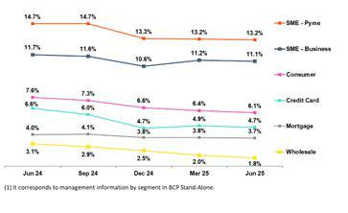

If we analyze the YoY evoluton of the NPL rato by Subsidiary, we see:

• BCP Stand-alone, where the NPL rato dropped 117 bps. In the case of all segments, except Mortgage, the decline was primarily atributable to a drop in NPL volumes. In the case of Mortgage, the rato fell mainly due to loan growth and secondarily, due to a reducton in NPL volumes.

- Mibanco, where the NPL rato decreased 202 bps, driven mainly by a reducton in NPL volumes and secondarily by loan growth.

| Earnings Release 2Q / 2025 Analysis of 2Q25 Consolidated Results

05. Portolio Quality and Provisions

5.2 Provisions and Cost of Risk of the Total Portolio

Loan Portolio Provisions |  | Quarter |  |  | % change |  | Up to | % change
S/000 | 2Q24 | 1Q25 | 2Q25 | QoQ | YoY | Jun 24 | Jun 25 | Jun 25 / Jun 24
Gross provision for credit losses on loan portolio | (1,193,548) | (695,733) | (683,965) | -1.7% | -42.7% | (2,103,737) | (1,379,698) | -34.4%
Recoveries of writen-of loans | 100,177 | 113,840 | 108,806 | -4.4% | 8.6% | 195,667 | 222,646 | 13.8%
Provision for credit losses on loan portolio, net of recoveries | (1,093,371) | (581,893) | (575,159) | -1.2% | -47.4% | (1,908,070) | (1,157,052) | -39.4%
Cost of risk ⁽¹⁾ | 3.0% | 1.6% | 1.6% | 1 bps | -141 bps | 2.6% | 1.6% | -100 bps
(1) Provisions for credit losses on loan portolio, net of annualized recoveries / Average Total Loans. It includes reversal of provisions for “El Niño” Phenomenon in 1Q24.

QoQ, provisions dropped 1.2% on the back of the evoluton at BCP Stand-alone and partally ofset by the result at Mibanco. At BCP Stand-alone, the reducton in provisions was atributable to Wholesale and Individuals segments. In Wholesale, provisions fell due to an improvement in payment performance. In Individuals, provisions dropped mainly on the back of a reducton in Credit Cards, which was mainly spurred by a base efect due to calibratons to our risk models and secondarily by an improvement in payment performance as lower-risk vintages contnued to gain tracton in the portolio mix. This evoluton was partally ofset by an increase in provisions in SME-Pyme, which was driven by an uptck in short-term disbursements, primarily for small-tcket and higher-yield loans. At Mibanco, the increase in provisions was atributable to a shif in the mix toward small tcket, higher-yield loans. In this context, the CofR at Credicorp remained stable QoQ to stand at a low level of 1.6%, in line with results in recent quarters. This result was impacted by initatves this year to shore up risk management and bolstered by favorable macro conditons in Peru.

Cost of Risk by Subsidiary ⁽¹⁾
YoY, provisions dropped 47.4%, driven by BCP Stand-alone and Mibanco, which reported improvements in payment performance in a context of economic recovery. At BCP Stand-alone, the decrease in provisions was fueled by the Individuals and SME-Pyme segments, which registered an increase in lower-risk vintages’ share of total loans. This evoluton was partally ofset by growth in provisions in Wholesale, which registered an increased in its balance due to a drop in repayments this quarter. At Mibanco, the reducton was fueled by an improvement in underlying risk as lower-risk vintages gained tracton and currently represent 70% of the portolio. In this context, the CofR at Credicorp dropped 141 bps YoY to stand at 1.6%.
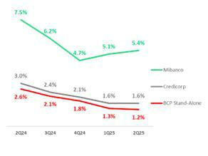

On a Full-Year basis, provisions fell 39.4%, driven by BCP Stand-alone and

Mibanco and on the tails of the same dynamics seen YoY. The cost of risk at

Credicorp fell 100 bps to stand at 1.6%.

QoQ Cost of Risk Evoluton YoY Cost of Risk Evoluton
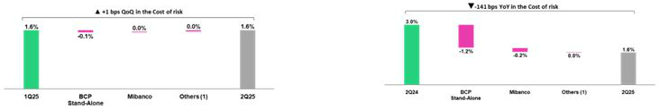

(1) Others include BCP Bolivia, Mibanco Colombia, ASB and eliminatons.
(1) Others include BCP Bolivia, Mibanco Colombia, ASB and eliminatons.

YTD Cost of Risk Evoluton*
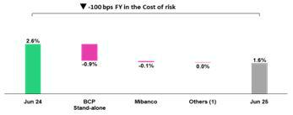

  - It includes reversal of provisions for “El Niño” Phenomenon in 1Q24.
- Others include BCP Bolivia, Mibanco Colombia, ASB and eliminatons.

| Earnings Release 2Q / 2025 Analysis of 2Q25 Consolidated Results

05. Portolio Quality and Provisions

NPL Coverage Rato (in Quarter-end balances)

Loan Portolio Quality and Delinquency Ratos |  | As of |  |  | % change
S/000 | 2Q24 | 1Q25 | 2Q25 | QoQ | YoY
Total loans (Quarter-end balance) | 146,946,546 | 141,196,646 | 140,961,978 | -0.2% | -4.1%
Allowance for loan losses | 8,350,024 | 7,742,792 | 7,658,595 | -1.1% | -8.3%
Non-performing loans (NPLs) | 8,785,896 | 7,207,677 | 6,991,921 | -3.0% | -20.4%
Allowance for loan losses over Total loans | 5.7% | 5.5% | 5.4% | -5 bps | -25 bps
Coverage rato of NPLs | 95.0% | 107.4% | 109.5% | 211 bps | 1449 bps

Allowance for loan losses

(in S/ millions)

QoQ, Allowances for Loan Losses dropped 1.1%, driven mainly by BCP Bolivia and secondarily by Mortgage at BCP Stand-alone.
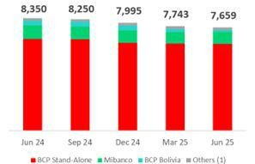

YoY, Allowances for Loan Losses dropped 8.3%, fueled mainly by SME-Pyme at BCP Stand-alone and secondarily by BCP Bolivia.

(1) Others include Mibanco Colombia, ASB and eliminatons.

NPL Coverage Rato

The total NPL Coverage rato at Credicorp stood at 109.5% at the end of 2Q25. If we exclude NPL volumes from the Government Loans Program (GP), the rato stands at 112.5%.
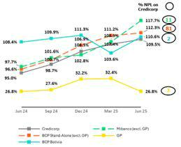

QoQ

The total NPL Coverage rato at Credicorp increased 211 bps, fueled by the evoluton at BCP Stand-alone and Mibanco.

Next, we will analyze this evoluton by isolatng the impact of NPLs from the Government Loans Program, which are backed by ample guarantees that are being honored satsfactorily.

The NPL Coverage rato at BCP Stand-alone, excluding GP loans, rose 108 bps to stand at 112.3%. This evoluton was driven primarily by a reducton in NPLs in Wholesale Banking. The NPL Coverage rato at Mibanco, excluding GP loans, increased 923 bps to stand at 117.7%. This evoluton was driven by a drop in NPLs, which was driven by the same dynamics seen QoQ.

YoY

The total NPL Coverage rato at Credicorp increased 1,449 bps, driven mainly by BCP Stand-alone and Mibanco. Next, we will analyze this evoluton by isolatng the efect of NPLs in the GP portolio.

The NPL Coverage rato at BCP Stand-alone, excluding GP loans, rose 1,571 bps, fueled by a drop in NPL volumes, which was driven by the same dynamics in play YoY. The NPL Coverage rato at Mibanco, excluding GP loans, rose 1,999 bps YoY, spurred by a decrease in NPLs, in line with the dynamics seen YoY.

| Earnings Release 2Q / 2025 Analysis of 2Q25 Consolidated Results

06 Other Income

QoQ, Other Income dropped 0.8%. Other Core Income increased 4.8%, reportng record highs that topped S/1.4 billion, mainly on the back of strong performance at BCP Stand-alone. Other Non-Core Income posted a relevant gain of S/106 million, related to the exchange of sovereign bonds at BCP Stand-alone.


YoY, Other Income rose 5.4%. Other Core Income expanded 8.1%, driven by growth in fee income from Yape and transactonal products at BCP Stand-alone.

Other Non-Core income contracted 6.4%, which was atributable to signifcant income at BCP Stand-alone and Pacifco in 2Q24.

YTD, Other Income rose 12.9%. Other Core Income increased 11.4%, driven primarily by twofold growth at Yape and high single- digit expansion in core transactonal fees and FX gains at BCP Stand-alone. Other Non-Core Income increased 19.6% mainly due to the consolidaton of Banmedica and the exchange of sovereign bonds.

6. Other Income¹
Other Income ⁽¹⁾ |  | Quarter |  | % Change |  |  | Up to | % change
(S/ 000) | 2Q24 | 1Q25 | 2Q25 | QoQ | YoY | Jun 24 | Jun 25 | Jun 25 / Jun 24
Other Core Income | 1,296,577 | 1,337,838 | 1,401,569 | 4.8% | 8.1% | 2,458,512 | 2,739,407 | 11.4%
Other Non-Core Income | 294,753 | 352,378 | 275,804 | -21.7% | -6.4% | 525,377 | 628,182 | 19.6%
Total Other Income | 1,591,330 | 1,690,216 | 1,677,373 | -0.8% | 5.4% | 2,983,889 | 3,367,589 | 12.9%
- Beginning in 1Q25, accountng reclassifcatons have been incorporated afectng Fee Income, Net Gain on Foreign Exchange Transactons, and Net Gain on Derivatves Held for Trading. Prior periods have been restated for comparability and may difer from previously reported fgures.

Other Income decreased by 0.8% QoQ, but increased by 5.4% YoY and 12.9% YTD.

6.1. Other Core Income¹
Other Core Income ⁽¹⁾ |  | Quarter |  | % Change |  |  | Up to | % change
(S/ 000) | 2Q24 | 1Q25 | 2Q25 | QoQ | YoY | Jun 24 | Jun 25 | Jun 25 / Jun 24
Fee Income | 947,228 | 994,024 | 1,024,553 | 3.1% | 8.2% | 1,803,793 | 2,018,577 | 11.9%
Net Gain on Foreign Exchange Transactons | 349,349 | 343,814 | 377,016 | 9.7% | 7.9% | 654,719 | 720,830 | 10.1%
Total Other Core Income | 1,296,577 | 1,337,838 | 1,401,569 | 4.8% | 8.1% | 2,458,512 | 2,739,407 | 11.4%
- Beginning in 1Q25, accountng reclassifcatons have been incorporated afectng Fee Income, Net Gain on Foreign Exchange Transactons, and Net Gain on Derivatves Held for Trading. Prior periods have been restated for comparability and may difer from previously reported fgures.

Revenue diversifcaton and our digital capabilites contnue to be key drivers behind the growth of the main recurring components of Other Income. This performance was partally ofset by weaker results at BCP Bolivia, where Net Gain on Foreign Exchange Transactons was impacted by the devaluaton of the Bolivian peso. Excluding the later, Other Core Income shows:

- QoQ, Other Core Income reported solid results to hit a record-high of S/1.4 billion. Growth in Fee Income will be described in the subsequent secton. The Net Gain on Foreign Exchange Transactons (+9.7%) refected positve results mainly at BCP Stand-alone, refectng higher client transactonal volumes.

- YoY, growth was driven mainly by an uptck in Fee Income, which will be discussed in the subsequent secton on fee income at BCP Stand-alone. A secondary driver of growth was the Net Gain on Foreign Exchange Transactons (+7.9%) at BCP Stand- alone, which was fueled by an increase in transacton volumes across banking segments, on the back of pricing strategies and retail campaigns.

- YTD, growth was fueled mainly by an uptck in Fee Income, to be discussed later. The 10.1% increase in the Net Gain on Foreign Exchange Transactons was fueled by BCP Stand-alone, which has been bolstered by our sustained bet on digital channels and an increase in our share of the FX business as we move to capture robust transactonal opportunites from Retail and Wholesale clients. This performance is proof of BCP’s capacity to innovate the transactonal experience and agilely adapt to new market dynamics, which has boosted greater fnancial inclusion among clients who previously relied on the informal market.

| Earnings Release 2Q / 2025 Analysis of 2Q25 Consolidated Results

06. Other Income

Fee Income by Subsidiary

Fee Income by Subsidiary |  | Quarter |  | % Change |  |  | Up to | % change
(S/ 000) | 2Q24 | 1Q25 | 2Q25 | QoQ | YoY | Jun 24 | Jun 25 | Jun 25 / Jun 24
BCP Stand-Alone ⁽¹⁾ | 742,354 | 831,427 | 853,720 | 2.7% | 15.0% | 1,446,982 | 1,685,147 | 16.5%
BCP Bolivia ⁽²⁾ | 21,115 | 12,844 | 14,552 | 13.3% | -31.1% | 35,983 | 27,396 | -23.9%
Mibanco | 21,773 | 28,339 | 27,633 | -2.5% | 26.9% | 45,946 | 55,972 | 21.8%
Mibanco Colombia | 11,042 | 9,126 | 12,395 | 35.8% | 12.3% | 22,292 | 21,521 | -3.5%
Pacífco | (2,488) | (3,757) | (6,287) | 67.3% | 152.7% | (5,687) | (10,044) | 76.6%
Prima | 99,103 | 94,072 | 97,233 | 3.4% | -1.9% | 193,631 | 191,305 | -1.2%
ASB | 15,485 | 13,826 | 12,841 | -7.1% | -17.1% | 32,547 | 26,667 | -18.1%
Credicorp Capital | 153,482 | 136,264 | 134,297 | -1.4% | -12.5% | 281,630 | 270,561 | -3.9%
Eliminatons and Other ⁽³⁾ | (114,638) | (128,117) | (121,831) | -4.9% | 6.3% | (249,531) | (249,948) | 0.2%
Total Net Fee Income | 947,228 | 994,024 | 1,024,553 | 3.1% | 8.2% | 1,803,793 | 2,018,577 | 11.9%
- Beginning in 1Q25, accountng reclassifcatons related to credit card loyalty program expenses and Yape’s transactonal fee expenses have been incorporated. These reclassifcatons afected Administratve and General Expenses as well as Fee Income. Prior periods have been restated for comparability and may difer from previously reported fgures.
- Beginning in 1Q25, reclassifcatons related to FX operatons at BCP Bolivia have been incorporated. These reclassifcatons afected Fee Income and Net Gain on Derivatves Held for Trading, which are now consolidated into Net Gain on Foreign Exchange Transactons. Prior periods have been restated for comparability and may difer from previously reported fgures.
- Correspond mainly to the eliminatons of bancassurance between Pacifco, BCP, and Mibanco.

QoQ, YoY and YTD, growth of 3.1%, 8.2% and 11.9% (respectvely) was fueled mainly by an uptck in fee income at BCP Stand-alone, whose dynamics will be examined in the next secton. In the YoY and YTD analysis, expansion was partally ofset by a drop in results at Credicorp Capital. This decline was fueled by base efect, given that the Corporate Finance business in Colombia, whose operatons have been discontnued, registered a large transacton in 2Q24. Fees were also impacted YoY and YTD, albeit to a lesser extent, by BCP Bolivia, which reported a drop in credit card transactons in USD.

Fee Income at BCP Stand-alone
Compositon of Fee Income at BCP Stand-alone ^{(*)}

 | BCP Stand-alone Fees (*) |  | Quarter |  | % Change |  |  | Up to | % change
 | (S/ 000,000) | 2Q24 | 1Q25 | 2Q25 | QoQ | YoY | Jun 24 | Jun 25 | Jun 25 / Jun 24
 | Payments and transactonal services ⁽¹⁾ | 263 | 283 | 287 | 1.3% | 9.0% | 535 | 570 | 6.5%
 | Yape ⁽²⁾ | 70 | 121 | 132 | 9.1% | 88.7% | 124 | 252 | 103.9%
 | Liability and Transactonal Accounts ⁽³⁾ | 190 | 197 | 201 | 2.0% | 5.6% | 369 | 398 | 7.7%
 | Loan Disbursement ⁽⁴⁾ | 101 | 98 | 104 | 6.7% | 3.1% | 191 | 202 | 5.9%
 | Of-balance sheet | 55 | 56 | 53 | -5.9% | -3.9% | 112 | 109 | -2.9%
 | Insurances | 35 | 48 | 40 | -17.8% | 13.9% | 68 | 88 | 28.3%
 | Wealth Management and Corporate Finance | 18 | 15 | 20 | 32.5% | 12.8% | 27 | 35 | 28.5%
 | Others ⁽⁵⁾ | 11 | 14 | 18 | 30.8% | 59.5% | 21 | 32 | 54.1%
 | Total | 743 | 831 | 854 | 2.7% | 15.0% | 1,447 | 1,685 | 16.5%
 | (*) Management Figures.
- Corresponds to fees from credit and debit cards, payments and collectons. Beginning in 1Q25, accountng reclassifcatons related to expenses associated with the credit card loyalty program have been incorporated. These reclassifcatons afected Administratve and General Expenses and Fee Income. Figures for prior periods have been restated for comparability and may difer from those previously reported.
- Not includes fees related to E-Commerce. Not includes FX and remitances. Beginning in 1Q25, accountng reclassifcatons associated with Yape’s transactonal fee expenses have been incorporated.
These reclassifcatons afected Administratve and General Expenses and Fee Income. Figures for prior periods have been restated for comparability and may difer from those previously reported.
- Corresponds to fees from Account maintenance, interbank transfers, natonal transfers, and internatonal transfers.
- Corresponds to fees from retail and wholesale loan disbursements.
- Use of third-party networks, other services to third partes, and Commissions in foreign branches.

QoQ, Fee Income at BCP Stand-alone rose 2.7%, driven by growth via:

- Yape, mainly due to Bill Payments and Checkout.

- Core Business, represented by accountng lines with more recurring and stable results, showed improved performance, mainly driven by Loan disbursements, in line with recovery in structural commercial loans. To a lesser extent, Payment and transactonal services, as well as Liability and transactonal accounts, contributed to growth through an uptck in transactonal actvity.

- Wealth Management and Corporate Finance, due to extraordinary income in the month of April from structuring and advisory fees.

Expansion was partally ofset by a drop in Insurance, which refects a base efect given that in 1Q25, extraordinary income was reported for D&S insurance.

YoY, Fee Income rose 15.0%, fueled mainly by growth in:

- Yape, which accounted for 56% of growth in fee income, boosted by Bill Payments and Merchant fees.

| Earnings Release 2Q / 2025 Analysis of 2Q25 Consolidated Results

- Other Income

  - Core businesses, where commission growth was mainly driven by (i) Payment and transactonal services, which accounted for 21% of the increase, rose on the back of higher billing in credit and debit cards, and (ii) Liability and transactonal accounts, which contributed 10% of the growth, associated with higher volumes of interbank and internatonal transfers, as well as an increase in current account openings.

YTD, Fee Income rose 16.5%, primarily due to:

- Yape, which accounted for 54% of the increase in fee income. The most mature functonalites, such as Bill Payments, Merchant fees, and Top-Ups were the main contributors, while new solutons like Checkout, Yape for Businesses, and Remitances are showing signifcant progress.

- Core businesses, through, in order of impact, (i) Payments and services, which fueled 15% of the growth in fee income through an uptck in transactons with credit and debit cards. Merchant fees for credit and debit card transactons have been rising at double-digit rates (CAGR); this growth, however, has been partally atenuated by an increase in fees paid for the loyalty program and incentves, and (ii) Liability and transactonal accounts, which rose on the back of Wires and Transfers (+8.9%) and Current Accounts (+12.5%) and through the same dynamics seen YoY; these accounts represented 12% of total growth in fee income over the period.

- Insurance, which fueled 8% of the growth in fee income on the back of regularizatons with Pacifco.

6.2 Other Non-core Income

Other Non-Core Income |  | Quarter |  |  | % change |  | Up to | % change
(S/ 000) | 2Q24 | 1Q25 | 2Q25 | QoQ | YoY | Jun 24 | Jun 25 | Jun 25 / Jun 24
Net Gain on Securites | 92,711 | (28,149) | 179,174 | -736.5% | 93.3% | 154,456 | 151,025 | -2.2%
Net Gain from Associates ⁽¹⁾ | 28,728 | 24,068 | 6,556 | -72.8% | -77.2% | 61,023 | 30,624 | -49.8%
Net Gain of Derivatves Held for Trading ⁽²⁾ | 41,748 | 18,499 | 21,418 | 15.8% | -48.7% | 81,732 | 39,917 | -51.2%
Net Gain from Exchange Diferences | (7,933) | 15,959 | 10,195 | -36.1% | -228.5% | (13,554) | 26,154 | -293.0%
Other Non-operatve Income | 139,499 | 322,001 | 58,461 | -81.8% | -58.1% | 241,720 | 380,462 | 57.4%
Total Other Non-Core Income | 294,753 | 352,378 | 275,804 | -21.7% | -6.4% | 525,377 | 628,182 | 19.6%
- Includes gains on other investments. Beginning in 1Q25, revenues from the EPS and Medical Services businesses are no longer reported under Net Gain from Associates. Instead, they are fully consolidated into the Underwritng Insurance Result and the newly created Medical Services Result, respectvely.
- Beginning in 1Q25, accountng reclassifcatons related to FX operatons at BCP Bolivia have been incorporated. These reclassifcatons afected Fee Income and Net Gain on Derivatves Held for Trading, which are now consolidated into Net Gain on Foreign Exchange Transactons. Figures for prior periods have been restated for comparability and may difer from those previously reported.

Other Non-Core Income | Other Non-Core Income
QoQ evoluton | YoY evoluton
(millions of soles) | (millions of soles)
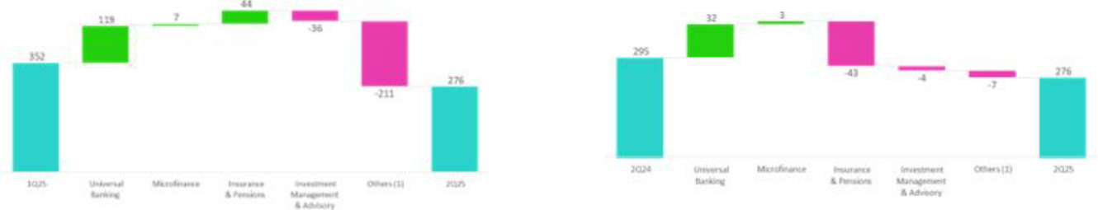

Other Non-Core Income

YTD evoluton
(millions of soles)
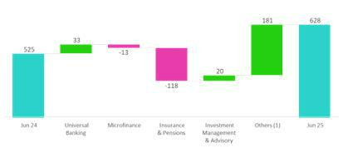

(1) Others: include Grupo Credito, Credicorp Stand-alone, eliminatons and others.

| Earnings Release 2Q / 2025 Analysis of 2Q25 Consolidated Results

06. Other Income

QoQ, Other Non-core Income dropped 21.7%, driven mainly by:

- Other Income: in Others, due to the extraordinary gain associated with the consolidaton of Banmedica from 1Q25 of S/236 million.

- Net gain from associates: at Pacifco, which experienced a change in accountng afer the acquisiton of Banmedica; currently, the results for corporate health insurance and medical services are consolidated in the Insurance Underwritng Result and Medical Services line rather than in the gain from associates line.

The aforementoned was partally atenuated by growth in the Net Gain (Loss) on Securites at BCP Stand-alone. This evoluton was driven primarily by an exchange of sovereign bonds in the trading portolio for S/106 million, which extended the duraton of the investment portolio, and secondarily by a base efect at Pacifco, which registered less impact from a credit downgrade in the investment portolio this quarter than last, and Others, due to a fund devaluaton in 1Q25.

YoY, Other Non-core Income dropped 6.4% due to:

- Other income: due to a 2Q24 base efect, where signifcant gains were recorded in (ii) BCP Stand-alone, driven primarily by the sale of real estate, and in (ii) Pacifco, due to a provision reversal.

- Net gain from associates: at Pacifco, in line with the same factors that drove the QoQ analysis.

- Net gain (loss) on Derivatves Held for Trading: due to a 2Q24 base efect, when stronger results were recorded in (i) Credicorp Capital, driven by trading strategies implemented in Colombia and Chile, and (ii) ASB, due to gains from foreign exchange hedging derivatves.

The aforementoned was partally atenuated by an increase in the result for the Net Gain (Loss) on Securites, which rose primarily on the back of beter results at BCP Stand-alone, through the same drivers seen in the QoQ analysis, and to a lesser extent, through an improvement in the Net Gain (Loss) from Exchange Diference at ASB, which was fueled by treasury gains to cover exposure in local currencies.

YTD, Other Non-core Income rose 19.6% due to:

- Other Income: in Others, due to an extraordinary gain for the acquisiton of Banmedica.
- Net Gain (Loss) from Exchange Diference: at ASB, driven by the same factors seen in the YoY analysis.

- Net Gain (Loss) on Securites: where higher income at BCP Stand-alone, related to a sovereign bond exchange, was ofset by Pacífco and Others, in line with the QoQ analysis.

The aforementoned was atenuated by the Net Gain (Loss) on Derivatves Held for Trading, driven by the same factors in play YoY, and by the Net Gain from Associates, which will contnue to be impacted in coming quarters as the results of the Group’s main associate (Banmedica) are no longer consolidated under this line.

| Earnings Release 2Q / 2025 Analysis of 2Q25 Consolidated Results

07 Insurance Underwritng and Medical Services Results

QoQ, the Insurance Underwritng Result rose 6.6%, driven primarily by (i) the Life Business via a drop in Insurance Service Expenses, which registered a decrease in claims in Credit Life and D&S lines, and (ii) by the EPS business.


YoY and YTD, results increased 11.2% and 14.4% respectvely on the back of growth in (i) the Life Business, through a drop in Insurance Service expenses in Individual Life; and growth in income in Credit Life, (ii) P & C, fueled by an increase in Insurance Income Services in Personal Lines and a reducton in expenses in Cars, and (iii) the EPS business.

Insurance Underwritng Results |  |  | Quarterly |  |  | % Change |  | Up to | %Change
S/millions |  | 2Q24 | 1Q25 | 2Q25 | QoQ | YoY | Jun 24 | Jun 25 | Jun 25 / Jun 24
 | Insurance Service Income | 909.1 | 987.9 | 1,185.6 | 20.0% | 30.4% | 1,847.1 | 2,173.5 | 17.7%
Total | Insurance Service Expenses | (496.1) | (571.8) | (738.8) | 29.2% | 48.9% | (972.3) | (1,310.6) | 34.8%
 | Reinsurance Results | (97.5) | (87.0) | (96.0) | 10.3% | -1.6% | (280.2) | (182.9) | -34.7%
 | Insurance Undewrwritng Result | 315.5 | 329.1 | 350.9 | 6.6% | 11.2% | 594.6 | 680.0 | 14.4%
 | Insurance Service Income | 454.0 | 490.0 | 480.0 | -2.1% | 5.7% | 922.3 | 970.0 | 5.2%
P&C | Insurance Service Expenses | (302.0) | (325.3) | (298.7) | -8.2% | -1.1% | (539.9) | (624.0) | 15.6%
 | Reinsurance Results | (70.2) | (72.4) | (88.7) | 22.5% | 26.3% | (220.2) | (161.1) | -26.8%
 | Insurance Undewrwritng Result | 81.8 | 92.3 | 92.6 | 0.3% | 13.2% | 162.2 | 185.0 | 14.0%
 | Insurance Service Income | 445.5 | 332.9 | 330.9 | -0.6% | -25.7% | 883.6 | 663.8 | -24.9%
Life | Insurance Service Expenses | (205.3) | (112.3) | (79.0) | -29.6% | -61.5% | (437.2) | (191.3) | -56.2%
 | Reinsurance Results | (23.4) | (13.3) | (7.6) | -43.0% | -67.5% | (50.4) | (20.9) | -58.5%
 | Insurance Undewrwritng Result | 216.8 | 207.2 | 244.3 | 17.9% | 12.7% | 396.0 | 451.5 | 14.0%
 | Insurance Service Income | 16.0 | 22.9 | 13.3 | -42.0% | -17.0% | 50.4 | 36.1 | -28.3%
Crediseguros | Insurance Service Expenses | 5.9 | (5.8) | (4.2) | -28.5% | -170.3% | (5.6) | (10.0) | 78.2%
 | Reinsurance Results | (10.1) | (8.3) | (3.8) | -54.3% | -62.4% | (18.6) | (12.1) | -34.7%
 | Insurance Undewrwritng Result | 11.8 | 8.7 | 5.3 | -39.3% | -55.2% | 26.2 | 14.0 | -46.6%
 | Insurance Service Income | 0.0 | 130.1 | 383.3 | 194.5% | n.a | 0.0 | 513.4 | n.a.
EPS | Insurance Service Expenses | 0.0 | (122.9) | (357.3) | 190.7% | n.a | 0.0 | (480.2) | n.a.
 | Reinsurance Results | 0.0 | (0.4) | (1.3) | 194.7% | n.a | 0.0 | (1.7) | n.a.
 | Insurance Undewrwritng Result | 0.0 | 6.8 | 24.7 | 263.1% | n.a | 0.0 | 31.5 | n.a.

QoQ, the Insurance Underwritng Result increased 6.6% on the back of growth in Insurance Service Income (+20.0%). This impact was partally atenuated by growth in Insurance Service Expenses (+29.2%) and a deterioraton in the Reinsurance Result (+10.3%).

YoY and YTD, the Insurance Underwritng Result rose 11.2% and 14.4% respectvely, fueled by an increase in Insurance Service Income (+30.4% and +17.7%) and an improvement in the Reinsurance Result (-1.6% and -34.7%). These impacts were partally atenuated by growth in Insurance Service Expenses (+48.9% and +34.8%).

P & C

Insurance Service Income Insurance Service Expenses
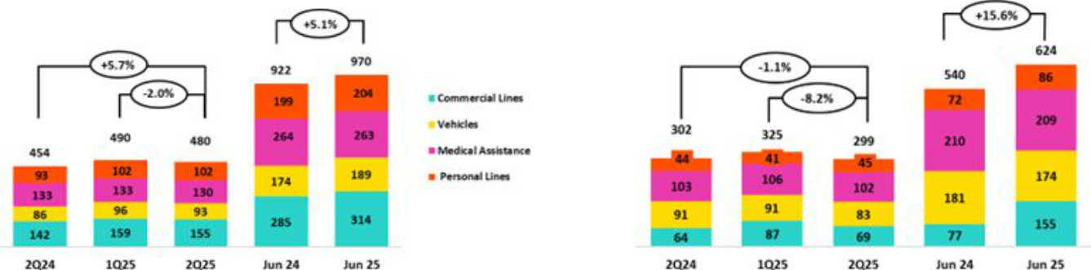

- As of 1Q25, the business previously known as “P & C” has been reclassifed into two separate categories: Personal Lines and Commercial Lines to beter refect the nature of insured risks. Historical fgures have been adjusted for comparability purposes.

QoQ, the Insurance Underwritng Result rose 0.3% on the tails of the following dynamics:

| Earnings Release 2Q / 2025 Analysis of 2Q25 Consolidated Results

- Insurance Underwritng and Medical Services Results

  - Insurance Service Income registered a slight decline of 2.0% with was driven mainly by (i) Commercial Lines and Medical Assistance, which dropped due to a reducton in premiums for renewals, which were impacted by seasonality, and (ii) Cars, where more Reserves for Current Risks were set aside, in line with growth in premium turnover.

  - Insurance Service Expenses dropped 8.2%, fueled by (i) Commercial Lines, which reported a reducton in claims in Fire and Third Party Liability risks, and (ii) Vehicles, via a drop in claims and release from onerous contracts.

  - The Reinsurance Result deteriorated, fueled primarily by a decrease in claims recovered from the reinsurance in Commercial Lines.

YoY, the Insurance Underwritng Result rose 13.2% due to the following dynamics:

- Insurance Service Income increased 5.7%, driven mainly by (i) Commercial Lines, which reported an increase in premiums alloted to the period due to new sales and an uptck in renewals, and (ii) Personal Lines, through the card protecton product, which registered growth in sales through the bancassurance channel, and (iii) Vehicles, via an uptck in sales through Yape.

- Insurance Service Expenses dropped 1.1%, fueled primarily by Vehicles via a drop in claims and releases from onerous contracts.
- The Reinsurance Result deteriorated, driven mainly by an increase in ceded premiums in Commercial Lines.

YTD, the Insurance Underwritng Result increased 14.0% through Cars and Personal Lines and was fueled primarily by (i) growth in Insurance Service Income, which rose on the back of growth in premiums, and (ii) a drop in Insurance Service Expense, which was associated with a reducton in claims.

Life Insurance

Insurance Service Income Insurance Service Expenses
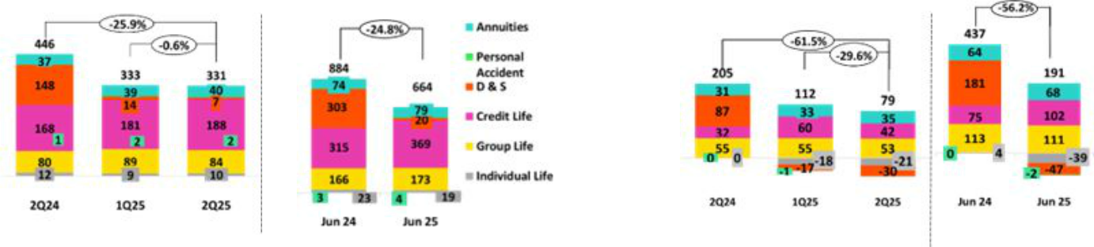

QoQ, the Insurance Underwritng Result rose 17.9% via the following dynamics:

- Insurance Service Income dropped 0.6%, driven primarily by (i) D&S, through a drop in regularizaton of premiums under SISCO VII, and (ii) Group Life, via a reducton in insurance for high-risk occupatons (SCTR), which was atributable to seasonality. The aforementoned was mitgated by the evoluton of Credit Life, which registered growth in premiums through Bancassurance and Alliances.

- Insurance Service Expenses dropped 29.6%, due primarily to (i) Credit Life, which reported a reducton in expenses for claims in the BCP Channel (Yape) and Mibanco, and (ii) D&S, which registered an increase in releases of reserves for claims under SISCO VII.

- The Reinsurance Result improved, fueled mainly by Group Life, which reported growth in claims recovered from reinsurers.

YoY, the Insurance Underwritng Result increased 12.7% due to the following dynamics:

- Insurance Service Income decreased 25.7%. This evoluton was driven mainly by the D&S line, given that the company was not awarded tranches of SISCO VIII in 2025 (vs partcipaton under SISCO VII in 2024). The impact of this decline was partally atenuated by Credit Life, which registered an increase in premiums alloted to the period via the Bancassurance and Alliances channels.

- Insurance Service Expenses dropped 61.5%, driven primarily by (i) D&S, in line with no contract award under SISCO VIII, and (ii) Individual Life, which reported a drop in claims. These dynamics were partally ofset by Credit Life, which reported an uptck in underwritng expenses in Alliances.

- The Reinsurance Result improved, mainly on the back of D&S, which registered a reducton in ceded premiums.

| Earnings Release 2Q / 2025 Analysis of 2Q25 Consolidated Results

07. Insurance Underwritng and Medical Services Results

YTD, the Insurance Underwritng Result increased 14.0%. This evoluton was fueled by Individual Life, which reported a drop in Insurance Service Expenses on the tails of a drop in claims, and by Credit Life, which reported growth in income, mainly in Alliances, through an uptck in premiums. The aforementoned was partally atenuated by D&S.

Medical Services Result

In March 2025, Credicorp completed its acquisiton of the remaining 50% stake in Empresas Banmédica under the joint venture with Pacífco Compañía de Seguros y Reaseguros S.A. ("Pacifco Seguros") set forth in December 2014. This transacton allowed Credicorp, through its subsidiaris Pacifco Seguros y Grupo Crédito S.A., to assume full ownership of Pacífco S.A. Entdad Prestadora de Salud ("Pacifco EPS"), which manages corporate healthcare for employees, medical services, and private medical insurance in Peru. This acquisiton strengthens Credicorp’s capacity to create a more sustainable and inclusive economy by improving access to health insurance and services and bolstering eforts to expand fnancial inclusion.

Consequently, as of March 2025, the EPS business’s result is primarily consolidated in Credicorp’s Insurance Underwritng Result line while the Medical Services business is reported in a new account named “Medical Services Result” It is important to note that in 1Q25, only the month of March was included.

YTD, the Medical Services Result contributed 166M soles.
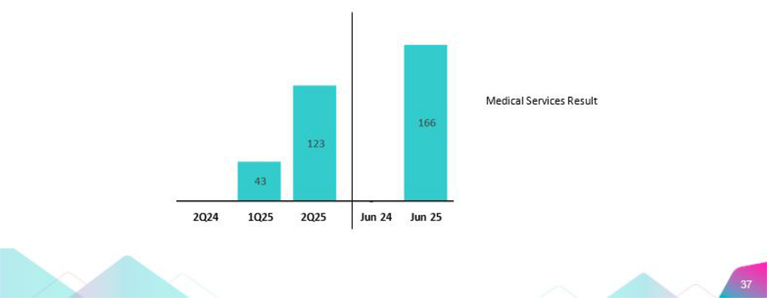

| Earnings Release 2Q / 2025 Analysis of 2Q25 Consolidated Results

08 Operatng Expenses

Operatng expenses rose 11.4% YTD, driven primarily by core businesses at BCP Stand-alone and innovaton portolio initatves at Credicorp. Core business expenses at BCP Stand-alone rose due to (i) higher expenses for Employee salaries and benefts, which was driven by growth in provisions for variable compensaton and an increase in head counts; and (ii) an increas e in administratve expenses, mainly at Pacifco, which refects the 100% consolidaton of operatons at Empresas Banmédica, and at BCP Stand-alone, which registered an uptck in cloud use due to growth in the transactons volume among increasingly digitalized clients. Expenses for innovaton portolio initatves at Credicorp rose 15.0%.

Total Operatng Expenses

Operatng expenses |  | Quarter |  | % change |  | Up to |  | % change
S/000 | 2Q24 | 1Q25 | 2Q25 | QoQ | YoY | Jun 24 | Jun 25 | Jun 25 / Jun 24
Salaries and employees benefts | 1,141,823 | 1,361,690 | 1,262,520 | -7.3% | 10.6% | 2,248,892 | 2,624,210 | 16.7%
Administratve and general expenses | 947,558 | 869,834 | 965,994 | 11.1% | 1.9% | 1,769,306 | 1,835,828 | 3.8%
Depreciaton and amortzaton | 172,204 | 203,766 | 212,662 | 4.4% | 23.5% | 347,350 | 416,428 | 19.9%
Associaton in partcipaton ⁽¹⁾ | 9,200 | 6,799 | 371 | -94.5% | -96.0% | 18,047 | 7,170 | -60.3%
Operatng expenses | 2,270,785 | 2,442,089 | 2,441,547 | 0.0% | 7.5% | 4,383,595 | 4,883,636 | 11.4%

The analysis of expenses that follows is based on YTD movements to eliminate the efects of seasonality between quarters.

Operatng Expenses rose 11.4% YTD due to:

- Growth in Salaries and Employee Benefts, which was driven mainly by (i) BCP Stand-alone, fueled primarily by growth in expenses for provisions for variable compensaton and secondarily by an uptck in hiring for new projects, and (ii) Mibanco and Pacifco, which reported growth in compensaton.

- An increase in Administratve and General Expenses, which was driven by Pacífco and BCP Stand-alone. At Pacifco, growth was mainly spurred by a change in the consolidaton perimeter following Credicorp’s acquisiton of the 50% share held by Empresas Banmédica in the joint venture with Pacifco Compañía de Seguros y Reaseguros S.A., efectve March 2025. At BCP Stand-alone, the volume of transactons through digital channels rose, which led to higher expenses for cloud use and other IT-related actvites.

Administratve and General Expenses

Administratve and General Expenses |  | Quarter |  |  | % change | Up to |  | % change
S/000 | 2Q24 | 1Q25 | 2Q25 | QoQ | YoY | 1H24 | 1H25 | 1H25 / 1H24
IT expenses and IT third-party services | 294,997 | 302,029 | 324,083 | 7.3% | 9.9% | 577,902 | 626,112 | 8.3%
Advertsing | 134,007 | 85,390 | 112,027 | 31.2% | -16.4% | 191,741 | 197,417 | 3.0%
Taxes and contributons | 94,448 | 83,347 | 86,321 | 3.6% | -8.6% | 187,335 | 169,668 | -9.4%
Audit Services, Consultng and professional fees | 75,845 | 71,072 | 92,086 | 29.6% | 21.4% | 134,837 | 163,158 | 21.0%
Transport and communicatons | 60,225 | 52,810 | 58,391 | 10.6% | -3.0% | 114,289 | 111,201 | -2.7%
Repair and maintenance | 34,598 | 31,635 | 37,886 | 19.8% | 9.5% | 67,236 | 69,521 | 3.4%
Agents' Fees | 29,375 | 26,102 | 28,067 | 7.5% | -4.5% | 56,763 | 54,169 | -4.6%
Services by third-party | 35,950 | 21,436 | 26,634 | 24.2% | -25.9% | 64,365 | 48,070 | -25.3%
Leases of low value and short-term | 31,002 | 33,177 | 34,937 | 5.3% | 12.7% | 61,467 | 68,114 | 10.8%
Miscellaneous supplies | 24,700 | 19,383 | 18,192 | -6.1% | -26.3% | 43,353 | 37,575 | -13.3%
Security and protecton | 16,544 | 16,946 | 16,940 | 0.0% | 2.4% | 32,447 | 33,886 | 4.4%
Subscriptons and quotes | 24,220 | 18,330 | 19,773 | 7.9% | -18.4% | 41,392 | 38,103 | -7.9%
Electricity and water | 13,614 | 10,275 | 12,513 | 21.8% | -8.1% | 25,350 | 22,788 | -10.1%
Electronic processing | 6,016 | 7,635 | 7,762 | 1.7% | 29.0% | 13,764 | 15,397 | 11.9%
Insurance | 7,370 | 11,719 | 16,441 | 40.3% | 123.1% | 12,542 | 28,160 | 124.5%
Cleaning | 5,629 | 6,558 | 7,014 | 7.0% | 24.6% | 11,373 | 13,572 | 19.3%
Others | 59,018 | 71,990 | 66,927 | -7.0% | 13.4% | 133,150 | 138,917 | 4.3%
Total | 947,558 | 869,834 | 965,994 | 11.1% | 1.9% | 1,769,306 | 1,835,828 | 3.8%

YTD, administratve expenses rose 3.8%. Growth in operatng expenses was driven mainly by Pacifco and BCP Stand-alone, which registered increases in expenses for IT and system outsourcing as well as an uptck in expenses for Audit Services, Consultng and Professional Fees, which rose on the back of digital transformaton initatves.

| Earnings Release 2Q / 2025 Analysis of 2Q25 Consolidated Results

08. Operatng Expenses

Operatng Expenses for Core Businesses and the Innovaton Portolio

Operatng Expenses ⁽¹⁾ |  | Quarter |  |  | % change | Up to |  | % change
S/ 000 | 2Q24 | 1Q25 | 2Q25 | QoQ | YoY | 1H24 | 1H25 | 1H25 / 1H24
Operatng Expenses Ex Innovaton | 1,986,433 | 2,138,640 | 2,123,767 | -0.7% | 6.9% | 3,843,400 | 4,262,407 | 10.9%
Innovaton Portolio ⁽²⁾ | 284,352 | 303,449 | 317,780 | 4.7% | 11.8% | 540,195 | 621,229 | 15.0%
Total Operatng Expenses | 2,270,785 | 2,442,089 | 2,441,547 | 0.0% | 7.5% | 4,383,595 | 4,883,637 | 11.4%

- Management fgures.
- Includes innovaton portolio initatves in subsidiaries and Krealo.

YoY, the 11.4% increase in operatng expenses was primarily driven by our core businesses, led by: (i) BCP Stand-alone, due to an increase in provisions for variable compensaton, and (ii) Pacífco, which reported growth in Employee Salaries and benefts on the back of the consolidaton of the operatons of Empresas Banmédica, which began in March 2025.

Innovaton portolio expenses represented 12.7% of total expenses, rising 15.0% YTD. In the frst half of 2025, Yape, Tenpo and Culqi accounted for 83% of the total expenses for innovaton portolio initatves.

Growth in expenses for core businesses at BCP Stand-alone was fueled by:

- Core business expenses excluding IT

  - Growth in expenses for Salaries and Employee Benefts due to (i) provisions for variable compensaton, in line with higher results, and (ii) an increase in headcount.

- Technology expenses (IT)
  - More personnel with specialized digital capacites were hired with above-average salaries, in line with strategic project executon.

  - Growth in expenses for the use of data processing servers, which refects growth in the volume of transactons through digital channels as clients become increasingly digitalized. Total monetary transactons through digital channels rose 58.2% and 68.2%, respectvely.


| Earnings Release 2Q / 2025 Analysis of 2Q25 Consolidated Results

09 Operatng Efciency

YTD, the efciency rato deteriorated 143 bps as growth in operatng expenses outpaced the expansion reported for operatng income. This evoluton was in line with an increase in expenses for the core business at BCP Stand-alone and for innovaton initatves at the Credicorp level.

Efciency rato ⁽¹⁾ reported by subsidiary

Subsidiary |  | Quarter |  | % change |  |  | As of | % change
 | 2Q24 | 1Q25 | 2Q25 | QoQ | YoY | 1H24 | 1H25 | 1H25 / 1H24
BCP Stand-alone | 37.1% | 37.7% | 38.3% | 70 bps | 130 bps | 36.1% | 38.0% | 190 bps
BCP Bolivia | 58.2% | 69.6% | 67.3% | -230 bps | 910 bps | 58.1% | 68.8% | 1070 bps
Mibanco Peru | 51.0% | 52.9% | 52.0% | -90 bps | 100 bps | 52.1% | 52.4% | 30 bps
Mibanco Colombia | 78.9% | 70.6% | 65.5% | -520 bps | -1340 bps | 82.1% | 67.9% | -1420 bps
Pacífco | 27.5% | 31.5% | 37.5% | 600 bps | 1000 bps | 27.6% | 44.6% | 1700 bps
Prima AFP | 52.1% | 54.4% | 51.4% | -310 bps | -80 bps | 51.3% | 52.9% | 160 bps
Credicorp | 44.2% | 45.7% | 44.2% | -160 bps | 0 bps | 43.5% | 44.9% | 143 bps

- Operatng expenses / Operatng income (under IFRS 1). Operatng expenses = Salaries and employee benefts + Administratve expenses + Depreciaton and amortzaton + Associaton in partcipaton + Acquisiton cost. Operatng income = Net interest, similar income, and expenses + Fee income + Net gain on foreign exchange transactons + Net gain from associates + Net gain on derivatves held for trading + Net gain from exchange diferences + Insurance Underwritng Results + Results for Medical Services

The analysis the be based on YTD movements to eliminate the efect of seasonality between quarters.

The efciency rato deteriorated 143 bps over the period. This evoluton was driven mainly by an uptck in operatng expenses through (i) core business at BCP, which registered growth in Employee Salaries and Benefts and in Administratve Expenses, and (ii) initatves in the innovaton portolio at Credicorp. The increase in operatng expenses was accompanied by growth in ordinary income.

It is important to note that as of 1Q25, a change was implemented in the calculaton of the efciency rato. Specifcally, within Operatng Income, expenses for credit card fdelity programs are neted in the Fee Income line instead of the General and Administratve Expenses line, as was the case prior to 1Q25.

| Earnings Release 2Q / 2025 Analysis of 2Q25 Consolidated Results

10 Regulatory Capital


The Regulatory Capital Rato at Credicorp was 135% higher than the regulatory minimum.

IFRS CET1 at BCP Stand-alone rose 51 bps YoY to stand at 12.56%, which is above our appette of 11%. Growth was driven by an uptck in Retained Earnings, which was atributable to business growth and partally ofset by an increase in operatng RWAS, which was fueled by growth in the bank’s margin.

Mibanco’s IFRS CET1 stood at 16.73%, which was aligned with our internal appette of 15%. This evoluton was driven by a drop in operatng RWAs, which was ofset by a decrease in Retained earnings, which fell on the back of dividend payments.

10.1 Regulatory Capital at Credicorp Capital Coverage Ratos
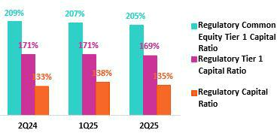

Capital Analysis of the Financial Group

At the end of 2Q25, Credicorp’s Regulatory Capital Rato stood 135% above the regulatory minimum. This atests to the Group’s fnancial solidity and stability. The rato dropped 351 bps QoQ, fueled primarily by a decrease in Discretonary Reserves due to dividend payments. This decline was partally ofset by an increase in Retained Earnings, which was driven by business growth and by a reducton in regulatory capital requirements. YoY, the rato rose 147 bps, impacted primarily by growth in Discretonary Reserves for proft sharing in 2024; an uptck in Subordinated Debt due to a bond issuance; and fnally, a rise in Retained Earnings, which was driven by the same dynamics that drove the QoQ result.

The Regulatory Tier 1 Rato stood at 169% (-140bps QoQ, -147 bps YoY), while the CET1 rato was situated at 205% (-251bps QoQ, +- 430 bps YoY), both above the regulatory minimum. Growth in both ratos QoQ was driven by the same dynamics that fueled the Qincrease in the Regulatory Capital Rato, with the excepton of Subordinated Debt, which had no impact on either the Regulatory Tier 1 or CET1 ratos.

10.2 Analysis of Capital at BCP Stand-alone | The IFRS CET1 rato at BCP Stand-alone rose 94 bps QoQ to stand at 12.56% in
 | 2Q25, which is above our internal appette of 11%. The increase this quarter
 | was driven by a growth in Retained Earnings This evoluton was driven by
 | business expansion and was partally ofset by an uptck in RWAS, which rose
 | on the back of an increase in the balance for the retail portolio. YoY, the rato
 | increased 51 bps, spurred by higher Retained earnings and ofset by an
 | increase in operatng RWAs, which rose due to growth in the bank’s margin.
 | Finally, under the parameters of current regulaton, the local CET1 rato stood
 | at 12.24% (versus 11.34% in 1Q25) driven by the same dynamics seen in the
 | evoluton of IFRS CET1. This compares favorably with the minimum
 | requirement of 7.75% at the end of June 2025. The Regulatory Global Capital
 | rato stood at 17.33% above the regulatory minimum of 14.55% but down 47
 | bps QoQ, driven by the same dynamics that drove the evoluton of IFRS CET1.
 | YoY, this rato rose 109 bps afer Subordinated Debt registered growth
 | following an issuance.
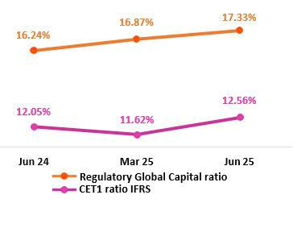

| Earnings Release 2Q / 2025 Analysis of 2Q25 Consolidated Results

10.Regulatory Capital

10.3 Capital Analysis at Mibanco | At the end of 2Q25, the IFRS CET 1 rato at Mibanco stood at 16.73% (+84 bps
 | QoQ), which was above our internal appette of 15%. QoQ, growth was
 | atributable to an uptck in Retained Earnings, which refected business
 | growth. The drop in operatng RWAs also drove a QoQ rise in the IFRS CET 1.
 | YoY, this rato remained stable, which was atributable to a drop in operatng
 | RWA due to QoQ dynamics, which was ofset by a decrease in Retained
 | Earnings following a dividend payment.
 | Under the parameters of current regulaton, the local CET 1 rato stood at
 | 16.48% (versus 15.48% in 1Q25), driven by the same dynamics that fueled the
 | evoluton of IFRS CET1. The Regulatory Global Capital rato situated at 19.61%
 | (down 108 bps QoQ), remaining comfortably above the regulatory minimum
 | of 14.55%. The QoQ decline was fueled by the same factors seen for IFRS CET
 | 1. YoY, the Regulatory Global Capital rato increased 66 bps, spurred mainly by
 | a reducton in the balance of RWAs and to a lesser extent, by the issuance of
 | Subordinated Debt and growth in the Reserves balance, which ofset the
 | decline in Retained Earnings generated by a dividend payment.
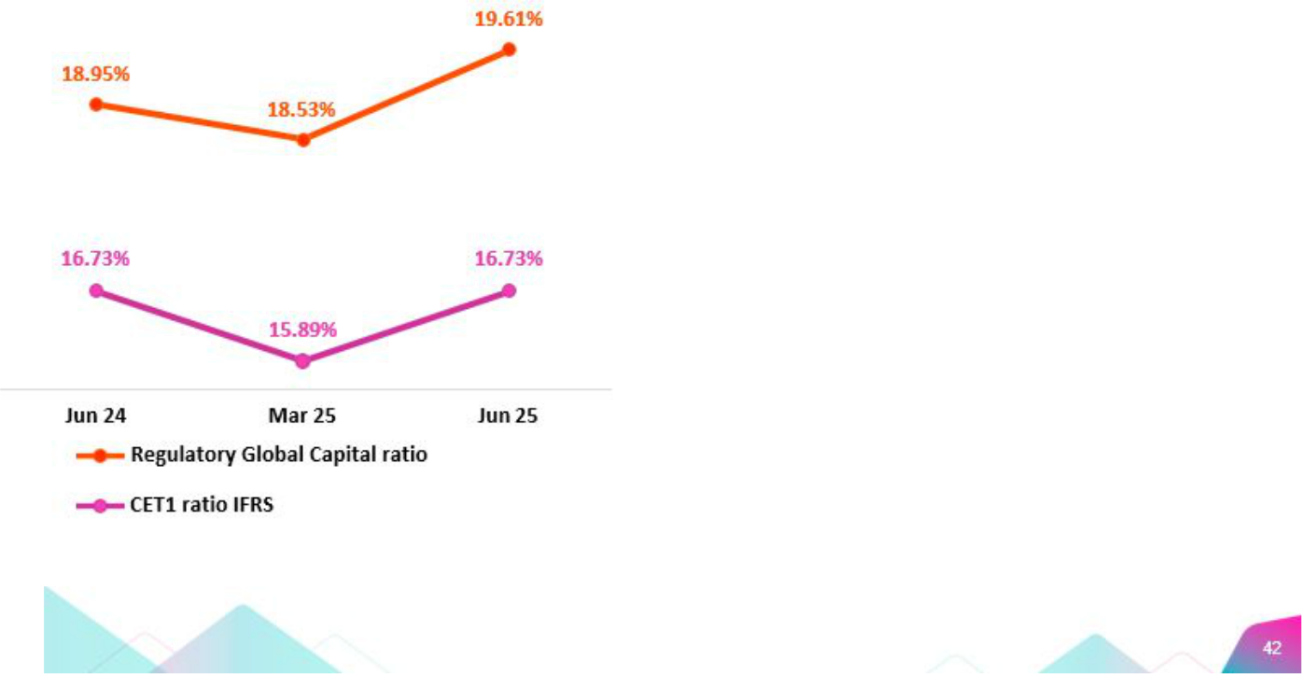

| Earnings Release 2Q / 2025 Analysis of 2Q25 Consolidated Results

11 Economic Outlook


In 2Q25, GDP grew around 3.0% YoY, supported by high terms of trade, a contnued recovery in formal employment, and infaton comfortably within the BCRP’s target range. The slowdown compared to 1Q25 was mainly due to weaker performance in primary sectors (mining, fshing, and agriculture).}

Infaton rose slightly, closing the quarter at 1.7% YoY (compared to 1.3% YoY in1Q25), marking seven consecutve months below the midpoint of the target range (1%–3%). Meanwhile, in its July meetng, the BCRP decided to keep the reference interest rate unchanged at 4.50%.

According to the BCRP, the exchange rate closed 2Q25 at USDPEN 3.54. Thus, the sol appreciated 3.5% compared to the end of 1Q25 and 6.0% compared to the end of 4Q24 (USDPEN 3.77).

Peru: Economic Forecast

 | Peru | 2019 | 2020 | 2021 | 2022 | 2023 | 2024 | 2025 (4)
 | GDP (US$ Millions) | 236,517 | 209,723 | 229,791 | 248,403 | 272,221 | 295,160 | 319,637
Real GDP (% change) |  | 2.2 | -10.9 | 13.4 | 2.8 | -0.4 | 3.3 | 3.2
GDP per capita (US$) |  | 7,361 | 6,428 | 6,956 | 7,438 | 8,072 | 8,671 | 9,305
Domestc demand (% change) |  | 2.9 | -9.3 | 13.9 | 2.4 | -1.1 | 4.0 | 4.8
Gross fxed investment (as % GDP) |  | 22 | 21 | 25 | 25 | 23 | 23 | 23
Financial system loan without Reactva (% change) (1) |  | 6.4 | -4.3 | 12.6 | 9.7 | 2.8 | 1.3 | 7.0
Infaton, end of period (2) |  | 1.9 | 2.0 | 6.4 | 8.5 | 3.2 | 2.0 | 2.0
Reference Rate, end of period |  | 2.25 | 0.25 | 2.50 | 7.50 | 6.75 | 5.00 | 4.25
Exchange rate, end of period |  | 3.31 | 3.62 | 3.99 | 3.81 | 3.71 | 3.76 | 3.65
Exchange rate, (% change) (3) |  | 1.8% | -9.3% | -10.3% | 4.5% | 2.7% | -1.3% | 2.8%
Fiscal balance (% GDP) |  | -1.6 | -8.7 | -2.5 | -1.7 | -2.7 | -3.5 | -2.8
Public Debt (as % GDP) |  | 26 | 34 | 35 | 33 | 32 | 32 | 32
Trade balance (US$ Millions) |  | 6,893 | 8,098 | 15,115 | 10,331 | 17,150 | 24,081 | 28,500
(As % GDP) |  | 2.9% | 3.9% | 6.6% | 4.2% | 6.3% | 8.2% | 8.9%
Exports |  | 47,995 | 42,822 | 63,114 | 66,339 | 67,108 | 76,172 | 86,000
Imports |  | 41,102 | 34,724 | 47,999 | 56,009 | 49,958 | 52,091 | 57,500
Current account balance (As % GDP) |  | -0.7% | 0.8% | -2.2% | -4.0% | 0.3% | 2.2% | 1.8%
Net internatonal reserves (US$ Millions) |  | 68,316 | 74,707 | 78,495 | 71,883 | 71,033 | 78,987 | 86,000
(As % GDP) |  | 28.9% | 35.6% | 34.2% | 28.9% | 26.1% | 26.8% | 26.9%
(As months of imports) |  | 20 | 26 | 20 | 15 | 17 | 18 | 18

Sources: INEI, BCRP y SBS.

- Financial System, Current Exchange Rate, End of Period

- Infaton target: 1% - 3%

- Negatve % change indicates depreciaton.

- Grey area indicate estmates by BCP Economic Research as of August 2025

| Earnings Release 2Q / 2025 Analysis of 2Q25 Consolidated Results

11. Economic Outlook

Main Macroeconomic Variables

Gross Domestc Product

(Annual Real Variatons, % YoY)

In 2Q25, GDP grew by around 3% year-on-year. Non- primary sectors and domestc demand showed even greater dynamism, supported by high terms of trade, a contnued recovery in formal employment, and infaton comfortably within the target range of the Central Bank (BCRP). Thus, the slowdown compared to 1Q25 was mainly due to weaker performance in primary sectors (mining, fshing, and agriculture).
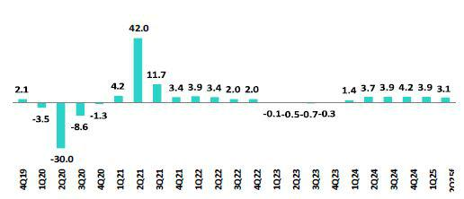

It is important to highlight the double-digit growth in key indicators for private investment, such as heavy vehicle sales, capital goods imports, and terms of trade (at a 75-year high). Meanwhile, business investment expectatons at 3 and 12 months reached their highest level in 12 years (or since 2013, when data frst became available), according to the BCRP survey.

Annual Infaton and Central Bank Reference Rate

(%)

Infaton, measured using the Consumer Price Index of Metropolitan Lima, slightly accelerated from 1.3% at the end of 1Q25 to 1.7% at the end of 2Q25, remaining below 2.0% (the midpoint of the BCRP’s target range of 1% – 3%) for the seventh consecutve month. This represents one of the lowest infaton rates among emerging and developed economies. Meanwhile, core infaton (excluding food and energy) eased from 1.9% to 1.7% over the same period, reaching its lowest level since February 2021 and marking its fourth consecutve month below 2.0%.
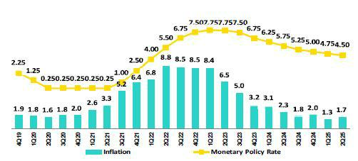

At its July 2025 monetary policy meetng, the BCRP decided to keep its reference rate at 4.50%. The previous cut occurred in April 2025, when the rate was lowered by 25 basis points. Since September 2023, when the rate-cutng cycle began, the reference rate has been reduced by a total of 325 basis points.

Fiscal Balance and Current Account Balance

(% of GDP, Quarter)

The annualized fscal defcit as of June 2025 stood at 2.6% of GDP, below the March 2025 level of 3.3% of GDP. In 2Q25, fscal revenues increased 16.1% YoY, driven by higher income tax collectons—mainly from regularizaton—and general sales tax, in a context of cyclical economic recovery and historically high terms of trade. Meanwhile, non-fnancial public spending grew 6.2% YoY, due to a 6.0% YoY increase in current expenditures (wages: +8.2% YoY) and a 6.5% YoY rise in public investment.
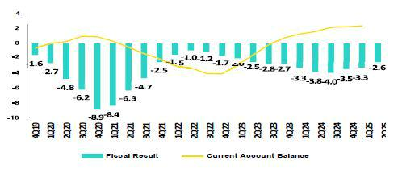

| Earnings Release 2Q / 2025 Analysis of 2Q25 Consolidated Results

11. Economic Outlook

In 2Q25, there were no changes from credit ratng agencies. The three main ratng agencies assign diferent assessments to Peru’s sovereign debt. Moody’s rates it at Baa1 (three notches above investment grade), Fitch at BBB (two notches above investment grade), and S&P at BBB- (the lowest investment grade level). All three maintain a stable outlook for the country’s credit ratng.

Regarding external accounts, the current account surplus closed 1Q25 at 2.3% of GDP (accumulated over the last four quarters), a slight increase from the 2.2% of GDP surplus at the end of 2024. This marks six consecutve quarters of surplus and represents the best result since Q2 2007.

The 12-month accumulated trade balance surplus as of May 2025 stood at US$ 26.2 billion, similar to the value recorded in March 2025. Imports grew 8.5% YoY to US$ 54.8 billion, driven by a 12.6% increase in capital goods and a 12.0% rise in consumer goods. Exports grew 18.2% YoY to US$ 81.0 billion, reaching a historic high. Export growth was led by gold exports (+41% YoY) amid favorable prices, and to a lesser extent by non-traditonal agricultural exports (+29% YoY).

In May 2025, terms of trade rose 17.3% YoY, reaching a new historic high, driven by a 10.2% YoY increase in export prices (mainly due to higher gold and copper prices). Import prices, on the other hand, fell 6.1% YoY due to lower prices for oil and industrial inputs.

Exchange Rate
(PEN per USD)
According to the BCRP, the exchange rate closed 2Q25 at USDPEN 3.54. Thus,

the Peruvian sol appreciated 3.5% compared to the end of 1Q25 and by 6.0%
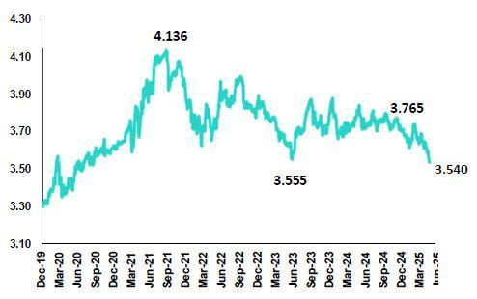
compared to the end of 4Q24 (USDPEN 3.77). The global dollar index

depreciated around 7% in 2Q25 compared to the previous quarter and 11%

compared to 4Q24, amid ongoing uncertainty caused by Trump’s policies. As a

result, regional currencies appreciated (Mexican peso 8.4%, Brazilian real

4.8%, Chilean peso 2.0%, and

Colombian peso 2.3%).

During 2Q25, the BCRP intervened in the spot foreign exchange market only once, selling US$ 1 million on May 13 at an exchange rate of USDPEN 3.689. This was the only spot sale so far this year.

Net Internatonal Reserves (NIR) closed 2Q25 at US$ 85.2 billion, above the US$ 81.0 billion at the end of 1Q25 and the US$ 79.0 billion at the end of 4Q24. Meanwhile, the BCRP’s foreign exchange positon closed 2Q25 at US$ 56.0 billion, an increase of US$ 991 million compared to the end of 1Q25 and US$ 2.4 billion compared to the end of 4Q24.

| Earnings Release 2Q / 2025 Analysis of 2Q25 Consolidated Results

Safe Harbor for Forward-Looking Statements

This material includes “forward-looking statements” within the meaning of Secton 27A of the U.S. Securites Act of 1933 and Secton 21E of the U.S. Securites Exchange Act of 1934. All statements other than statements of historical fact are forward-looking and may contain informaton about fnancial results, economic conditons, trends and known uncertaintes. Forward-looking statements are not assurances of future performance. Instead, they are based only on our management’s current views, beliefs, expectatons and assumptons regarding the future of our business, future plans and strategies, projectons, antcipated events and trends, the economy and other future conditons.

Many forward-looking statements can be identfed by words such as: “antcipate”, “intend”, “plan”, “goal”, “seek”, “believe”, “project”, “estmate”, “expect”, “strategy”, “future”, “likely”, “would”, “may”, “should”, “will”, “see” and similar references to future periods. Examples of forward-looking statements include, among others, statements or estmates we make regarding guidance relatng to losses in our credit portolio, efciency rato, provisions and non-performing loans, current or future market risk and future market conditons, expected macroeconomic events and conditons, our belief that we have sufcient capital and liquidity to fund our business operatons, expectatons of the efect on our fnancial conditon of claims, legal actons, environmental costs, contngent liabilites and governmental and regulatory investgatons and proceedings, strategy for customer retenton, growth, governmental programs and regulatory initatves, credit administraton, product development, market positon, fnancial results and reserves and strategy for risk management.

We cauton readers that forward-looking statements involve known and unknown risks and uncertaintes that could cause actual results, performance, or events to difer materially from those that we expect or that are expressed or implied in the forward-looking statements, depending on the outcome of certain factors, including, without limitaton, adverse changes in:

- The occurrence of natural disasters or politcal or social instability in Peru;
- The adequacy of the dividends that our subsidiaries are able to pay to us, which may afect our ability to pay dividends to shareholders and corporate expenses;
- Performance of, and volatlity in, fnancial markets, including Latn-American and other markets;
- The frequency, severity and types of insured loss events;
- Fluctuatons in interest rate levels;
- Foreign currency exchange rates, including the Sol/US Dollar exchange rate;
- Deterioraton in the quality of our loan portolio;
- Increasing levels of competton in Peru and other markets in which we operate;
- Developments and changes in laws and regulatons afectng the fnancial sector and adopton of new internatonal guidelines;
- Changes in the policies of central banks and/or foreign governments;
- Efectveness of our risk management policies and of our operatonal and security systems;
- Losses associated with counterparty exposures;

- The scope of the coronavirus (“COVID-19”) outbreak, actons taken to contain the COVID-19 and related economic efects from such actons and our ability to maintain adequate stafng; and

- Changes in Bermuda laws and regulatons applicable to so-called non-resident enttes.

See “Item 3. Key Informaton—3. D Risk Factors” and “Item 5. Operatng and Financial Review and Prospects” in our most recent Annual Report on Form 20-F fled with the U.S. Securites and Exchange Commission for additonal informaton and other such factors. You are cautoned not to place undue reliance on these forward-looking statements, which speak only as of the date hereof and are based only on informaton currently available to us. Therefore, you should not rely on any of these forward-looking statements. We undertake no obligaton to publicly update or revise these or any other forward-looking statements that may be made to refect events or circumstances afer the date hereof, whether as a result of changes in our business strategy or new informaton, to refect the occurrence of unantcipated events or otherwise.

| Earnings Release 2Q / 2025 Analysis of 2Q25 Consolidated Results

12 Appendix

12.1. | Evoluton of Loans in Average Daily Balances | 46
12.2. | Loan Portolio Quality | 46
12.3. | Net Interest Income (NII) | 51
12.4. | Net Interest Margin (NIM) and Risk Adjusted NIM | 50
12.5. | Physical Point of Contact | 46
12.6. | Regulatory Capital | 51
12.7. | Financial Statements and Ratos by Business | 55
12.7.1. Credicorp Consolidated |  | 55
12.7.2. Credicorp Stand-alone |  | 57
12.7.3. BCP Consolidated |  | 58
12.7.4. BCP Stand-alone |  | 60
12.7.5. BCP Bolivia |  | 62
12.7.6. Mibanco |  | 63
12.7.7. Prima AFP |  | 64
12.7.8. Grupo Pacifco |  | 65
12.7.9. Investment Management and Advisory |  | 67
12.8. | Table of Calculatons | 68
12.9. | Glossary of terms | 69

| Earnings Release 2Q / 2025 Analysis of 2Q25 Consolidated Results

12. Appendix

12.1. Evoluton of Loans in Average Daily Balances

Total Loans (in Average Daily Balances) ⁽¹⁾⁽²⁾

Total Loans |  | As of |  | Volume change |  |  | % change |  | % Part. in total loans
(S/ millions) | Jun 24 | Mar 25 | Jun 25 | QoQ | YoY | QoQ | YoY | Jun 24 | Mar 25 | Jun 25
BCP Stand-alone | 117,591 | 118,771 | 119,142 | 371 | 1,551 | 0.3% | 1.3% | 81.8% | 82.6% | 82.4%
Wholesale Banking | 53,814 | 54,548 | 54,096 | -452 | 283 | -0.8% | 0.5% | 37.4% | 37.9% | 37.4%
Corporate | 32,393 | 32,977 | 32,206 |  | -188 | -2.3% | -0.6% | 22.5% | 22.9% | 22.3%
 |  |  |  | -771
Middle - Market | 21,420 | 21,571 | 21,891 | 320 | 470 | 1.5% | 2.2% | 14.9% | 15.0% | 15.1%
Retail Banking | 63,778 | 64,223 | 65,046 | 823 | 1,268 | 1.3% | 2.0% | 44.4% | 44.6% | 45.0%
SME - Business | 7,528 | 7,590 | 7,521 | -68 | -7 | -0.9% | -0.1% | 5.2% | 5.3% | 5.2%
SME - Pyme | 16,282 | 15,940 | 15,922 | -18 | -360 | -0.1% | -2.2% | 11.3% | 11.1% | 11.0%
Mortgage | 21,257 | 21,870 | 22,439 |  |  | 2.6% | 5.6% | 14.8% | 15.2% | 15.5%
 |  |  |  | 569 | 1,182
Consumer | 12,724 | 12,961 | 13,207 | 246 | 483 | 1.9% | 3.8% | 8.9% | 9.0% | 9.1%
Credit Card | 5,987 | 5,862 | 5,957 | 94 | -30 | 1.6% | -0.5% | 4.2% | 4.1% | 4.1%
Mibanco | 12,815 | 12,147 | 12,514 | 366 | -301 | 3.0% | -2.4% | 8.9% | 8.4% | 8.7%
Mibanco Colombia | 1,746 | 1,832 | 1,889 | 57 | 143 | 3.1% | 8.2% | 1.2% | 1.3% | 1.3%
Bolivia | 9,645 | 9,469 | 9,537 | 69 | -108 | 0.7% | -1.1% | 6.7% | 6.6% | 6.6%
ASB Bank Corp. | 1,909 | 1,644 | 1,560 | -84 | -349 | -5.1% | -18.3% | 1.3% | 1.1% | 1.1%
BAP's total loans | 143,705 | 143,863 | 144,642 | 779 | 936 | 0.5% | 0.7% | 100.0% | 100.0% | 100.0%

For consolidaton purposes, loans generated in FC are converted to LC.

- Includes Special accounts, and other banking.

- Portolio Management Figures. Non-audited fgures.

12.2. Loan Portolio Quality

Portolio Quality Ratos by Segment
Wholesale Banking
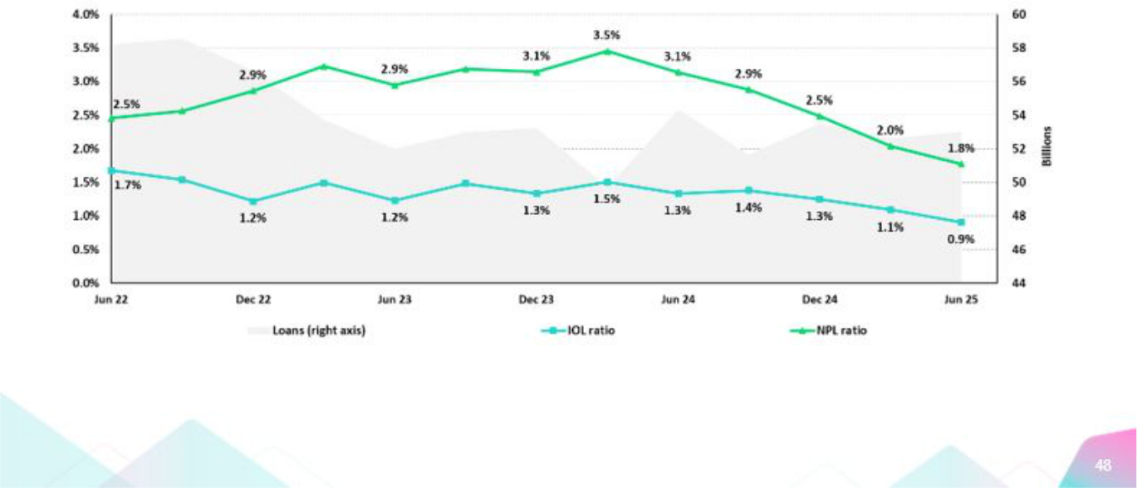

| Earnings Release 2Q / 2025 Analysis of 2Q25 Consolidated Results

12. Appendix

SME-Business
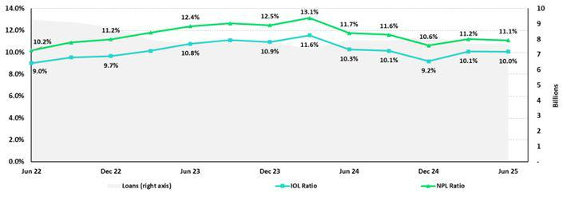

SME-Pyme
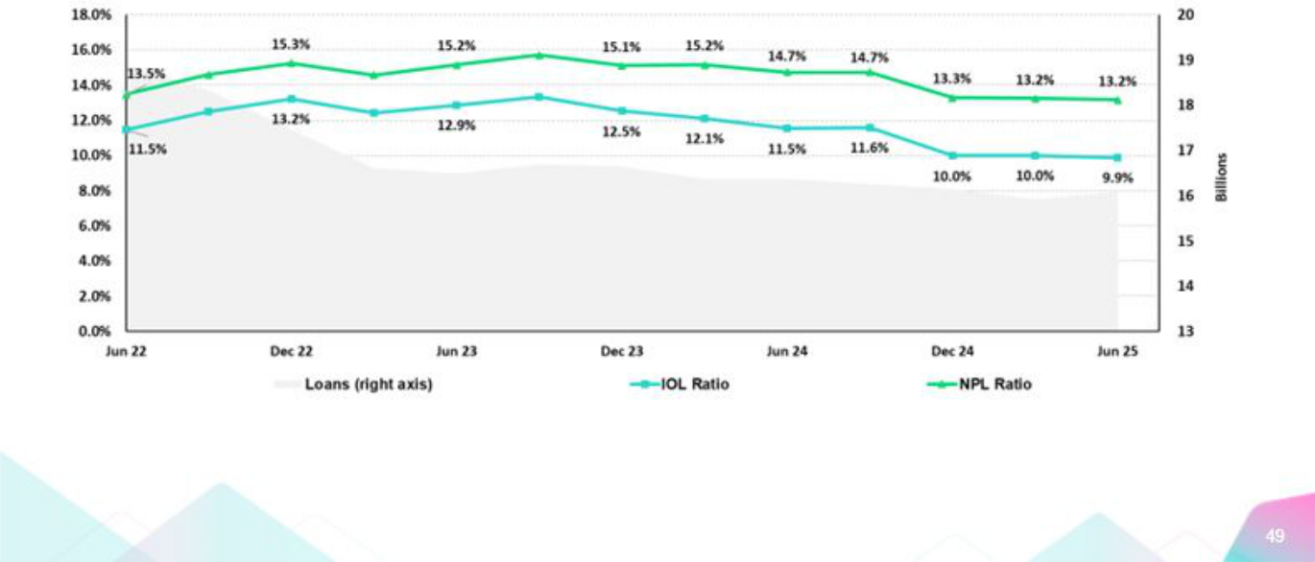

| Earnings Release 2Q / 2025 Analysis of 2Q25 Consolidated Results

12. Appendix

Mortgage
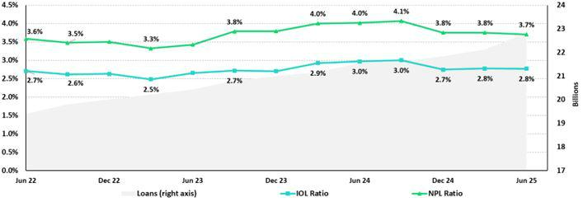

Consumer
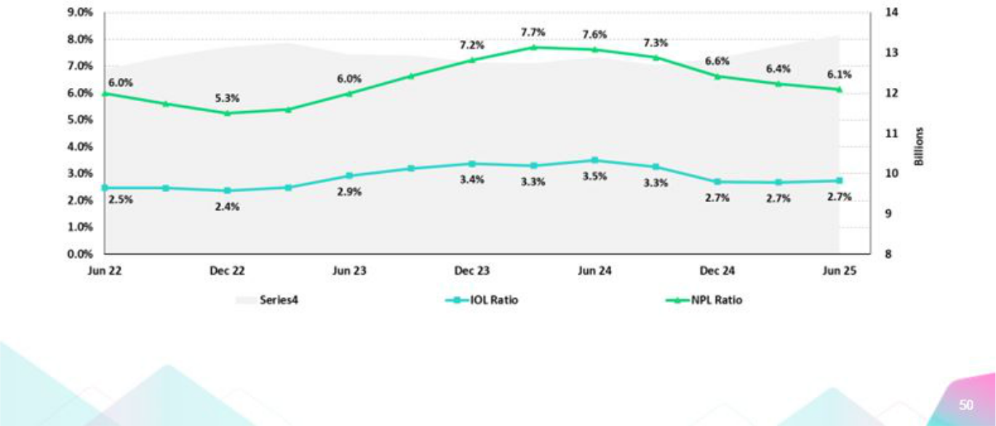

| Earnings Release 2Q / 2025 Analysis of 2Q25 Consolidated Results

12. Appendix

Credit Cards
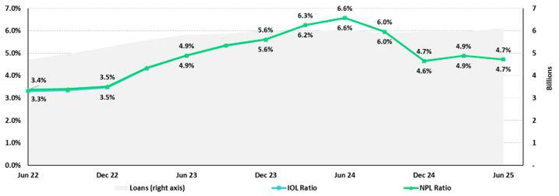

Mibanco
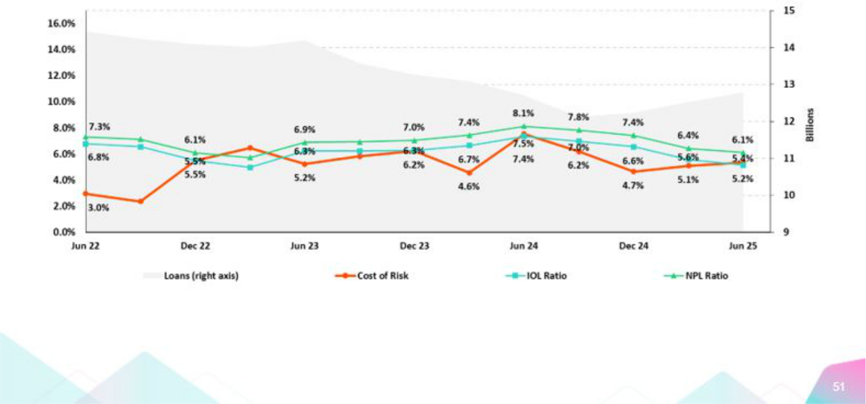

| Earnings Release 2Q / 2025 Analysis of 2Q25 Consolidated Results

12. Appendix

BCP Bolivia
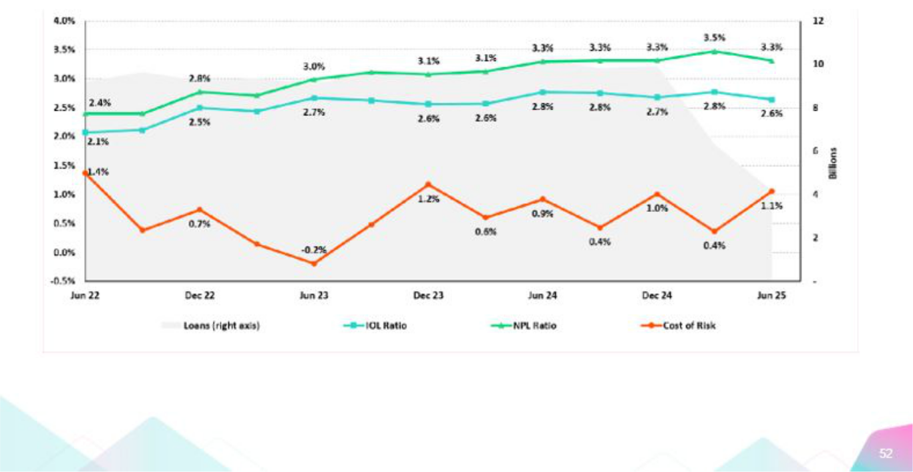

| Earnings Release 2Q / 2025 Analysis of 2Q25 Consolidated Results

12. Appendix

12.3. Net Interest Income (NII)

NII Summary

Net interest income |  | Quarter |  |  | % change |  | Up to | % Change
S/000 | 2Q24 | 1Q25 | 2Q25 | QoQ | YoY | Jun 24 | Jun 25 | Jun 25 / Jun 24
Interest income | 4,935,238 | 4,894,790 | 4,922,292 | 0.6% | -0.3% | 9,861,164 | 9,817,082 | -0.4%
Interest on loans | 3,921,374 | 3,847,640 | 3,840,725 | -0.2% | -2.1% | 7,790,166 | 7,688,365 | -1.3%
Dividends on investments | 10,136 | 25,109 | 22,923 | -8.7% | 126.2% | 20,997 | 48,033 | 128.8%
Interest on deposits with banks | 319,829 | 344,622 | 342,323 | -0.7% | 7.0% | 654,288 | 686,945 | 5.0%
Interest on securites | 657,897 | 657,872 | 647,186 | -1.6% | -1.6% | 1,340,972 | 1,305,058 | -2.7%
Other interest income | 26,002 | 19,547 | 69,135 | 253.7% | 165.9% | 54,741 | 88,681 | 62.0%
Interest expense | 1,466,774 | 1,322,778 | 1,306,921 | -1.2% | -10.9% | 2,966,577 | 2,629,699 | -11.4%
Interest expense (excluding Net Insurance Financial Expenses) | 1,342,088 | 1,187,156 | 1,167,866 | -1.6% | -13.0% | 2,719,887 | 2,355,023 | -13.4%
Interest on deposits | 738,010 | 619,613 | 541,014 | -12.7% | -26.7% | 1,517,536 | 1,160,627 | -23.5%
Interest on borrowed funds | 267,285 | 266,202 | 265,710 | -0.2% | -0.6% | 532,169 | 531,913 | 0.0%
Interest on bonds and subordinated notes | 200,739 | 168,024 | 193,125 | 14.9% | -3.8% | 397,369 | 361,150 | -9.1%
Other interest expense | 136,054 | 133,317 | 168,017 | 26.0% | 23.5% | 272,813 | 301,333 | 10.5%
Net Insurance Financial Expenses | 124,686 | 135,622 | 139,055 | 2.5% | 11.5% | 246,690 | 274,676 | 11.3%
Net interest, similar income and expenses | 3,468,464 | 3,572,012 | 3,615,371 | 1.2% | 4.2% | 6,894,587 | 7,187,383 | 4.2%
Provision for credit losses on loan portolio, net of recoveries | 1,093,371 | 581,893 | 575,159 | -1.2% | -47.4% | 1,908,070 | 1,157,052 | -39.4%
Net interest, similar income and expenses, afer provision for credit losses on loan | 2,375,093 | 2,990,119 | 3,040,212 | 1.7% | 28.0% | 4,986,517 | 6,030,331 | 20.9%
portolio
Average interest earning assets | 227,161,179 | 238,435,117 | 233,761,957 | -2.0% | 2.9% | 226,444,444 | 236,038,086 | 4.2%
Net interest margin (1) | 6.3% | 6.2% | 6.4% | 20 bps | 9 bps | 6.3% | 6.3% | 1 bps
Risk-adjusted Net interest margin (1) | 4.4% | 5.2% | 5.4% | 20 bps | 104 bps | 4.6% | 5.3% | 72 bps
Net provisions for loan losses / Net interest income (1) | 31.5% | 16.3% | 15.9% | -38 bps | -1561 bps | 27.7% | 16.1% | -1157 bps

(1) Annualized. For further detail on the NIM calculaton due to IFRS17, please refer to Annex 12.8.

12.4. Net Interest Margin (NIM) and Risk-Adjusted NIM by Subsidiary

NIM Breakdown | BCP Stand-alone | Mibanco | BCP Bolivia | Credicorp
2Q24 | 6.08% | 13.61% | 3.03% | 6.33%
1Q25 | 5.80% | 13.94% | 2.85% | 6.22%
2Q25 | 6.00% | 14.38% | 2.57% | 6.42%

NIM: Annualized Net interest income (excluding Net Insurance Financial Expenses) / Average period end and period beginning interest-earning assets.

Risk-Adjusted NIM | BCP | Mibanco | BCP | Credicorp
Breakdown | Stand-alone | Mibanco | Bolivia | Credicorp
2Q24 | 4.30% | 7.67% | 2.25% | 4.40%
1Q25 | 4.98% | 10.14% | 2.62% | 5.24%
2Q25 | 5.22% | 10.34% | 1.89% | 5.44%

Risk-Adjusted NIM: (Annualized Net interest income (excluding Net Insurance Financial Expenses) - annualized provisions) / Average period end and period beginning interest-earning assets.

| Earnings Release 2Q / 2025 Analysis of 2Q25 Consolidated Results

12.5. Physical Point of contact

Physical Point of Contact ⁽¹⁾ |  | As of |  | Change (units)
(Units) | Jun 24 | Mar 25 | Jun 25 | QoQ | YoY
Branches ⁽²⁾ | 650 | 648 | 649 | 1 | -1
ATMs | 2,737 | 2,787 | 2,763 | (24) | 26
Agents | 11,328 | 12,448 | 12,386 | (62) | 1,058
Total | 14,715 | 15,883 | 15,798 | (85) | 1,083

- Includes Physical Point of Contact of BCP Stand-Alone, Mibanco and BCP Bolivia
- Includes Banco de la Nacion branches, which in June 24 were 36, in March 25 were 36 and in June 25 were 36

12.6. Regulatory Capital

Regulatory Capital and Capital Adequacy Ratos

(IFRS)

Regulatory Capital and Capital Adequacy Ratos |  | As of |  |  | Change%
S(000) | Jun 24 | Mar 25 | Jun 25 | QoQ | YoY
Capital Stock | 1,318,993 | 1,318,993 | 1,318,993 | - | -
Treasury Stocks | (208,918) | (209,845) | (209,845) | 0.0% | 0.4%
Capital Surplus | 172,303 | 124,148 | 133,387 | 7.4% | -22.6%
Legal and Other Capital reserves | 28,008,038 | 32,792,830 | 29,602,851 | -9.7% | 5.7%
Minority interest | 518,838 | 476,695 | 474,990 | -0.4% | -8.5%
Current and Accumulated Earnings (1) | 3,914,339 | 3,410,505 | 5,123,469 | 50.2% | 30.9%
Unrealized Gains or Losses (2) | (936,472) | (462,800) | (246,716) | -46.7% | -73.7%
Goodwill | (763,671) | (1,698,492) | (1,692,823) | -0.3% | 121.7%
Intangible Assets (3) | (2,151,581) | (2,590,377) | (2,655,440) | 2.5% | 23.4%
Deductons in Common Equity Tier 1 instruments (4) | (685,466) | (38,573) | (73,488) | 90.5% | -89.3%
Subordinated Debt | 5,896,957 | 7,892,454 | 7,240,645 | -8.3% | 22.8%
Loan loss reserves (5) | 2,041,564 | 1,972,285 | 1,972,667 | 0.0% | -3.4%
Deductons in Tier 2 instruments (6) | (973,281) | (751,236) | (1,289,380) | 71.6% | 32.5%
Total Regulatory Capital (A) | 36,151,641 | 42,236,587 | 39,699,311 | -6.0% | 9.8%
Total Regulatory Common Equity Tier 1 Capital (B) | 29,186,401 | 33,123,084 | 31,775,379 | -4.1% | 8.9%
Total Regulatory Tier 1 Capital (C) | 29,186,145 | 33,123,084 | 31,775,379 | -4.1% | 8.9%
Total Regulatory Capital Requirement (D) | 27,146,595 | 30,571,363 | 29,484,940 | -3.6% | 8.6%
Total Regulatory Common Equity Tier 1 Capital Requirement (E) | 13,975,808 | 15,997,614 | 15,535,244 | -2.9% | 11.2%
Total Regulatory Tier 1 Capital Requirement (F) | 17,108,445 | 19,424,645 | 18,788,044 | -3.3% | 9.8%
Regulatory Capital Rato (A) / (D) | 133% | 138% | 135% | (351) | 147 bps
Regulatory Common Equity Tier 1 Capital Rato (B) / (E) | 209% | 207% | 205% | (251) | -430 bps
Regulatory Tier 1 Capital Rato (C) / (F) | 171% | 171% | 169% | (140) | -147 bps

- Earnings include Banco de Crédito del Perú and Mibanco Perú. Losses include all subsidiaries.
- Gains include Investment Grade Government Bonds and Peruvian Central Bank Certfcates of Deposits. Losses include all bonds.
- Diferent to Goodwill. Includes Diferred Tax Assets.
- Investments in Equity.
- Up to 1.25% of total risk-weighted assets of Banco de Crédito del Perú, Solución Empresa Administradora Hipotecaria, Mibanco and Atlantc Security Bank.
- Investments in Tier 2 Subordinated Debt.

| Earnings Release 2Q / 2025 Analysis of 2Q25 Consolidated Results

Regulatory and Capital Adequacy Ratos at BCP Stand-alone

Regulatory Capital |  | Quarter |  |  | Change %
(S/ thousand) | Jun 24 | Mar 25 | Jun 25 | QoQ | YoY
Capital Stock | 12,973,175 | 12,973,175 | 12,973,175 | 0.0% | 0.0%
Reserves | 6,591,330 | 6,124,302 | 6,125,452 | 0.0% | -7.1%
Accumulated earnings | 3,920,795 | 3,418,149 | 5,129,250 | 50.1% | 30.8%
Loan loss reserves (1) | 1,749,878 | 1,740,158 | 1,757,305 | 1.0% | 0.4%
Subordinated Debt | 5,171,850 | 7,152,600 | 6,552,700 | -8.4% | 26.7%
Unrealized Proft or Losses | (621,417) | (341,947) | (200,969) | -41.2% | -67.7%
Investment in subsidiaries and others, net of unrealized proft and net income in subsidiaries | (2,465,969) | (2,310,402) | (2,380,842) | 3.0% | -3.5%
Intangibles | (1,303,792) | (1,509,701) | (1,549,091) | 2.6% | 18.8%
Goodwill | (122,083) | (122,083) | (122,083) | 0.0% | 0.0%
Total Regulatory Capital | 25,893,766 | 27,124,251 | 28,284,896 | 4.3% | 9.2%
Tier 1 Common Equity (2) | 18,972,038 | 18,231,493 | 19,974,891 | 9.6% | 5.3%
Regulatory Tier 1 Capital (3) | 18,972,038 | 18,231,493 | 19,974,891 | 9.6% | 5.3%
Regulatory Tier 2 Capital (4) | 6,921,728 | 8,892,758 | 8,310,005 | -6.6% | 20.1%
Total risk-weighted assets |  | Quarter |  |  | % Change
(S/ thousand) | Jun 24 | Mar 25 | Jun 25 | QoQ | YoY
Market risk-weighted assets | 3,300,703 | 3,903,493 | 4,400,226 | 12.7% | 33.3%
Credit risk-weighted assets | 138,806,587 | 138,028,766 | 139,386,096 | 1.0% | 0.4%
Operatonal risk-weighted assets | 17,335,423 | 18,895,091 | 19,384,021 | 2.6% | 11.8%
Total | 159,442,714 | 160,827,350 | 163,170,343 | 1.5% | 2.3%
Capital requirement |  | Quarter |  |  | % Change
(S/ thousand) | Jun 24 | Mar 25 | Jun 25 | QoQ | YoY
Market risk capital requirement | 330,070 | 390,349 | 440,023 | 12.7% | 33.3%
Credit risk capital requirement | 12,492,593 | 13,802,877 | 13,938,610 | 1.0% | 11.6%
Operatonal risk capital requirement | 1,733,542 | 1,889,509 | 1,938,402 | 2.6% | 11.8%
Additonal capital requirements | 5,709,468 | 7,057,150 | 7,142,933 | 1.2% | 25.1%
Total | 20,265,673 | 23,139,885 | 23,459,967 | 1.4% | 15.8%
Capital Ratos under Local Regulaton
Capital ratos under Local Regulaton |  | Quarter |  |  | % Change
 | Jun 24 | Mar 25 | Jun 25 | QoQ | YoY
Common Equity Tier 1 rato | 11.90% | 11.34% | 12.24% | 91 bps | 34 bps
Tier 1 Capital rato | 11.90% | 11.34% | 12.24% | 91 bps | 34 bps
Regulatory Global Capital rato | 16.24% | 16.87% | 17.33% | 47 bps | 109 bps

- Up to 1.25% of total risk-weighted assets.
- Common Equity Tier 1 = Capital Stock + Reserves + Accumulated earnings – Unrealized profts or losses - 100% deductons (investment in subsidiaries, goodwill, intangible assets and deferred tax assets based on future returns).
- Regulatory Tier 1 Capital = Common Equity Tier 1 + Tier 1 Subordinated Debt (Perpetual).
- Regulatory Tier 2 Capital = Subordinated Debt + Loan loss reserves.

| Earnings Release 2Q / 2025 Analysis of 2Q25 Consolidated Results

Regulatory Capital and Capital Adequacy Ratos at Mibanco

Regulatory Capital |  | As of |  |  | % Change
(S/ thousand) | Jun 24 | Mar 25 | Jun 25 | QoQ | YoY
Capital Stock | 1,840,606 | 1,840,606 | 1,840,606 | 0.0% | 0.0%
Reserves | 334,650 | 365,847 | 365,847 | 0.0% | 9.3%
Accumulated earnings | 356,449 | 168,090 | 238,272 | 41.8% | -33.2%
Loan loss reserves (1) | 150,127 | 149,412 | 153,732 | 2.9% | 2.4%
Perpetual subordinated debt | - | - | - | n.a | n.a.
Subordinated debt | 167,000 | 267,000 | 261,000 | -2.2% | 56.3%
Unrealidez Proft or Losses | (600) | (4,037) | 3,035 | -175.2% | -605.6%
Investment in subsidiaries and others, net of unrealized proft and net income in subsidiaries | (288) | (295) | (148) | -49.7% | -48.5%
Intangibles | (123,177) | (119,759) | (124,515) | 4.0% | 1.1%
Goodwill | (139,180) | (139,180) | (139,180) | 0.0% | 0.0%
Total Regulatory Capital | 2,585,586 | 2,527,685 | 2,598,649 | 2.8% | 0.5%
Tier Common Equity (2) | 2,268,460 | 2,111,272 | 2,183,917 | 3.4% | -3.7%
Regulatory Tier 1 Capital (3) | 2,268,460 | 2,111,272 | 2,183,917 | 3.4% | -3.7%
Regulatory Tier 2 Capital (4) | 317,127 | 416,412 | 414,732 | -0.4% | 30.8%
Total risk-weighted assets |  | As of |  |  | % change
(S/ thousand) | Jun 24 | Mar 25 | Jun 25 | QoQ | YoY
Market risk-weighted assets | 249,120 | 225,498 | 193,276 | -14.3% | -22.4%
Credit risk-weighted assets | 11,811,650 | 11,793,102 | 12,139,570 | 2.9% | 2.8%
Operatonal risk-weighted assets | 1,584,653 | 1,623,262 | 920,354 | -43.3% | -41.9%
Total | 13,645,422 | 13,641,862 | 13,253,200 | -2.8% | -2.9%
Capital requirement |  | As of |  |  | % change
(S/ thousand) | Jun 24 | Mar 25 | Jun 25 | QoQ | YoY
Market risk capital requirement | 24,912 | 22,550 | 19,328 | -14.3% | -22.4%
Credit risk capital requirement | 1,063,048 | 1,179,310 | 1,213,957 | 2.9% | 14.2%
Operatonal risk capital requirement | 158,465 | 162,326 | 92,035 | -43.3% | -41.9%
Additonal capital requirements | 159,457 | 176,897 | 182,094 | 2.9% | 14.2%
Total | 1,405,883 | 1,541,083 | 1,507,414 | -2.2% | 7.2%

Capital Ratos under Local Regulaton

Capital ratos under Local Regulaton |  | As of |  |  | % change
 | Jun 24 | Mar 25 | Jun 25 | QoQ | YoY
Common Equity Tier 1 Rato | 16.62% | 15.48% | 16.48% | 100 bps | -15 bps
Tier 1 Capital rato | 16.62% | 15.48% | 16.48% | 100 bps | -15 bps
Regulatory Global Capital Rato | 18.95% | 18.53% | 19.61% | 108 bps | 66 bps

- Up to 1.25% of total risk-weighted assets.
- Common Equity Tier 1 = Capital Stock + Reserves + Accumulated earnings – Unrealized profts or losses - 100% deductons (investment in subsidiaries, goodwill, intangible assets and deferred tax assets based on future returns).
- Regulatory Tier 1 Capital = Common Equity Tier 1 + Tier 1 Subordinated Debt (Perpetual).
- Regulatory Tier 2 Capital = Subordinated Debt + Loan loss reserves.

| Earnings Release 2Q / 2025 Analysis of 2Q25 Consolidated Results

Common Equity Tier 1 IFRS

BCP Stand-alone

Common Equity Tier 1 IFRS |  | As of |  |  | % Change
(S/ thousand) | Jun 24 | Mar 25 | Jun 25 | QoQ | YoY
Capital and reserves | 19,052,262 | 18,585,234 | 18,586,384 | 0.0% | -2.4%
Retained earnings | 4,674,213 | 4,176,630 | 5,926,516 | 41.9% | 26.8%
Unrealized gains (losses) | (97,152) | 140,002 | 282,927 | 102.1% | -391.2%
Goodwill and intangibles | (1,694,308) | (1,706,438) | (1,739,625) | 1.9% | 2.7%
Investments in subsidiaries | (2,602,553) | (2,416,979) | (2,463,279) | 1.9% | -5.4%
Total | 19,332,463 | 18,778,449 | 20,592,923 | 9.7% | 6.5%
Adjusted RWAs IFRS | 160,418,064 | 161,628,694 | 163,938,888 | 1.4% | 2.2%
Adjusted Credit RWAs IFRS | 139,781,938 | 138,830,109 | 140,154,641 | 1.0% | 0.3%
Others | 20,636,126 | 22,798,584 | 23,784,246 | 4.3% | 15.3%
CET1 rato IFRS | 12.05% | 11.62% | 12.56% | 94 bps | 51 bps
 |  | Mibanco
Common Equity Tier 1 IFRS |  | As of |  |  | % Change
(S/ thousand) | Jun 24 | Mar 25 | Jun 25 | QoQ | YoY
Capital and reserves | 2,703,385 | 2,734,582 | 2,734,582 | 0.0% | 1.2%
Retained earnings | (26,918) | (247,483) | (202,552) | -18.2% | 652.5%
Unrealized gains (losses) | (3,821) | (4,257) | 2,712 | -163.7% | -171.0%
Goodwill and intangibles | (355,382) | (292,948) | (296,719) | 1.3% | -16.5%
Investments in subsidiaries | (281) | (299) | (152) | -49.1% | -45.8%
Total | 2,316,984 | 2,189,595 | 2,237,872 | 2.2% | -3.4%
Adjusted RWAs IFRS | 13,852,449 | 13,782,186 | 13,378,616 | -2.9% | -3.4%
Adjusted Credit RWAs IFRS | 12,013,076 | 11,933,425 | 12,264,985 | 2.8% | 2.1%
Others | 1,839,373 | 1,848,760 | 1,113,630 | -39.8% | -39.5%
CET1 rato IFRS | 16.73% | 15.89% | 16.73% | 84 bps | 0 bps


| Earnings Release 2Q / 2025 Analysis of 2Q25 Consolidated Results

12.7. Financial Statements and Ratos by Business

12.7.1.Credicorp Consolidated

Consolidated Statement of Financial Positon

(S/ Thousands, IFRS)

 |  | As of |  |  | % change
 | Jun 24 | Mar 25 | Jun 25 | QoQ | YoY
ASSETS
Cash and due from banks
Non-interest bearing | 7,705,769 | 7,015,098 | 7,266,155 | 3.6% | -5.7%
Interest bearing | 27,157,901 | 37,521,839 | 34,206,000 | -8.8% | 26.0%
Total cash and due from banks | 34,863,670 | 44,536,937 | 41,472,155 | -6.9% | 19.0%
Cash collateral, reverse repurchase agreements and securites borrowing | 1,777,491 | 1,835,893 | 4,593,501 | 150.2% | 158.4%
Fair value through proft or loss investments | 4,282,606 | 5,149,628 | 4,819,230 | -6.4% | 12.5%
Fair value through other comprehensive income investments | 39,156,806 | 41,705,253 | 37,852,722 | -9.2% | -3.3%
Amortzed cost investments | 8,986,734 | 8,749,729 | 8,931,495 | 2.1% | -0.6%
Loans | 146,946,546 | 141,196,646 | 140,961,978 | -0.2% | -4.1%
Current | 140,715,785 | 135,990,251 | 135,917,766 | -0.1% | -3.4%
Internal overdue loans | 6,230,761 | 5,206,395 | 5,044,212 | -3.1% | -19.0%
Less - allowance for loan losses | (8,350,024) | (7,742,792) | (7,658,595) | -1.1% | -8.3%
Loans, net | 138,596,522 | 133,453,854 | 133,303,383 | -0.1% | -3.8%
Financial assets designated at fair value through proft or loss | 891,335 | 871,626 | 904,621 | 3.8% | 1.5%
Property, plant and equipment, net | 1,792,615 | 2,681,862 | 2,646,168 | -1.3% | 47.6%
Due from customers on acceptances | 473,382 | 639,749 | 559,370 | -12.6% | 18.2%
Investments in associates | 712,728 | 1,002 | 43,199 | 4211.3% | -93.9%
Intangible assets and goodwill, net | 3,295,236 | 4,420,422 | 4,444,424 | 0.5% | 34.9%
Reinsurance contract assets | 959,661 | 976,832 | 949,932 | -2.8% | -1.0%
Other assets ⁽¹⁾ | 12,278,373 | 9,049,787 | 8,510,166 | -6.0% | -30.7%
Total Assets | 248,067,159 | 254,072,574 | 249,030,366 | -2.0% | 0.4%
LIABILITIES AND EQUITY
Deposits and obligatons
Non-interest bearing | 43,190,989 | 49,620,679 | 45,734,508 | -7.8% | 5.9%
Interest bearing | 108,780,995 | 107,998,403 | 108,988,826 | 0.9% | 0.2%
Total deposits and obligatons | 151,971,984 | 157,619,082 | 154,723,334 | -1.8% | 1.8%
Payables from repurchase agreements and securites lending | 7,689,689 | 10,158,614 | 11,265,393 | 10.9% | 46.5%
BCRP instruments | 5,542,892 | 7,064,476 | 5,096,459 | -27.9% | -8.1%
Repurchase agreements with third partes | 2,077,638 | 2,872,797 | 5,974,353 | 108.0% | 187.6%
Repurchase agreements with customers | 69,159 | 221,341 | 194,581 | -12.1% | 181.4%
Due to banks and correspondents | 12,620,346 | 10,899,579 | 11,152,813 | 2.3% | -11.6%
Bonds and notes issued | 17,953,508 | 14,391,733 | 12,112,403 | -15.8% | -32.5%
Banker’s acceptances outstanding | 473,382 | 639,749 | 559,370 | -12.6% | 18.2%
Insurance contract liability | 12,814,831 | 13,725,052 | 13,804,935 | 0.6% | 7.7%
Financial liabilites at fair value through proft or loss | 811,015 | 736,192 | 840,022 | 14.1% | 3.6%
Other liabilites | 10,707,332 | 9,487,673 | 9,497,596 | 0.1% | -11.3%
Total Liabilites | 215,042,087 | 217,657,674 | 213,955,866 | -1.7% | -0.5%
Net equity | 32,413,767 | 35,843,202 | 34,459,012 | -3.9% | 6.3%
Capital stock | 1,318,993 | 1,318,993 | 1,318,993 | 0.0% | 0.0%
Treasury stock | (208,918) | (209,845) | (209,845) | 0.0% | 0.4%
Capital surplus | 172,303 | 124,149 | 133,388 | 7.4% | -22.6%
Reserves | 28,008,038 | 32,792,830 | 29,602,851 | -9.7% | 5.7%
Other reserves | 267,987 | 33,460 | 19,199 | -42.6% | -92.8%
Retained earnings | 2,855,364 | 1,783,615 | 3,594,426 | 101.5% | 25.9%
Non-controlling interest | 611,305 | 571,698 | 615,488 | 7.7% | 0.7%
Total Net Equity | 33,025,072 | 36,414,900 | 35,074,500 | -3.7% | 6.2%
Total liabilites and equity | 248,067,159 | 254,072,574 | 249,030,366 | -2.0% | 0.4%
Of-balance sheet | 164,970,468 | 144,439,635 | 144,197,254 | -0.2% | -12.6%
Total performance bonds, stand-by and L/Cs. | 20,671,941 | 20,843,657 | 21,026,042 | 0.9% | 1.7%
Undrawn credit lines, advised but not commited | 90,965,846 | 79,021,358 | 75,858,566 | -4.0% | -16.6%
Total derivatves (notonal) and others | 53,332,681 | 44,574,620 | 47,312,646 | 6.1% | -11.3%

(1) Includes mainly accounts receivables from brokerage and others

* Due to reclassifcatons, the Balance Sheet may difer from those reported in previous quarters.


| Earnings Release 2Q / 2025 Analysis of 2Q25 Consolidated Results

Consolidated Statement of Income
(S/ Thousands, IFRS)

 |  | Quarter |  | % change |  |  | Up to | % change
 | 2Q24 | 2Q25 | 2Q25 | QoQ | YoY | Jun 24 | Jun 25 | Jun 25 / Jun 24
Interest income and expense
Interest and similar income | 4,935,238 | 4,894,790 | 4,922,292 | 0.6% | -0.3% | 9,861,164 | 9,817,082 | -0.4%
Interest and similar expenses | (1,466,774) | (1,322,778) | (1,306,921) | -1.2% | -10.9% | (2,966,577) | (2,629,699) | -11.4%
Net interest, similar income and expenses | 3,468,464 | 3,572,012 | 3,615,371 | 1.2% | 4.2% | 6,894,587 | 7,187,383 | 4.2%
Provision for credit losses on loan portolio | (1,193,548) | (695,733) | (683,965) | -1.7% | -42.7% | (2,103,737) | (1,379,698) | -34.4%
Recoveries of writen-of loans | 100,177 | 113,840 | 108,806 | -4.4% | 8.6% | 195,667 | 222,646 | 13.8%
Provision for credit losses on loan portolio, net of recoveries | (1,093,371) | (581,893) | (575,159) | -1.2% | -47.4% | (1,908,070) | (1,157,052) | -39.4%
Net interest, similar income and expenses, afer provision for credit | 2,375,093 | 2,990,119 | 3,040,212 | 1.7% | 28.0% | 4,986,517 | 6,030,331 | 20.9%
losses on loan portolio
Other income
Fee income | 947,228 | 994,024 | 1,024,553 | 3.1% | 8.2% | 1,803,793 | 2,018,577 | 11.9%
Net gain on foreign exchange transactons | 349,349 | 343,814 | 377,016 | 9.7% | 7.9% | 654,719 | 720,830 | 10.1%
Net loss on securites | 92,711 | (28,149) | 179,174 | -736.5% | 93.3% | 154,456 | 151,025 | -2.2%
Net gain from associates | 28,728 | 24,068 | 6,556 | -72.8% | -77.2% | 61,023 | 30,624 | -49.8%
Net gain (loss) on derivatves held for trading | 41,748 | 18,499 | 21,418 | 15.8% | -48.7% | 81,732 | 39,917 | -51.2%
Net gain (loss) from exchange diferences | (7,933) | 15,959 | 10,195 | -36.1% | -228.5% | (13,554) | 26,154 | -293.0%
Others | 139,499 | 322,001 | 58,461 | -81.8% | -58.1% | 241,720 | 380,462 | 57.4%
Total other income | 1,591,330 | 1,690,216 | 1,677,373 | -0.8% | 5.4% | 2,983,889 | 3,367,589 | 12.9%
Insurance underwritng result
Insurance Service Result | 407,666 | 416,106 | 446,835 | 7.4% | 9.6% | 866,663 | 862,941 | -0.4%
Reinsurance Result | (92,166) | (86,972) | (95,962) | 10.3% | 4.1% | (272,101) | (182,934) | -32.8%
Total insurance underwritng result | 315,500 | 329,134 | 350,873 | 6.6% | 11.2% | 594,562 | 680,007 | 14.4%
Medical services result
Sales of medical services | - | 78,121 | 473,746 | 506.4% | n.a. | - | 551,867 | n.a.
Cost of sales of medical services | - | (35,432) | (350,427) | 889.0% | n.a. | - | (385,859) | n.a.
Total medical services result | - | 42,689 | 123,319 | 188.9% | n.a. | - | 166,008 | n.a.
Total Expenses
Salaries and employee benefts | (1,141,823) | (1,361,690) | (1,262,520) | -7.3% | 10.6% | (2,248,892) | (2,624,210) | 16.7%
Administratve, general and tax expenses | (947,558) | (869,834) | (965,994) | 11.1% | 1.9% | (1,769,306) | (1,835,828) | 3.8%
Depreciaton and amortzaton | (172,204) | (203,766) | (212,662) | 4.4% | 23.5% | (347,350) | (416,428) | 19.9%
Impairment loss on goodwill | - | - | - | n.a. | n.a. | - | - | n.a.
Associaton in partcipaton | (9,200) | (6,799) | (371) | -94.5% | -96.0% | (18,047) | (7,170) | -60.3%
Other expenses | (124,420) | (90,785) | (188,763) | 107.9% | 51.7% | (224,092) | (279,548) | 24.7%
Total expenses | (2,395,205) | (2,532,874) | (2,630,310) | 3.8% | 9.8% | (4,607,687) | (5,163,184) | 12.1%
Proft before income tax | 1,886,718 | 2,519,284 | 2,561,467 | 1.7% | 35.8% | 3,957,281 | 5,080,751 | 28.4%
Income tax | (519,344) | (704,469) | (696,969) | -1.1% | 34.2% | (1,047,810) | (1,401,438) | 33.7%
Net proft | 1,367,374 | 1,814,815 | 1,864,498 | 2.7% | 36.4% | 2,909,471 | 3,679,313 | 26.5%
Non-controlling interest | 28,278 | 37,118 | 42,483 | 14.5% | 50.2% | 58,718 | 79,601 | 35.6%
Net proft atributable to Credicorp | 1,339,096 | 1,777,697 | 1,822,015 | 2.5% | 36.1% | 2,850,753 | 3,599,712 | 26.3%

| Earnings Release 2Q / 2025 Analysis of 2Q25 Consolidated Results

12.7.2. Credicorp Stand-alone

Statement of Financial Positon
(S/ Thousands, IFRS)

 |  | As of |  |  | % change
 | Jun 24 | Mar 25 | Jun 25 | QoQ | YoY
ASSETS
Cash and cash equivalents | 265,981 | 399,817 | 399,817 | 0.0% | 50.3%
At fair value through proft or loss | - | - | - | n.a. | n.a.
Fair value through other comprehensive income investments | 1,455,030 | 1,232,139 | 109,057 | -91.1% | -92.5%
In subsidiaries and associates investments | 36,415,839 | 39,435,439 | 38,318,421 | -2.8% | 5.2%
Investments at amortzed cost | 668,698 | 686,418 | 686,418 | 0.0% | 2.6%
Other assets | 1,560 | 250,990 | 9,359 | -96.3% | n.a.
Total Assets | 38,807,108 | 42,004,803 | 38,578,179 | -8.2% | -0.6%
LIABILITIES AND NET SHAREHOLDERS' EQUITY
Due to banks, correspondents and other enttes | - | - | - | n.a. | n.a.
Bonds and notes issued | 1,859,959 | 1,796,058 | - | n.a. | n.a.
Other liabilites | 214,061 | 276,279 | 150,294 | -45.6% | -29.8%
Total Liabilites | 2,074,020 | 2,072,337 | 150,294 | -92.7% | -92.8%
NET EQUITY
Capital stock | 1,318,993 | 1,318,993 | 1,318,993 | 0.0% | 0.0%
Capital Surplus | 384,542 | 384,542 | 384,542 | 0.0% | 0.0%
Reserve | 27,689,804 | 32,291,005 | 28,465,226 | -11.8% | 2.8%
Unrealized results | 40,503 | (245,864) | (323,985) | n.a. | n.a.
Retained earnings | 7,299,246 | 6,183,790 | 8,583,109 | 38.8% | 17.6%
Total net equity | 36,733,088 | 39,932,466 | 38,427,885 | -3.8% | 4.6%
Total Liabilites And Equity | 38,807,108 | 42,004,803 | 38,578,179 | -8.2% | -0.6%

Statement of Income
(S/ Thousands, IFRS)

 |  | Quarter |  |  | % Change |  | Up to | % Change
 | 2Q24 | 1Q25 | 2Q25 | QoQ | YoY | Jun 24 | Jun 25 | Jun 25 / Jun 24
Interest income
Net share of the income from investments in subsidiaries and associates | 1,899,078 | 1,660,468 | 2,490,226 | 50.0% | 31.1% | 3,456,472 | 4,150,694 | 20.1%
Interest and similar income | 28,052 | 21,312 | 19,281 | -9.5% | -31.3% | 46,777 | 40,593 | -13.2%
Net gain on fnancial assets at fair value through proft or loss | - | - | - | n.a. | n.a. | 1,234 | - | n.a.
Total income | 1,927,130 | 1,681,780 | 2,509,507 | 49.2% | 30.2% | 3,504,483 | 4,191,287 | 19.6%
Interest and similar expense | (13,508) | (13,129) | (11,388) | -13.3% | -15.7% | (27,073) | (24,517) | -9.4%
Administratve and general expenses | (5,115) | (4,958) | (5,211) | 5.1% | 1.9% | (9,916) | (10,169) | 2.6%
Total expenses | (18,623) | (18,087) | (16,599) | -8.2% | -10.9% | (36,989) | (34,686) | -6.2%
Operatng income | 1,908,507 | 1,663,693 | 2,492,908 | 49.8% | 30.6% | 3,467,494 | 4,156,601 | 19.9%
Results from exchange diferences | (2,830) | 65 | (3,468) | n.a. | 22.5% | (2,737) | (3,403) | 24.3%
Other, net | (29) | (295) | (121) | n.a. | n.a. | n.a. | n.a. | n.a.
Proft before income tax | 1,905,648 | 1,663,463 | 2,489,319 | 49.6% | 30.6% | 3,464,839 | 4,152,782 | 19.9%
Income tax | (51,879) | (45,071) | (52,310) | n.a. | 0.8% | (94,983) | (97,381) | 2.5%
Net income | 1,853,769 | 1,618,392 | 2,437,009 | 50.6% | 31.5% | 3,369,856 | 4,055,401 | 20.3%
Double Leverage Rato | 99.1% | 98.8% | 99.7% | 96 bps | 58 bps | 99.1% | 99.7% | 58 bps


| Earnings Release 2Q / 2025 Analysis of 2Q25 Consolidated Results

12.7.3BCP Consolidated

Consolidated Statement of Financial Positon
(S/ Thousands, IFRS)

 |  | As of |  |  | % change
 | Jun 24 | Mar 25 | Jun 25 | QoQ | YoY
ASSETS
Cash and due from banks
Non-interest bearing | 5,464,859 | 5,330,664 | 5,990,377 | 12.4% | 9.6%
Interest bearing | 26,093,132 | 35,977,823 | 32,653,406 | -9.2% | 25.1%
Total cash and due from banks | 31,557,991 | 41,308,487 | 38,643,783 | -6.5% | 22.5%
Cash collateral, reverse repurchase agreements and securites borrowing | 839,649 | 776,081 | 574,653 | -26.0% | -31.6%
Fair value through proft or loss investments | 439,004 | 537,503 | 617,368 | 14.9% | 40.6%
Fair value through other comprehensive income investments | 22,661,943 | 24,940,660 | 21,881,734 | -12.3% | -3.4%
Amortzed cost investments | 8,321,181 | 8,134,166 | 8,262,941 | 1.6% | -0.7%
Loans | 132,958,919 | 131,470,639 | 133,011,844 | 1.2% | 0.0%
Current | 127,103,518 | 126,570,181 | 128,218,187 | 1.3% | 0.9%
Internal overdue loans | 5,855,401 | 4,900,458 | 4,793,657 | -2.2% | -18.1%
Less - allowance for loan losses | (7,799,646) | (7,323,541) | (7,310,931) | -0.2% | -6.3%
Loans, net | 125,159,273 | 124,147,098 | 125,700,913 | 1.3% | 0.4%
Property, furniture and equipment, net ⁽¹⁾ | 1,490,388 | 1,643,626 | 1,604,393 | -2.4% | 7.6%
Due from customers on acceptances | 473,382 | 639,749 | 559,370 | -12.6% | 18.2%
Investments in associates | 26,754 | 24,738 | 22,452 | -9.2% | -16.1%
Other assets ⁽²⁾ | 11,820,436 | 8,045,520 | 6,811,768 | -15.3% | -42.4%
Total Assets | 202,790,001 | 210,197,628 | 204,679,375 | -2.6% | 0.9%
Liabilites and Equity
Deposits and obligatons
Non-interest bearing | 41,187,095 | 46,181,912 | 44,615,769 | -3.4% | 8.3%
Interest bearing | 96,391,919 | 100,410,686 | 102,043,442 | 1.6% | 5.9%
Total deposits and obligatons | 137,579,014 | 146,592,598 | 146,659,211 | 0.0% | 6.6%
Payables from repurchase agreements and securites lending | 6,095,858 | 7,892,912 | 5,968,190 | -24.4% | -2.1%
BCRP instruments | 5,542,892 | 7,064,476 | 5,096,459 | -27.9% | -8.1%
Repurchase agreements with third partes | 552,966 | 828,436 | 871,731 | 5.2% | 57.6%
Due to banks and correspondents | 12,141,299 | 10,314,235 | 10,402,291 | 0.9% | -14.3%
Bonds and notes issued | 14,284,148 | 10,759,498 | 10,170,286 | -5.5% | -28.8%
Banker’s acceptances outstanding | 473,382 | 639,749 | 559,370 | -12.6% | 18.2%
Financial liabilites at fair value through proft or loss | 468,746 | 367,988 | 387,867 | 5.4% | -17.3%
Other liabilites ⁽³⁾ | 7,978,251 | 10,599,135 | 5,604,105 | -47.1% | -29.8%
Total Liabilites | 179,020,698 | 187,166,115 | 179,751,320 | -4.0% | 0.4%
Net equity | 23,624,852 | 22,896,863 | 24,790,836 | 8.3% | 4.9%
Capital stock | 12,679,794 | 12,679,794 | 12,679,794 | 0.0% | 0.0%
Reserves | 6,372,468 | 5,905,440 | 5,906,590 | 0.0% | -7.3%
Unrealized gains and losses | (95,961) | 141,193 | 284,780 | 101.7% | n.a.
Retained earnings | 4,668,551 | 4,170,436 | 5,919,672 | 41.9% | 26.8%
Non-controlling interest | 144,451 | 134,650 | 137,219 | 1.9% | -5.0%
Total Net Equity | 23,769,303 | 23,031,513 | 24,928,055 | 8.2% | 4.9%
Total liabilites and equity | 202,790,001 | 210,197,628 | 204,679,375 | -2.6% | 0.9%
Of-balance sheet | 152,205,005 | 136,896,925 | 139,056,539 | 1.6% | -8.6%
Total performance bonds, stand-by and L/Cs. | 20,008,285 | 20,571,287 | 20,908,399 | 1.6% | 4.5%
Undrawn credit lines, advised but not commited | 79,567,802 | 72,392,139 | 71,484,467 | -1.3% | -10.2%
Total derivatves (notonal) and others | 52,628,918 | 43,933,499 | 46,663,673 | 6.2% | -11.3%

- Right of use asset of lease contracts is included by applicaton of IFRS 16.
- Mainly includes intangible assets, other receivable accounts, trading derivatves receivable accounts and tax credit.
- Mainly includes other payable accounts, trading derivatves payable accounts and taxes for payable.

| Earnings Release 2Q / 2025 Analysis of 2Q25 Consolidated Results

Consolidated Statement of Income
(S/ Thousands, IFRS)

 |  | Quarter |  | % change |  |  | Up to | % Change
 | 2Q24 | 1Q25 | 2Q25 | QoQ | YoY | Jun 24 | Jun 25 | Jun 25 / Jun 24
Interest income and expense
Interest and similar income | 4,321,539 | 4,260,384 | 4,309,923 | 1.2% | -0.3% | 8,600,440 | 8,570,307 | -0.4%
Interest and similar expense ⁽¹⁾ | (1,101,415) | (975,337) | (953,011) | -2.3% | -13.5% | (2,221,073) | (1,928,348) | -13.2%
Interest income and expense | 3,220,124 | 3,285,047 | 3,356,912 | 2.2% | 4.2% | 6,379,367 | 6,641,959 | 4.1%
Provision for credit losses on loan portolio | (1,117,597) | (648,883) | (633,987) | -2.3% | -43.3% | (1,961,748) | (1,282,870) | -34.6%
Recoveries of writen-of loans | 95,174 | 108,978 | 105,024 | -3.6% | 10.3% | 185,972 | 214,002 | 15.1%
Provision for credit losses on loan portolio, net of recoveries | (1,022,423) | (539,905) | (528,963) | -2.0% | -48.3% | (1,775,776) | (1,068,868) | -39.8%
Net interest, similar income and expenses, afer provision for credit losses on loan portolio | 2,197,701 | 2,745,142 | 2,827,949 | 3.0% | 28.7% | 4,603,591 | 5,573,091 | 21.1%
Other income
Fee income | 764,394 | 860,089 | 881,866 | 2.5% | 15.4% | 1,494,094 | 1,741,955 | 16.6%
Net gain on foreign exchange transactons | 291,722 | 305,799 | 349,277 | 14.2% | 19.7% | 553,604 | 655,076 | 18.3%
Net gain (loss) on securites | 33,920 | 11,361 | 121,126 | n.a. | n.a. | 23,391 | 132,487 | n.a.
Net gain on derivatves held for trading | 21,197 | 14,635 | 30,207 | 106.4% | 42.5% | 39,153 | 44,842 | 14.5%
Net loss (gain) from exchange diferences | 723 | 784 | 7,541 | n.a. | n.a. | 7,249 | 8,325 | 14.8%
Others | 74,705 | 23,975 | 30,424 | 26.9% | -59.3% | 131,641 | 54,399 | -58.7%
Total other income | 1,186,661 | 1,216,643 | 1,420,441 | 16.8% | 19.7% | 2,249,132 | 2,637,084 | 17.2%
Total expenses
Salaries and employee benefts | (821,206) | (979,534) | (951,711) | -2.8% | 15.9% | (1,616,775) | (1,931,245) | 19.5%
Administratve expenses | (712,685) | (628,741) | (732,854) | 16.6% | 2.8% | (1,342,699) | (1,361,595) | 1.4%
Depreciaton and amortzaton ⁽²⁾ | (140,270) | (168,136) | (176,020) | 4.7% | 25.5% | (282,540) | (344,156) | 21.8%
Other expenses | (63,530) | (53,526) | (57,092) | 6.7% | -10.1% | (116,504) | (110,618) | -5.1%
Total expenses | (1,737,691) | (1,829,937) | (1,917,677) | 4.8% | 10.4% | (3,358,518) | (3,747,614) | 11.6%
Proft before income tax | 1,646,671 | 2,131,848 | 2,330,713 | 9.3% | 41.5% | 3,494,205 | 4,462,561 | 27.7%
Income tax | (399,971) | (549,462) | (576,345) | 4.9% | 44.1% | (862,549) | (1,125,807) | 30.5%
Net proft | 1,246,700 | 1,582,386 | 1,754,368 | 10.9% | 40.7% | 2,631,656 | 3,336,754 | 26.8%
Non-controlling interest | (1,749) | (4,721) | (5,135) | 8.8% | 193.6% | (6,379) | (9,856) | 54.5%
Net proft atributable to BCP Consolidated | 1,244,951 | 1,577,665 | 1,749,233 | 10.9% | 40.5% | 2,625,277 | 3,326,898 | 26.7%

- Financing expenses related to lease agreements are included according to the applicaton of IFRS 16.
- The efect of the applicaton of IFRS 16 is included, which corresponds to a greater depreciaton for the asset for right-of-use".

Selected Financial Indicators

 |  | Quarter |  |  | Change
 | 2Q24 | 1Q25 | 2Q25 | QoQ | YoY
Proftability
_{ROAA} (1)(2) | 2.5% | 3.0% | 3.4% | 37 bps | 88 bps
_{ROAE} (1)(2) | 21.7% | 25.8% | 29.3% | 354 bps | 767 bps
Net interest margin ⁽¹⁾⁽²⁾ | 6.77% | 6.48% | 6.73% | 25 bps | -3 bps
Risk-adjusted Net interest margin ⁽¹⁾⁽²⁾ | 4.62% | 5.42% | 5.67% | 25 bps | 105 bps
Funding cost ⁽¹⁾⁽²⁾⁽³⁾ | 2.63% | 2.20% | 2.20% | 0 bps | -43 bps
Loan portolio quality
Internal overdue rato | 4.4% | 3.7% | 3.6% | -12 bps | -80 bps
NPL rato | 6.3% | 5.2% | 5.0% | -18 bps | -126 bps
Coverage rato of IOLs | 133.2% | 149.4% | 152.5% | 307 bps | 1931 bps
Coverage rato of NPLs | 93.6% | 107.5% | 109.8% | 232 bps | 1625 bps
Cost of risk ⁽⁴⁾ | 3.1% | 1.6% | 1.6% | -4 bps | -154 bps
Operatng efciency
Operatng expenses / Total income ⁽⁵⁾ | 39.0% | 39.8% | 40.2% | 45 bps | 127 bps
Operatng expenses / Total average assets ⁽¹⁾⁽²⁾⁽⁵⁾ | 3.4% | 3.4% | 3.6% | 21 bps | 23 bps

- Ratos are annualized.
- Averages are determined as the average of period-beginning and period-ending balances.
- The funding costs difers from previously reported due to a methodology change in the denominator, which no longer includes the following accounts: acceptances outstanding, reserves for property and casualty claims, reserve for unearned premiums, reinsurance payable and other liabilites.
- Cost of risk: Annualized provision for loan losses / total loans.
- Total income includes net interest income, fee income, net gain on foreign exchange transactons, result on exchange diference and net gain on derivatves. Operatng expenses includes Salaries and social benefts, administratve, general and tax expenses and depreciaton and amortzaton.

| Earnings Release 2Q / 2025 Analysis of 2Q25 Consolidated Results

12.7.4. BCP Stand-alone

Statement of Financial Positon

(S/ Thousands, IFRS)

 |  | As of |  |  | % change
 | Jun 24 | Mar 25 | Jun 25 | QoQ | YoY
ASSETS
Cash and due from banks
Non-interest bearing | 4,832,098 | 4,776,238 | 5,338,286 | 11.8% | 10.5%
Interest bearing | 25,834,580 | 34,709,343 | 31,838,979 | -8.3% | 23.2%
Total cash and due from banks | 30,666,678 | 39,485,581 | 37,177,265 | -5.8% | 21.2%
Cash collateral, reverse repurchase agreements and securites borrowing | 839,649 | 776,081 | 574,653 | -26.0% | -31.6%
Fair value through proft or loss investments | 439,004 | 537,503 | 617,368 | 14.9% | 40.6%
Fair value through other comprehensive income investments | 19,504,805 | 21,877,682 | 19,097,277 | -12.7% | -2.1%
Amortzed cost investments | 8,258,140 | 8,072,234 | 8,169,062 | 1.2% | -1.1%
Loans | 121,055,851 | 119,378,598 | 120,998,975 | 1.4% | 0.0%
Current | 116,139,749 | 115,180,766 | 116,868,257 | 1.5% | 0.6%
Internal overdue loans | 4,916,102 | 4,197,832 | 4,130,718 | -1.6% | -16.0%
Less - allowance for loan losses | (6,809,141) | (6,453,864) | (6,418,672) | -0.5% | -5.7%
Loans, net | 114,246,710 | 112,924,734 | 114,580,303 | 1.5% | 0.3%
Property, furniture and equipment, net ⁽¹⁾ | 1,250,424 | 1,428,475 | 1,395,819 | -2.3% | 11.6%
Due from customers on acceptances | 473,382 | 639,749 | 559,370 | -12.6% | 18.2%
Investments in associates | 2,613,220 | 2,431,259 | 2,478,728 | 2.0% | -5.1%
Other assets ⁽²⁾ | 10,988,530 | 7,642,354 | 6,772,832 | -11.4% | -38.4%
Total Assets | 189,280,542 | 195,815,652 | 191,422,677 | -2.2% | 1.1%
Liabilites and Equity
Deposits and obligatons
Non-interest bearing | 41,171,770 | 46,158,361 | 44,639,208 | -3.3% | 8.4%
Interest bearing | 85,955,135 | 89,206,307 | 91,339,219 | 2.4% | 6.3%
Total deposits and obligatons | 127,126,905 | 135,364,668 | 135,978,427 | 0.5% | 7.0%
Payables from repurchase agreements and securites lending | 5,526,878 | 7,070,379 | 5,227,145 | -26.1% | -5.4%
BCRP instruments | 4,973,913 | 6,241,943 | 4,355,414 | -30.2% | -12.4%
Repurchase agreements with third partes | 552,965 | 828,436 | 871,731 | 5.2% | 57.6%
Due to banks and correspondents | 10,892,721 | 9,007,034 | 8,935,346 | -0.8% | -18.0%
Bonds and notes issued | 13,711,522 | 10,350,044 | 9,772,249 | -5.6% | -28.7%
Due from customers on acceptances | 473,382 | 639,749 | 559,370 | -12.6% | 18.2%
Financial liabilites at fair value through proft or loss | 468,746 | 367,988 | 387,867 | 5.4% | -17.3%
Other liabilites ⁽³⁾ | 7,451,061 | 10,113,925 | 5,766,446 | -43.0% | -22.6%
Total Liabilites | 165,651,215 | 172,913,787 | 166,626,850 | -3.6% | 0.6%
Net equity | 23,629,323 | 22,901,866 | 24,795,827 | 8.3% | 4.9%
Capital stock | 12,679,794 | 12,679,794 | 12,679,794 | 0.0% | 0.0%
Reserves | 6,372,468 | 5,905,440 | 5,906,590 | 0.0% | -7.3%
Unrealized gains and losses | (97,152) | 140,002 | 282,927 | n.a. | n.a.
Retained earnings | 4,674,213 | 4,176,630 | 5,926,516 | 41.9% | 26.8%
Total Net Equity | 23,629,323 | 22,901,866 | 24,795,827 | 8.3% | 4.9%
Total liabilites and equity | 189,280,538 | 195,815,653 | 191,422,677 | -2.2% | 1.1%
Of-balance sheet | 147,994,313 | 133,060,043 | 135,664,961 | 2.0% | -8.3%
Total performance bonds, stand-by and L/Cs. | 20,008,285 | 20,571,287 | 20,908,399 | 1.6% | 4.5%
Undrawn credit lines, advised but not commited | 77,032,694 | 69,917,928 | 68,251,113 | -2.4% | -11.4%
Total derivatves (notonal) and others | 50,953,334 | 42,570,828 | 46,505,449 | 9.2% | -8.7%

- Right of use asset of lease contracts is included by applicaton of IFRS 16.
- Mainly includes intangible assets, other receivable accounts, trading derivatves receivable accounts and tax credit
- Mainly includes other payable accounts, trading derivatves payable accounts and taxes for payable.


| Earnings Release 2Q / 2025 Analysis of 2Q25 Consolidated Results

Statement of Income
(S/ Thousands, IFRS)

 |  | Quarter |  | % Change |  |  | Up to | % Change
 | 2Q24 | 1Q25 | 2Q25 | QoQ | YoY | Jun 24 | Jun 25 | Jun 25 / Jun 24
Interest income and expense
Interest and similar income | 3,565,956 | 3,519,001 | 3,535,213 | 0.5% | -0.9% | 7,088,663 | 7,054,214 | -0.5%
Interest and similar expenses ⁽¹⁾ | (904,173) | (814,465) | (783,739) | -3.8% | -13.3% | (1,815,872) | (1,598,204) | -12.0%
Interest income and expense | 2,661,783 | 2,704,536 | 2,751,474 | 1.7% | 3.4% | 5,272,791 | 5,456,010 | 3.5%
Provision for credit losses on loan portolio | (844,236) | (467,002) | (441,020) | -5.6% | -47.8% | (1,501,620) | (908,022) | -39.5%
Recoveries of writen-of loans | 64,914 | 84,839 | 81,258 | -4.2% | 25.2% | 120,234 | 166,097 | 38.1%
Provision for credit losses on loan portolio, net of recoveries | (779,322) | (382,163) | (359,762) | -5.9% | -53.8% | (1,381,386) | (741,925) | -46.3%
Net interest, similar income and expenses, afer provision for credit losses on loan portolio | 1,882,461 | 2,322,373 | 2,391,712 | 3.0% | 27.1% | 3,891,405 | 4,714,085 | 21.1%
Other income
Fee income | 742,354 | 831,427 | 853,720 | 2.7% | 15.0% | 1,446,982 | 1,685,147 | 16.5%
Net gain on foreign exchange transactons | 289,381 | 303,693 | 347,077 | 14.3% | 19.9% | 548,440 | 650,770 | 18.7%
Net gain on securites | 66,080 | 100,397 | 215,491 | 114.6% | 226.1% | 144,061 | 315,888 | 119.3%
Net gain (loss) from associates | 2,647 | 1,509 | 1,352 | -10.4% | -48.9% | 2,112 | 2,861 | 35.5%
Net gain on derivatves held for trading | 17,151 | 13,752 | 35,945 | 161.4% | 109.6% | 35,877 | 49,697 | 38.5%
Net loss (gain) from exchange diferences | 6,109 | 1,549 | 1,622 | 4.7% | -73.4% | 15,096 | 3,171 | -79.0%
Others | 72,302 | 23,180 | 27,968 | 20.7% | -61.3% | 117,289 | 51,148 | -56.4%
Total other income | 1,196,024 | 1,275,507 | 1,483,175 | 16.3% | 24.0% | 2,309,857 | 2,758,682 | 19.4%
Total expenses
Salaries and employee benefts | (623,526) | (745,935) | (721,895) | -3.2% | 15.8% | (1,212,270) | (1,467,830) | 21.1%
Administratve expenses | (637,878) | (562,439) | (655,997) | 16.6% | 2.8% | (1,193,067) | (1,218,436) | 2.1%
Depreciaton and amortzaton ⁽²⁾ | (117,218) | (145,142) | (152,670) | 5.2% | 30.2% | (236,243) | (297,812) | 26.1%
Other expenses | (57,643) | (48,353) | (51,591) | 6.7% | -10.5% | (103,597) | (99,944) | -3.5%
Total expenses | (1,436,265) | (1,501,869) | (1,582,153) | 5.3% | 10.2% | (2,745,177) | (3,084,022) | 12.3%
Proft before income tax | 1,642,220 | 2,096,011 | 2,292,734 | 9.4% | 39.6% | 3,456,085 | 4,388,745 | 27.0%
Income tax | (397,170) | (517,741) | (542,848) | 4.8% | 36.7% | (828,840) | (1,060,589) | 28.0%
Net proft | 1,245,050 | 1,578,270 | 1,749,886 | 10.9% | 40.5% | 2,627,245 | 3,328,156 | 26.7%
Non-controlling interest
Net proft atributable to BCP | 1,245,050 | 1,578,270 | 1,749,886 | 10.9% | 40.5% | 2,627,245 | 3,328,156 | 26.7%

- Financing expenses related to lease agreements are included according to the applicaton of IFRS 16.
- The efect of the applicaton of IFRS 16 is included, which corresponds to a greater depreciaton for the asset for right-of-use".

Selected Financial Indicators

 |  | Quarter |  |  | Change
 | 2Q24 | 1Q25 | 2Q25 | QoQ | YoY
Proftability
_{ROAA} (1)(2) | 2.7% | 3.2% | 3.6% | 40 bps | 94 bps
_{ROAE} (1)(2) | 21.7% | 25.8% | 29.3% | 354 bps | 767 bps
Net interest margin ⁽¹⁾⁽²⁾ | 6.08% | 5.80% | 6.00% | 21 bps | -8 bps
Risk-adjusted Net interest margin ⁽¹⁾⁽²⁾ | 4.30% | 4.98% | 5.22% | 24 bps | 92 bps
Funding cost ⁽¹⁾⁽²⁾⁽³⁾ | 2.34% | 1.99% | 1.95% | -4 bps | -39 bps
Loan portolio quality
Internal overdue rato | 4.1% | 3.5% | 3.4% | -10 bps | -65 bps
NPL rato | 6.0% | 5.0% | 4.9% | -17 bps | -117 bps
Coverager rato of IOLs | 138.5% | 153.7% | 155.4% | 165 bps | 1688 bps
Coverage rato of NPLs | 93.3% | 107.6% | 109.3% | 178 bps | 1600 bps
Cost of risk ⁽⁴⁾ | 2.6% | 1.3% | 1.2% | -8 bps | -144 bps
Operatng efciency
Operatng expenses / Total income ⁽⁵⁾ | 37.1% | 37.7% | 38.3% | 66 bps | 128 bps
Operatng expenses / Total average assets ⁽¹⁾⁽²⁾⁽⁵⁾ | 3.0% | 3.0% | 3.2% | 21 bps | 21 bps

- Ratos are annualized.
- Averages are determined as the average of period-beginning and period-ending balances.
- The funding costs difers from previously reported due to a methodology change in the denominator, which no longer includes the following accounts: acceptances outstanding, reserves for property and casualty claims, reserve for unearned premiums, reinsurance payable and other liabilites.
- Cost of risk: Annualized provision for loan losses / Average total loans.
- Total income includes net interest income, fee income, net gain on foreign exchange transactons, result on exchange diference and net gain on derivatves. Operatng expenses includes Salaries and social benefts, administratve, general and tax expenses and depreciaton and amortzaton.


| Earnings Release 2Q / 2025 Analysis of 2Q25 Consolidated Results

12.7.5.BCP Bolivia

Statement of Financial Positon
(S/ Thousands, IFRS)

 |  | As of |  |  | % change
 | Jun 24 | Mar 25 | Jun 25 | QoQ | YoY
ASSETS
Cash and due from banks | 2,385,328 | 1,646,883 | 1,218,865 | -26.0% | -48.9%
Investments | 1,495,591 | 1,248,084 | 685,760 | -45.1% | -54.1%
Loans | 10,228,586 | 6,293,810 | 4,189,040 | -33.4% | -59.0%
Current | 9,891,230 | 6,075,092 | 4,050,247 | -33.3% | -59.1%
Internal overdue loans | 282,934 | 174,431 | 110,562 | -36.6% | -60.9%
Refnanced loans | 54,422 | 44,287 | 28,231 | -36.3% | -48.1%
Less - allowance for loan losses | (365,686) | (226,534) | (153,555) | -32.2% | -58.0%
Loans, net | 9,862,900 | 6,067,276 | 4,035,485 | -33.5% | -59.1%
Property, furniture and equipment, net | 67,289 | 81,105 | 52,161 | -35.7% | -22.5%
Other assets | 370,700 | 210,298 | 194,583 | -7.5% | -47.5%
Total assets | 14,181,808 | 9,253,646 | 6,186,854 | -33.1% | -56.4%
LIABILITIES AND NET SHAREHOLDERS' EQUITY
Deposits and obligatons | 12,327,706 | 7,971,085 | 5,195,468 | -34.8% | -57.9%
Due to banks and correspondents | - | - | - | n.a. | n.a.
Bonds and subordinated debt | 167,652 | 97,465 | 64,048 | -34.3% | -61.8%
Other liabilites | 703,718 | 475,663 | 374,043 | -21.4% | -46.8%
Total liabilites | 13,199,076 | 8,544,213 | 5,633,559 | -34.1% | -57.3%
Net equity | 982,732 | 709,433 | 553,295 | -22.0% | -43.7%
TOTAL LIABILITIES AND NET EQUITY | 14,181,808 | 9,253,646 | 6,186,854 | -33.1% | -56.4%

Statement of Income
(S/ Thousands, IFRS)

 |  | Quarter |  |  | % change |  |  |  | Up to | % Change
 | 2Q24 | 1Q25 | 2Q25 |  | QoQ | YoY |  | Jun 24 | Jun 25 | Jun 25 / Jun 24
Interests income, net | 91,048 | 71,066 | 41,983 | -40.9% |  | -53.9% | 177,896 |  | 113,049 | -36.5%
Provisions for doubtul accounts receivable, net of recoveries | (23,466) | (5,743) | (11,042) | 92.3% |  | -52.9% | (38,119) |  | (16,785) | -56.0%
Net interest income afer provisions | 67,582 | 65,323 | 30,941 | -52.6% |  | -54.2% | 139,777 |  | 96,264 | -31.1%
Non fnancial income | 91,766 | 60,815 | 30,938 | -49.1% |  | -66.3% | 154,514 |  | 91,753 | -40.6%
Total expenses | (98,349) | (93,862) | (44,737) | -52.3% |  | -54.5% | (199,771) |  | (138,599) | -30.6%
Translaton result | (236) | 3,768 | 2,934 | -22.1% |  | n.a. | (399) |  | 6,702 | n.a.
Income tax | (27,725) | (11,817) | (5,846) | -50.5% |  | -78.9% | (40,727) |  | (17,663) | -56.6%
Net proft | 33,038 | 24,227 | 14,230 | -41.3% |  | -56.9% | 53,394 |  | 38,457 | -28.0%
 |  | Selected Financial Indicators
 |  | Quarter |  |  | % change |  |  |  | Up to | % Change
 | 2Q24 | 1Q25 | 2Q25 |  | QoQ | YoY |  | Jun 24 | Jun 25 | Jun 25 / Jun 24
Efciency rato | 58.2% | 69.6% | 67.3% |  | -233 bps | 910 bps |  | 58.1% | 68.8% | 1062 bps
ROAE | 14.0% | 11.3% | 9.0% |  | -228 bps | -503 bps |  | 11.4% | 9.9% | -155 bps
L/D rato | 83.0% | 79.0% | 80.6% |  | 167 bps | -234 bps
IOL rato | 2.8% | 2.8% | 2.6% |  | -13 bps | -13 bps
NPL rato | 3.3% | 3.5% | 3.3% |  | -16 bps | 1 bps
Coverage of IOLs | 129.2% | 129.9% | 138.9% |  | 902 bps | 964 bps
Coverage of NPLs | 108.4% | 103.6% | 110.6% |  | 706 bps | 224 bps
Branches | 46 | 46 | 46 |  | 0.0% | 0.0%
Agentes | 1,350 | 1,848 | 2,056 |  | 11.3% | 52.3%
ATMs | 315 | 314 | 314 |  | 0.0% | -0.3%
Employees | 1,745 | 1,859 | 1,897 |  | 2.0% | 8.7%

| Earnings Release 2Q / 2025 Analysis of 2Q25 Consolidated Results

12. Appendix

12.7.6. Mibanco

Statement of Financial Positon
(S/ Thousands, IFRS)

 |  | As of |  |  | % change
 | Jun 24 | Mar 25 | Jun 25 | QoQ | YoY
ASSETS
Cash and due from banks | 1,017,485 | 1,931,908 | 1,668,841 | -13.6% | 64.0%
Investments | 3,220,179 | 3,124,911 | 2,878,335 | -7.9% | -10.6%
Total loans | 12,705,605 | 12,525,099 | 12,785,249 | 2.1% | 0.6%
Current | 11,672,954 | 11,719,353 | 12,004,020 | 2.4% | 2.8%
Internal overdue loans | 934,676 | 698,528 | 659,287 | -5.6% | -29.5%
Refnanced | 97,975 | 107,218 | 121,942 | 13.7% | 24.5%
Allowance for loan losses | (984,286) | (864,812) | (887,976) | 2.7% | -9.8%
Net loans | 11,721,319 | 11,660,287 | 11,897,273 | 2.0% | 1.5%
Property, plant and equipment, net | 132,122 | 127,401 | 126,975 | -0.3% | -3.9%
Other assets | 890,770 | 719,368 | 715,448 | -0.5% | -19.7%
Total assets | 16,981,875 | 17,563,875 | 17,286,872 | -1.6% | 1.8%
LIABILITIES AND NET SHAREHOLDERS' EQUITY
Deposits and obligatons | 10,531,506 | 11,330,151 | 10,836,660 | -4.4% | 2.9%
Due to banks and correspondents | 2,107,877 | 1,763,462 | 2,309,869 | 31.0% | 9.6%
Bonds and subordinated debt | 572,626 | 409,454 | 398,037 | -2.8% | -30.5%
Other liabilites | 1,097,220 | 1,577,966 | 1,207,564 | -23.5% | 10.1%
Total liabilites | 14,309,229 | 15,081,033 | 14,752,130 | -2.2% | 3.1%
Net equity | 2,672,646 | 2,482,842 | 2,534,742 | 2.1% | -5.2%
TOTAL LIABILITIES AND NET SHAREHOLDERS' EQUITY | 16,981,875 | 17,563,875 | 17,286,872 | -1.6% | 1.8%

Statement of Income
(S/ Thousands, IFRS)

 |  | Quarter |  | % change |  | Up to |  | % change
 | 2Q24 | 1Q25 | 2Q25 | QoQ | YoY | Jun 24 | Jun 25 | Jun 25 / Jun 24
Net interest income | 556,858 | 579,900 | 604,031 | 4.2% | 8.5% | 1,103,129 | 1,183,931 | 7.3%
Provision for loan losses, net of recoveries | (242,774) | (158,212) | (169,741) | 7.3% | -30.1% | (393,499) | (327,953) | -16.7%
Net interest income afer provisions | 314,084 | 421,688 | 434,290 | 3.0% | 38.3% | 709,630 | 855,978 | 20.6%
Non-fnancial income | 26,399 | 32,815 | 37,492 | 14.3% | 42.0% | 67,086 | 70,307 | 4.8%
Total expenses | (301,850) | (327,944) | (335,792) | 2.4% | 11.2% | (613,578) | (663,736) | 8.2%
Translaton result | (85) | (749) | (79) | -89.5% | -7.1% | (1,057) | (828) | -21.7%
Income taxes | (2,834) | (31,423) | (33,369) | 6.2% | 1077.5% | (33,794) | (64,792) | 91.7%
Net income | 35,714 | 94,387 | 102,542 | 8.6% | 187.1% | 128,287 | 196,929 | 53.5%
 | Selected Financial Indicators
 |  | Quarter |  | % change |  | Up to |  | % change
 | 2Q24 | 1Q25 | 2Q25 | QoQ | YoY | Jun 24 | Jun 25 | Jun 25 / Jun 24
Efciency rato | 51.0% | 52.9% | 52.0% | -88 bps | 98 bps | 52.1% | 52.4% | 30 bps
ROAE | 5.4% | 14.7% | 16.3% | 169 bps | 1096 bps | 9.1% | 15.1% | 609 bps
ROAE incl. Goowdill | 5.1% | 13.9% | 15.5% | 158 bps | 1036 bps | 8.6% | 14.4% | 574 bps
L/D rato | 120.6% | 110.5% | 118.0% | 743 bps | -266 bps
IOL rato | 7.4% | 5.6% | 5.2% | -42 bps | -220 bps
NPL rato | 8.1% | 6.4% | 6.1% | -32 bps | -202 bps
Coverage of IOLs | 105.3% | 123.8% | 134.7% | 1088 bps | 2938 bps
Coverage of NPLs | 95.3% | 107.3% | 113.7% | 633 bps | 1835 bps
Branches (1) | 285 | 283 | 284 | 1 | -1
Employees | 10,107 | 9,679 | 9,756 | 77 | -351

(1) Includes Banco de la Nacion branches, which in June 24 were 36, in March 25 were 36 and in June 25 were 36.

| Earnings Release 2Q / 2025 Analysis of 2Q25 Consolidated Results

12. Appendix

12.7.7. Prima AFP

Statement of Financial Positon
(S/ Thousands, IFRS)

 |  | As of |  | % change
 | Jun 24 | Mar 25 | Jun 25 | QoQ | YoY
Cash and due from banks | 55,243 | 132,293 | 5,582 | -95.8% | -89.9%
Non-interest bearing | 8,333 | 2,244 | 3,876 | 72.7% | -53.5%
Interest bearing | 46,910 | 130,049 | 1,706 | -98.7% | -96.4%
Fair value through proft or loss investments | 374,810 | 302,482 | 361,646 | 19.6% | -3.5%
Fair value through other comprehensive income | 1,035 | 1,968 | 1,405 | -28.6% | 35.7%
investments
Property, plant and equipment, net | 8,704 | 6,233 | 5,751 | -7.7% | -33.9%
Other Assets | 227,174 | 214,822 | 212,969 | -0.9% | -6.3%
Total Assets | 666,966 | 657,798 | 587,353 | -10.7% | -11.9%
Due to banks and correspondents | 6 | 29 | 11 | -62.1% | 83.3%
Lease payable | 5,172 | 2,745 | 2,401 | -12.5% | -53.6%
Other liabilites | 182,283 | 265,049 | 153,573 | -42.1% | -15.8%
Total Liabilites | 187,461 | 267,823 | 155,985 | -41.8% | -16.8%
Capital stock | 40,505 | 40,505 | 40,505 | 0.0% | 0.0%
Reserves | 20,243 | 20,243 | 20,243 | 0.0% | 0.0%
Other reserves | 330 | 445 | 681 | 53.0% | 106.4%
Retained earnings | 344,510 | 304,310 | 304,309 | 0.0% | -11.7%
Net Income for the Period | 73,917 | 24,472 | 65,630 | 168.2% | -11.2%
Total Liabilites and Equity | 666,966 | 657,798 | 587,353 | -10.7% | -11.9%

Statement of Income
(S/ Thousands, IFRS)

 |  | Quarter |  | % change |  |  | Up to | % change
 | 2Q24 | 1Q25 | 2Q25 | QoQ | YoY | Jun 24 | Jun 25 | Jun 25 / Jun 24
Financial income | 816 | 1,481 | 557 | -62.4% | -31.7% | 2,463 | 2,038 | -17.3%
Financial expenses | (779) | (453) | (518) | 14.3% | -33.5% | (1,246) | (971) | -22.1%
Interest income, net | 37 | 1,028 | 39 | n.a. | 5.4% | 1,217 | 1,067 | -12.3%
Fee income | 99,103 | 94,072 | 97,233 | 3.4% | -1.9% | 193,630 | 191,305 | -1.2%
Net gain (loss) on securites | 3,516 | (7,380) | 8,618 | n.a. | n.a. | n.a. | n.a. | n.a.
Net gain (loss) from exchange diferences | (351) | 250 | 202 | n.a. | n.a. | n.a. | n.a. | n.a.
Other income | 1,210 | 206 | 463 | 124.8% | -61.7% | 1,385 | 669 | -51.7%
Salaries and employee benefts | (22,740) | (23,431) | (24,878) | 6.2% | 9.4% | (45,702) | (48,309) | 5.7%
Administratve expenses | (22,218) | (21,577) | (18,206) | -15.6% | -18.1% | (40,753) | (39,783) | -2.4%
Depreciaton and amortzaton | (6,560) | (6,870) | (6,970) | 1.5% | 6.3% | (13,166) | (13,840) | 5.1%
Other expenses | (604) | (165) | (594) | n.a. | -1.7% | (933) | (759) | -18.6%
Proft before income tax | 51,393 | 36,133 | 55,907 | 54.7% | 8.8% | 105,134 | 92,040 | -12.5%
Income tax | (14,489) | (11,661) | (14,749) | 26.5% | 1.8% | (31,217) | (26,410) | -15.4%
Net proft | 36,904 | 24,472 | 41,158 | 68.2% | 11.5% | 73,917 | 65,630 | -11.2%

Selected Financial Indicators

 |  | Quarter |  | Change |  |  | Up to | % change
 | 2Q24 | 1Q25 | 2Q25 | QoQ | YoY | Jun 24 | Jun 25 | Jun 25 / Jun 24
ROE | 32.0% | 22.6% | 40.1% | 1747 bps | 807 bps | 30.2% | 28.9% | -124 bps
Net Interest Margin | 0.0% | 1.0% | 0.0% | -92 bps | 1 bps | 0.6% | 0.5% | -3 bps
Efciency Rato | 52.2% | 54.4% | 51.4% | -306 bps | -80 bps | 51.3% | 52.9% | 158 bps
Operatng Expenses / Total Average Assets | 28.4% | 31.5% | 32.2% | 62 bps | 372 bps | 28.3% | 32.7% | 443 bps

Main Indicators and Market Share

 | Prima | System | Share % | Prima | System | Share %
 | 1Q25 | 1Q25 | 1Q25 | 2Q25 | 2Q25 | 2Q25
AUMs (S/ Millions) | 31,702 | 107,622 | 29% | 32,943 | 113,513 | 29%
Afliates (S/ Millions) | 2,338,126 | 9,928,899 | 24% | 2,339,871 | 10,049,438 | 23%
Collectons (S/ Millions) | 1,085 | 4,158 | 26% | 1,121 | 4,348 | 26%

Source: Superintendencia de Banca, Seguros y AFPs.


| Earnings Release 2Q / 2025 Analysis of 2Q25 Consolidated Results

12. Appendix

12.7.8. Grupo Pacifco

Key Indicators of Financial Positon
(S/ Thousands, IFRS)

 |  |  | As of |  |  | % Change
 |  | Jun 24 | Mar 25 | Jun 25 | QoQ | YoY
 | Total assets | 17,027,499 | 20,203,139 | 20,049,143 | -0.8% | 17.7%
 | Total Invesment ⁽¹⁾ | 12,823,140 | 14,117,211 | 14,228,488 | 0.8% | 11.0%
 | Total Liabilites | 14,044,909 | 16,280,582 | 16,007,803 | -1.7% | 14.0%
 | Net equity | 2,967,599 | 3,177,756 | 3,341,104 | 5.1% | 12.6%

Statement of Income
(S/ Thousands, IFRS)

 |  | Quarter |  |  | % Change |  | Up to | % change
 | 2Q24 | 1Q25 | 2Q25 | QoQ | YoY | Jun 24 | Jun 25 | Jun 25 / Jun 24
Insurance Service Result | 286,987 | 279,931 | 342,243 | 22.3% | 19.3% | 628,781 | 622,174 | -1.1%
Reinsurance Result | (95,236) | (94,861) | (107,333) | 13.1% | 12.7% | (275,289) | (202,194) | -26.6%
Insurance underwritng result | 191,751 | 185,070 | 234,910 | 26.9% | 22.5% | 353,492 | 419,980 | 18.8%
Sale of medical services | - | 78,267 | 474,732 | 506.6% | n.a. | - | 552,999 | n.a.
Cost of sales of medical services | - | (35,393) | (351,512) | 893.2% | n.a. | - | (386,905) | n.a.
Medical services result | - | 42,874 | 123,220 | 187.4% | n.a. | - | 166,094 | n.a.
Interest income | 197,175 | 238,213 | 234,866 | -1.4% | 19.1% | 416,720 | 473,079 | 13.5%
Interest Expenses | (131,448) | (145,698) | (156,502) | 7.4% | 19.1% | (260,562) | (302,200) | 16.0%
Interest expenses atributable to insurance actvites | (124,686) | (135,622) | (139,054) | 2.5% | 11.5% | (246,690) | (274,676) | 11.3%
Net Interest Income | 65,727 | 92,515 | 78,364 | -15.3% | 19.2% | 156,158 | 170,879 | 9.4%
Fee Income and Gain in FX | (2,262) | (4,151) | (6,397) | 54.1% | 182.8% | (5,524) | (10,548) | 90.9%
Other Income No Core:
Net gain (loss) from exchange diferences | (1,817) | (351) | 488 | -239.0% | -126.9% | (1,999) | 137 | -106.9%
Net loss on securites and associates | 24,856 | (34,396) | (15,390) | -55.3% | -161.9% | 48,078 | (49,786) | -203.6%
Other Income not operatonal | 44,208 | 26,264 | 34,343 | 30.8% | -22.3% | 73,959 | 60,607 | -18.1%
Other Income | 64,985 | (12,634) | 13,043 | -203.2% | -79.9% | 114,514 | 409 | -99.6%
Operatng expenses | (75,397) | (105,415) | (161,499) | 53.2% | 114.2% | (151,571) | (266,914) | 76.1%
Other expenses | (29,351) | (3,837) | (25,822) | 573.0% | -12.0% | (34,330) | (29,659) | -13.6%
Total Expenses | (104,748) | (109,252) | (187,321) | 71.5% | 78.8% | (185,901) | (296,573) | 59.5%
Income tax | (23,596) | (16,052) | (37,568) | 134.0% | 59.2% | (27,391) | (53,620) | 95.8%
Net income | 194,119 | 182,521 | 224,649 | 23.1% | 15.7% | 410,872 | 407,170 | -0.9%

*Financial statements without consolidaton adjustments.

(1) Excluding investments in real estate.

Up to February 2025, Grupo Pacifco’s fnancial statements refect the agreement with Banmedica (in equal parts) of the businesses of:
- private health insurance managed by Grupo Pacifco and included in its Financial Statements in each of the accountng lines;
- corporate health insurance (dependent workers); and

- medical services.

The businesses described in ii) and iii) are managed by Banmedica, therefore they do not consolidate in Grupo Pacifco’s fnancial statements. The 50% of net income generated by Banmedica is recorded in Grupo Pacifco’s Income Statement as a gain/loss on investments in subsidiaries.

As explained before, corporate health insurance and medical services businesses are consolidated by Banmedica. The following table refects the consolidated results from which Grupo Pacifco receives the 50% net income.


| Earnings Release 2Q / 2025 Analysis of 2Q25 Consolidated Results

12. Appendix

12.7.9. Investment Management & Advisory *

Investment Management & Advisory * |  | Quarter |  | % change |  | Up to |  | % Change
S/ 000 | 2Q24 | 1Q25 | 2Q25 | QoQ | YoY | Jun 24 | Jun 25 | Jun 25 / Jun
 |  |  |  |  |  |  |  | 24
Net interest income | 5,278 | 10,441 | 13,978 | 33.9% | 164.8% | 11,737 | 24,419 | 108.1%
Other income | 255,814 | 264,926 | 232,110 | -12.4% | -9.3% | 489,204 | 497,036 | 22.2%
Fee income | 168,823 | 150,272 | 147,138 | -2.1% | -12.8% | 313,921 | 297,410 | 22.5%
Net gain on foreign exchange | 19,083 | 15,069 | 21,497 | 42.7% | 12.7% | 31,720 | 36,566 | 9.7%
transactons
Net gain on sales of securites | 45,641 | 41,192 | 64,298 | 56.1% | 40.9% | 100,212 | 105,490 | -13.6%
Derivatve Result | 20,551 | 3,864 | (8,789) | -327.5% | -142.8% | 42,579 | (4,925) | -184.3%
Result from exposure to the | (4,378) | 12,599 | 4,870 | -61.3% | -211.2% | (17,351) | 17,469 | -155.1%
exchange rate
Other income | 6,094 | 41,930 | 3,096 | -92.6% | -49.2% | 18,123 | 45,026 | 0.1%
Operatng expenses ⁽¹⁾ | (172,693) | (202,074) | (183,696) | -9.1% | 6.4% | (352,784) | (385,770) | 6.6%
Operatng income | 88,399 | 73,293 | 62,392 | -14.9% | -29.4% | 148,157 | 135,685 | 31.7%
Income taxes | (23,942) | (11,098) | (11,686) | 5.3% | -51.2% | (34,885) | (22,784) | 112.1%
Non-controlling interest | (2,426) | 152 | 167 | 9.9% | -106.9% | 150 | 319 | -108.1%
Net income | 66,883 | 62,043 | 50,539 | -18.5% | -24.4% | 113,122 | 112,582 | 15.6%

* Includes ASB and Credicorp Capital. Does not include Wealth Management at BCP.
- Includes: Salaries and employee’s benefts + Administratve expenses + Assigned expenses + Depreciaton and amortzaton + Tax and contributons + Other expenses.


| Earnings Release 2Q / 2025 Analysis of 2Q25 Consolidated Results

12. Appendix

12.8. Table of calculatons


Table of calculatons ⁽¹⁾
 | Interest earning assets |  |  |  |  |  |  |  |  | Cash and due from banks+Total investments
 | Interest earning assets |  | +Cash collateral, reverse repurchase agreements and securites borrowing+Loans
 | Funding |  |  | Deposits and obligatons+Due to banks and correspondents+BCRP instruments
 | Funding |  |  | +Repurchase agreements with clients and third partes+Bonds and notes issued
 | Net Interest Margin (NIM) |  |  |  |  |  |  |  | Net Interest Income (excluding Net Insurance Financial Expenses)
 | Net Interest Margin (NIM) |  |  |  |  |  |  |  |  |  | Average Interest Earning Assets
 | Risk-adjusted Net |  |  |  | Annualized Net Interest Income (excluding Net Insurance Financial Expenses)-
 | Interest Margin (Risk- |  |  |  |  |  |  |  |  |  |  |  |  |  | Annualized Provisions )
 | adjusted NIM) |  |  |  |  |  |  |  | Average period end and period beginning interest earning assets
 | Funding cost |  |  |  |  |  |  | Interest Expense (Does not Include Net Insurance Financial Expenses)
 | Funding cost |  |  |  |  |  |  |  |  |  |  |  |  |  |  | Average Funding
 | Core income |  |  |  |  | Net Interest Income+Fee Income+Net Gain on Foreign exchange transactons
 | Other core income |  |  |  |  |  |  |  | Fee Income+Net Gain on Foreign exchange transactons
 |  |  |  | Net Gain Securites+Net Gain from associates+Net Gain of derivatves held for
 | Other non-core income |  |  |  |  |  |  |  |  |  |  |  |  |  |  |  |  |  | trading
 |  |  |  |  |  |  |  | +Net Gain from exchange diferences+Other non operatve income
 | Return on average assets (ROA) |  |  |  |  |  |  |  |  | Annualized Net Income atributable to Credicorp
 | Return on average assets (ROA) |  |  |  |  |  |  |  |  |  |  |  |  |  |  | Average Assets
 | Return on average equity (ROE) |  |  |  |  |  |  |  |  | Annualized Net Income atributable to Credicorp
 | Return on average equity (ROE) |  |  |  |  |  |  |  |  |  |  |  |  |  | Average Net Equity
 | Internal overdue rato |  |  |  |  |  |  |  |  |  |  |  |  | (Internal overdue loans)
 | Internal overdue rato |  |  |  |  |  |  |  |  |  |  |  |  |  |  |  |  | Total Loans
 | Non – performing loans rato (NPL |  |  |  |  |  |  |  |  |  | (Internal overdue loans+Refnanced loans)
 | rato) |  |  |  |  |  |  |  |  |  |  |  |  |  |  |  |  | Total Loans
 | Coverage rato of internal overdue |  |  |  |  |  |  |  |  |  |  | Allowance for loans losses
 | loans |  |  |  |  |  |  |  |  |  |  |  |  |  | Internal overdue loans
 | Coverage rato of non – performing loans |  |  |  |  |  |  |  |  |  |  | Allowance for loans losses
 | Coverage rato of non – performing loans |  |  |  |  |  |  |  |  |  |  |  |  |  | Non-performing loans
 | Cost of risk |  |  |  |  | Annualized provision for credit losses on loans portolio, net of recoveries
 | Cost of risk |  |  |  |  |  |  |  |  |  |  |  |  |  | Average Total Loans
 |  |  |  |  |  | Salaries and employees benefts+Administrtve expenses+Depreciaton and
 | Operatng expenses |  |  |  |  |  |  |  |  |  |  |  |  |  |  |  |  | amortzaton
 |  |  |  |  |  |  |  |  |  | +Associaton in partcipaton +Acquisiton cost
 |  |  |  |  |  | Net interest, similar income, and expenses+Fee income+Net gain on foreign
 | Operatng Income |  |  |  |  |  |  |  |  |  |  |  |  |  | exchange transactons
 | Operatng Income |  | +Net gain from associates+Net gain on derivatves held for trading+Net gain from
 |  |  |  |  |  |  |  |  | echange diferences+ Net Insurance Underwritng Results
 |  |  |  |  |  | Salaries and employee benefts + Administratve expenses + Depreciaton and
 |  |  |  |  |  |  |  |  |  |  |  |  |  |  |  |  |  | amortzaton
 |  |  |  |  |  |  |  |  |  |  |  | + Associaton in partcipaton
 | Efciency rato |  |  |  |  | Net interest, similar income and expenses + Fee Income + Net gain on foreign
 |  |  | exchange transactons + Net gain from associates+Net gain on derivatves held for
 |  |  |  |  |  |  |  |  |  |  |  |  |  |  |  |  |  |  | trading
 |  |  |  |  |  |  |  |  | + Result on exchange diferences+Insurance Underwritng Result
 |  |  |  | Total High Quality Liquid Assets + Min(Total Infow 30 days; 75% * Total Outlow 30
 | Liquidity Coverage rato |  |  |  |  |  |  |  |  |  |  |  |  |  |  |  |  |  |  | days)
 |  |  |  |  |  |  |  |  |  |  |  |  |  |  | Total Outlow |  |  |  |  |  | 30 days
 | Regulatory Capital rato |  |  |  |  |  |  |  |  |  |  |  |  |  |  | Regulatory Capital
 | Regulatory Capital rato |  |  |  |  |  |  |  |  |  |  |  |  |  | (Risk -weighted assets)
 | Tier 1 rato |  |  |  |  |  |  |  |  |  |  |  |  |  |  |  |  | Tier 1 |  |  | (2)
 | Tier 1 rato |  |  |  |  |  |  |  |  |  |  |  |  |  | Risk -weighted assets
 |  |  | Capital+Reserves -100% of applicable deductons |  |  |  |  |  |  |  |  |  |  |  |  |  |  |  |  |  |  |  |  |  | (4) |  | + Retained Earnings+Unrealized
 | Common Equity Tier 1 rato ⁽³⁾
 | Common Equity Tier 1 rato ⁽³⁾ |  |  |  |  |  |  |  |  |  |  |  |  |  |  |  | gains or losses
 |  |  |  |  |  |  |  |  |  |  |  |  |  |  | Risk -weighted assets

- Averages are determined as the average of period-beginning and period-ending balances.

- Includes investment in subsidiaries, goodwill, intangibles, and deferred tax that rely on future proftability.

- Common Equity Tier 1 = Capital Stock + Reserves + Accumulated earnings – Unrealized profts or losses - 100% deductons (investment in subsidiaries, goodwill, intangible assets, and deferred tax assets based on future returns).

- Includes investment in subsidiaries, goodwill, intangible assets, and deferred taxes based on future returns.


| Earnings Release 2Q / 2025 Analysis of 2Q25 Consolidated Results

12. Appendix

12.9. | Glossary of terms
 | Term | Defniton
 | AFP | Administradora de Fondo de Pensiones or Private Pension Funds Administrators
 | BCRP | Banco Central de Reserva del Perú or Peruvian Central Bank
 |  | Stock of fnancially included clients through BCP since 2020. New clients with BCP
 |  | savings accounts or new Yape afliates that: (i) Do not have debt in the fnancial system nor
 | Financially Included | other BCP products in the 12 months prior to their inclusion,
 |  | and (ii) Have performed at least 3 monthly transactons on average through any BCP channel
 |  | in the last 3 months
 | GMV | Gross Merchant Volume
 | Government Program Loans ("GP" or "GP | Loan Portolio related to Reactva Peru, FAE-Mype and Impulso Myperu programs to respond
 | Loans") | quickly and efectvely to liquidity needs and maintain the payment chain
 | MAU | Monthly Actve Users
 | MEF | Ministry of Economy and Finance of Peru
 | TPV | Total Payment Volume

